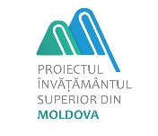
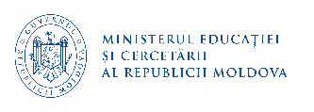


Progress Report

on Moldova Higher Education Project activities

as of December 31, 2024
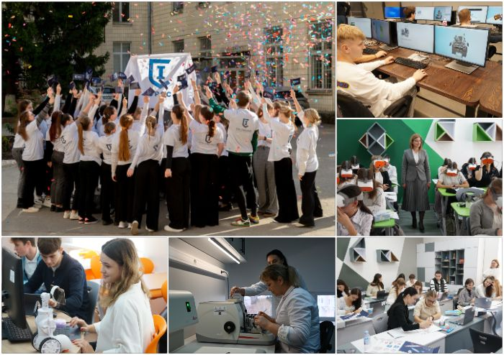

Content
Project background 3
Component 1: - Improving the Quality Assurance Mechanisms 5
Sub-component 1.1 – National Qualifications Framework and Quality Assurance 5
Sub-component 1.2 – System management and monitoring 10
Sub-component 1.3 – Higher Education Financing 13
Component 2 - Improving the labor market orientation through targeted interventions 15
Project Promotion 18
Component 3. Project Management 26
Project restructuring 27
Component 4 – Internationalization of higher education 27
Monitoring the environmental and social aspects of the Project 32
Financial management and disbursements within Moldova Higher Education Project 37
Project Monitoring and Evaluation 38
Annex 1. Moldova Higher Education Project Results Framework and Monitoring Indicators as of December 31, 2024 42
Annex 2. Progress report on implementation of 20 sub-projects by HEIP beneficiaries under the first call within Component 2 of the Project as of December 31, 2024. 57
Annex 3. Progress report on implementation of 13 sub-projects by HEIP beneficiaries under the second call within Component 2 of the Project as of December 31, 2024 97

Project background
The Government of the Republic of Moldova (GoM), through the Ministry of Education and Research (MoER) is implementing the Moldova Higher Education Project (MHEP). The Project is financed by the International Development Association (IDA) Credit of EUR 35.7 million. The Financing Agreement between the Republic of Moldova and the International Development Association was signed on May 19, 2020 and was ratified by the Parliament of the Republic of Moldova by the Law no. 103 dated June 18, 2020. The Project is implemented over a period of 5 years, from May 2020 to December 2025.
In April 2024, the MoER requested the restructuring of the Project to utilize the savings accrued from the activities under Component 1, which was approved by the Bank on July 07, 2024. The Amendment no 2 to the Financing Agreement was signed on August 14, 2024, and became effective on November 6, 2024.
The Project includes systemic interventions for improving higher education quality, financing, and management, as well as a targeted program named Higher Education Improvement Program (HEIP), which are implemented by selected higher education institutions and pedagogical colleges to address some of their most pressing needs in labour market orientation.
The systemic interventions will be transformational and complement the GoM’s efforts toward an improved higher education system that is more efficient, affordable and of better quality. The Project supports fundamental activities such as the improvement of the system’s quality assurance mechanisms, as well as its overall capacity to collect, analyse and use data to inform on decision process.
According to the original Project design, the initial priority areas set by the GoM for the MHEP are the following: (i) Engineering and engineering activities, (ii) Information and Communication Technologies, (iii) Education (pedagogy), and (iv) Health, which are fundamental for addressing key education system’s issues (e.g. shortage of teachers) and for economic growth.

In 2023, the MoER identified additional field of studies based on the demand of the labour market and expanded the number of priority areas for sub-projects under HEIP, including also: (i) Educational Sciences, (ii) Chemical Sciences, (iii) Biological Sciences, (iv) Environmental Sciences, (v) Physical Sciences, (vi) Mathematics and Statistics, (vii) Information and Communication Technologies, (viii) Engineering and engineering activities, (ix) Agricultural Sciences, (x) Veterinary medicine, and (xi)Health.

The Project Development Objective (PDO) is to improve the labor market orientation of selected higher education institutions and the quality assurance mechanisms.
The project is comprised of 4 components after first restructuring:
- Component 1. Improving Quality Assurance Mechanisms;
- Component 2. Improving the Labor Market Orientation through Targeted Interventions;
- Component 3. Project Management
- Component 4 - Internationalization of higher education

Since the Project starting, the Project activities have been carried out according to the Project Operations Manual (POM) and Project Implementation Plan (PIP) to achieve the PDO and key performance indicators.
As of December 31, 2024, the amount of EUR 20.1 million or 56.4% was disbursed out of the credit of EUR 35.7 million to support the Project implementation.

Summary of MHEP implementation progress as of December 31, 2024
- 308 qualifications standards developed for Bachelor’s, Master’s, and PhD programs (levels 6 to 8) in 23 fields of study;
- 1662 managers and teaching staff trained in developing the curricula related to the National Qualification Framework levels 6-8 in the 23 fields of study;
- 1116 managers and teaching staff trained in monitoring quality, relevance, regular assessment and updating of qualifications;
- 350 teachers, vice-rectors etc. trained in best practices of Quality Assurance policies;
- Digitalization of archive of diplomas’ registries has been completed;
- The new functionalities have been developed for the National Qualification Register and it has been publicly launched on November 21, 2024;
- Two Quality assurance methodologies for higher education have been improved;
- The e-admission system has been developed and piloted. The Landing page was available at https://eadmitere.gov.md/. Starting with July 22, 2024, the national e-admission system was rolled out for general usage. During the piloting period, the system has served its purpose as being the unique access point to higher education, providing more than 16 thousand candidates with the opportunity to apply for higher education degree. Currently, the national e-admission system is in its redesign phase, piloting of the revised system is expected to start in March 2025, internally with higher education institutions, and in July 2025, externally with the national admission schedule.
- Higher Education Management Information System is under development.
- The Graduate Tracer Study (GTS) has been conducted under MHEP, which targeted graduates of 2020 of 16 higher education institutions;
- The financial mechanism in higher education has been improved and is under implementation.
- 74 laboratories and 93 learning premises have been equipped by higher education institutions and pedagogical colleges with furniture, ICT equipment, teaching materials and/or specialized equipment under the first call of sub-project proposals;
- 77 Bachelor/Master programs have been developed/updated by higher education institutions under the first call;
- 49 curricula have been developed/updated for the Bachelor/Master programs by higher education institutions under the first call;
- 62 course materials have been developed/updated by pedagogical colleges under the first call;
- 3017 teaching staff of the higher education institutions and pedagogical colleges have been trained under the first call.
- In 2024, two surveys have been conducted under MHEP: 1) one survey was conducted at the national level (baseline) to measure the perception of employers about the labor market orientation of selected higher education institutions’ programs of 7 additional areas of studies (agricultural science, veterinary science, mathematics and statistics, physical science, environmental science, biological science, and chemical science), and 2) the second survey (progress evaluation) has been conducted to determine to what extent the objectives of the MHEP have been achieved for the effective involvement of educational actors and partners in the processes of improving the labor market orientation of higher education institutions and quality assurance mechanisms.

Component 1: - Improving the Quality Assurance Mechanisms
Component 1 aims to improve Moldova Higher Education system’s quality assurance mechanisms, which would also contribute to improve its labor market orientation. It comprises three sub-components that support activities in: (i) National Qualifications Framework (NQF) and Quality Assurance (QA); (ii) System Management and Monitoring; (iii) Higher Education Financing, which would benefit all higher education institutions in Moldova.
Please see below the implementation progress of activities under Component 1 as of December 31, 2024.

Sub-component 1.1 – National Qualifications Framework and Quality Assurance
This subcomponent is financing relevant activities in higher education quality assurance, including (i) development and review of qualification standards in compliance with the NQF, and (ii) improvement of the existing QA mechanisms.
The activities under this sub-component are implemented by the MoER’s National Qualification Framework Department in close collaboration with the MoER’s Higher Education Department, with the support of the Project Management Team (PMT).
The development of qualification standards has been carried out in several stages as follows.

Activity no 1.1.1.1 - Development and Review of Qualification Standards (QS)
Implementation Period | Implementation progress
Stage 1  January 2021 – February 2023 | Contracts completed for development of qualification standards for 4 fields of study (Administrative Sciences -3 standards; Economic Sciences – 25 standards; Manufacturing and Processing Technologies - 23 standards; Law – 4 standards). A total of 55 qualification standards have been developed for 4 fields of study.
Stage 2  November 2021 – December 2023 | Contracts completed for development of qualification standards for 14 fields of study (Engineering and engineering activities (55 standards), Architecture and construction (19 standards), Transport services (3 standards), Arts (48 standards), Humanistic sciences (15 standards), Philology (11 standards), Social and behavioural sciences (13 standards), Journalism and Information (9 standards), Chemical Sciences (5 standards), Biological Sciences (7 standards), Environmental Sciences (3 standards), Physical Sciences (13 standards), Mathematics and statistics (7 standards), Security services field (13 standards).  A total of 221 qualification standards have been developed for 14 fields of study mentioned above.
Stage 3.  January 2023 – December 2024 | Contracts completed for development of qualification standards for 5 fields of study (Agriculture – 13 standards; Forestry – 3 standards; Veterinary medicine– 3 standards; Science of sports – 8 standards, Public Services – 5 standards). A total of 32 qualification standards have been developed for the 5 fields of study.
Stage 4  January 2024 - April 2025 | Ongoing contracts for consulting services to review/update the qualification standards for 3 fields of study (Education sciences, Information and communication technologies, and Health). 45 qualification standards are under development for the 3 fields of study.
Revision of Bachelor and Master programs
The qualification standards that are developed through the Project are followed by the revision of the curriculum, and then the accreditation of new academic programs. The development of qualification standards is done with the participation of relevant employers or their associations in each specific field.

In this context, the training has been delivered to 1662 managers and teaching staff in developing the curricula related to NQF levels 6-8 in the 23 fields of study, based on the qualification standards and learning outcomes.
At the same time, for the specialists responsible of internal quality management and university curricula, training has been delivered to 1116 managers and teaching staff in monitoring quality, relevance, regular assessment and updating of qualifications, assessment of implementation the qualification standards in teaching and learning processes, in evaluation of learning outcomes, and final certification of qualification.

As of December 31, 2024, a total of 255 Bachelor and Master programs have been updated by the higher education institutions based on the standards developed.

Activity 1.1.1.2 – Assistance to the implementation of the NQF
Implementation period  January – December 2025 | Implementation progress  Ongoing activity. The procurement process has been launched to hire a consultant to provide assistance to the National Qualifications Framework (NQF) Department, and currently the evaluation is conducted to select the consultant.
Activity 1.1.1.3 - Technical assistance for the management of the National Qualifications Register (NQR)
Implementation period:  January 2022 – December 2025 | Implementation progress  Ongoing contracts. Two consultants have been hired to provide technical assistance to the NQF Department for the management of the NQR, and for the self-certification of the NQF.
Activity 1.1.1.4 - Technical assistance for the maintenance of the National Qualifications Register
The Project supports the development and maintenance of the NQR intended for various groups of beneficiaries, which represents a database of qualifications in the Republic of Moldova.
Contract signing with the selected firm: June 2023
Consultant: Cristalion Plus JSC
Implementation period: June 2023 – July 2025 | Implementation progress  Ongoing contract. A firm was hired under MHEP based on single-source selection to ensure maintenance of the NQR existing functionalities and to develop new adjustments and functionalities in accordance with the new National Qualifications Framework, approved by the Government Decision (GD) no 330/2023 and normative act on NQR implementation based on the MoER request.  Currently, the NQR is filled with: i) 252 qualification standards by fields of professional training and ii) for 17 general fields of study (011 Educational Sciences,021 Arts, 022 Humanities, 023 Languages, 031 Social and behavioural sciences, 032 Journalism and information, 040 Administrative sciences, 041 Economics, 042 Law, 051 Biological sciences, 061 ICT, 071 Engineering and engineering trades, 072 Manufacturing and processing technologies, 073 Architecture and construction, 084 Veterinary medicine, 091 Health, and 103 Security services), the information was recorded on the providers of accredited study programs – 52 educational institutions and 295 study programs were registered in the mentioned fields.  The following sections have been developed for the NQR: Moldova education system, VET qualifications, Higher education qualifications, sectoral qualifications framework, list of economic agents per sectors of the national economy, standards – competences - learning results, evaluations, and certification of qualifications, and the NQR was completed with relevant information on these sections.  The design of the NQR home page, interactive schemes on the development of qualifications in accordance with the needs of the labor market and the evaluation, marking and certification of qualifications by educational levels were developed and implemented.  At the same time, in accordance with the GD no. 3/2024 on ensuring the interoperability of the NQR with the European qualifications registers/databases, according to the European Union recommendations, the Company developed in collaboration with European Training Foundation (ETF) experts the NQR Information System to ensure this objective. The interoperability of the NQR with the European Qualifications Dataset Register (QDR) was conducted and tested, currently being transferred about 20 qualifications from the NQR to the QDR.  The NQF Department publicly launched the NQR on November 21, 2024. Around 70 people were present, representatives of the central public administration, development partners of the NQF, higher education and VET institutions from the Republic of Moldova. Information on the event can be found on the MoER website by accessing the link https://mecc.gov.md/ro/content/mec-lansat-registrul-national-al-calificarilor-cu-peste-300-de-standarde-de-calificare.
Activity 1.1.1.5 - Digitalization of the archived diplomas’ registries that were issued before 2008
Contract signing with the selected firm: January 2024
Consultant: Andmevara SRL
Implementation period:  January 2024 – January 2025 | Implementation progress  Ongoing contract. To simplify the processes of verification and validation of higher education diplomas, a firm was hired under MHEP to digitise the registers of higher education diplomas issued from 1992 to 2008, a volume of about 270,000 records.  As of December 31, 2024, the stage of scanning the registers is completed in: Chisinau – 16 institutions, Taraclia – 1, Cahul – 1, Comrat -1, Balti – 1 institution. The indexing of the scanned registers and the internal verification of the quality of the entered data is in process.  The MoER identified human resources for main Universities to speedup external verification of entered data and validation of scanned registers. The deadline for the external data verification and validation of scanned registers has been extended by March 15, 2025.
Quality assurance (QA). To address the challenges with the QA of Moldova’s higher education system, this sub-component supports activities aimed at strengthening National Agency for Quality Assurance in Education and Research (NAQAER, ANACEC – Romanian abbreviation) ’s capacity as the key external QA authority, as well as universities’ capacity in this area. These activities are implemented by the MoER’s Higher Education Department in close collaboration with the NAQAER, with the support of the PMT.
Activity 1.1.2.1 - Technical assistance for the accreditation of higher education programs and institutions offering Master's and Doctoral programs
August 2021 – April 2024 | Completed contract. The international consultant hired under MHEP provided support to the MoER in the accreditation of higher education programs and institutions offering Master's and Doctoral programs. The international consultant revised the Methodologies for the external evaluation of Master's and Doctoral Programs and higher education institutions offering Doctoral Programs, in accordance with the European Standards and Guidelines for Quality Assurance in Higher Education (ESG 2015), and Recommendations were submitted on the preparation of institutional self-evaluation reports for Master's and Doctoral Higher Education Programs.  During February 15-29, 2024, the consultant provided 4 workshops to about 120 representatives of the higher education institutions with Master’s and Doctoral Higher Education Programs on the revised methodologies.
Activity 1.1.2.2 - Enhancing the existing QA capacity of NAQAER and universities
January – July 2022 | Completed contract. During June 21-24, 2022, an international consultant hired under MHEP conducted training for 200 representatives of 21 higher education institutions on internal quality assurance, development of internal evaluation reports (self-evaluation) and promotion of inter-institutional collaboration, based on the Standards and guidelines for quality assurance in the European Higher Education Area (EHEA) 2015.
Activity 1.1.2.4 - Supporting NAQAER registration in European Quality Assurance Register (EQAR)
Implementation period  November 2021 – December 2025 | Implementation progress  Ongoing activity. During June 19- 21, 2023, the documentation visit of the European Network for Quality Assurance in Higher Education (ENQA) Review Panel was carried out at NAQAER for institutional evaluation of the Agency. On November 8, 2023, NAQAER applied for registration in the EQAR Register. The external evaluation report and several other documents developed by NAQAER and ENQA were examined at the EQAR board meeting in December 2023.  On January 15, 2024, ANACEC received a letter from the EQAR board informing that in accordance with EQAR’s Procedures for Applications, the Register Committee deferred the ANACEC’s application and asked to make additional representation based on the recommendations provided. Currently, the MoER is implementing the recommendations of the ENQA Committee, and will resubmit the application in 2025.
Activity 1.1.2.5 - Training activities for NAQAER and MoER staff
January 2023 – February 2024 | Contract completed. During December 2023 - January 2024, an international consultant hired under MHEP delivered several trainings to about 50 representatives of the MoER and NAQAER in management, planning, evaluation, and in the area related to the European Standards and Guidelines for Quality Assurance in the European Higher Education Area (ESG).

Sub-component 1.2 – System management and monitoring
Sub-component 1.2 finances activities to improve the management and monitoring capacity of the higher education system. This sub-component supports the development and implementation of the following information systems:
- unified electronic higher education admission system (E-Admission), and
- unique Higher Education Management Information System (HEMIS)
Activity 1.2.1 - Develop a unified electronic higher education admission system (e-Admission)
Activity 1.2.1.1 Development of Terms of Reference for e-Admission System and technical assistance for managing the system development and implementation and for the acceptance of e-Admission System.
November 2021 – September 2025 | The ToR for development of e-admission system was developed and approved by the Bank.  Ongoing contract. The IT consultant hired under MHEP provides technical assistance for managing the system development and implementation and for the acceptance of e-Admission System.
Activity 1.2.1.2 Development of e-Admission System, Maintenance and Training of Users
Contract signing date with the selected firm: February 05, 2024
Consultant: EBS Integrator SRL
Implementation period: | Implementation progress
December 2022 - September 2025 | Ongoing contract. The Concept and Terms of Reference for the e-Admission system were revised and consulted with higher education institutions, namely: the e-Admission centralized process was changed to semi-centralized process, which means that the e-Admission system will only ensure the submission of applications, while the candidates selection will be provided by each institution. The e-Admission Concept has been approved by the Government Decision no 680 dated September 13, 2023.  The procurement procedure has been conducted under MHEP to hire a firm to develop e-admission system.  The selected firm developed the following documents: a) The software design description document; ii) Interface design document; and iii) The database design document. The system interface has been developed and placed in the test environment. The Landing page was available at https://eadmitere.gov.md/.  From June 26 to July 5, 2024, informational sessions were held regarding the online admission procedure for graduates of general education institutions.  Starting with July 22, 2024, the national e-admission system was rolled out for general usage. During the piloting period, the system has served its purpose as being the unique access point to higher education, providing more than 16 thousand candidates with the opportunity to apply for higher education degree.  Candidates were provided technical support through the call centre set-up. Moreover, MHEP and MoER has also ensured daily communication and support to all higher education institutions, through end of day catch-ups and continuous feedback and improvement.  Currently, the national e-admission system is in its redesign phase, piloting of the revised system is expected to start in March 2025, internally with higher education institutions, and in July 2025, externally with the national admission schedule.  Starting with 2025, national admission to higher education through the e-admission platform will be carried out exclusively with user authentication through MPass. All graduates of 2025 will be provided free of charge with a mobile/digital signature to access the system. MoER has partnered with mobile services providers in this regard and will be monitoring, on a weekly basis, the roll-out and uptake of mobile/digital signatures and mobile teams' visits within all educational institutions, both in the capital and throughout the country.  E-admission platform fully complies with national General Data Protection Regulation (GDPR) requirements and data storage is ensured in governmental cloud.
Activity 1.2.1.3 - Purchase of Equipment and Furniture for the Unit Responsible for Implementing e-Admission
April – December 2024 - | Completed contracts. The necessary equipment and furniture were procured and delivered to the Unit responsible for implementing e-Admission system under the MoER.
Activity 1.2.2 – Development of the Higher Education Management Information System (HEMIS)
Activity 1.2.2.1 - Development of Terms of Reference for the HEMIS and technical assistance for managing the HEMIS development, implementation, and for HEMIS acceptance.
Implementation period:  November 2021 – December 2025 | Implementation progress  The ToR for development of HEMIS was developed and approved in August 2023. The ToR has been discussed with main higher education institutions from Moldova. It was concluded that most universities have their own University management system, and the only issue is reporting to various institutions including the MoER. Therefore, it was decided to revise the ToR so that the HEMIS will be single window system for universities’ reporting. Also, the HEMIS will allow integration with existing University Management Systems. The Concept on HEMIS was developed and approved by the Government Decision.  Ongoing contract.  The IT consultant hired under MHEP provides technical assistance for managing the HEMIS development, implementation, and for HEMIS acceptance.
Activity 1.2.2.2 - HEMIS development, maintenance, and training of users. Enhancing the MoER's and Universities' Capacity in Data Utilization.
Contract signing date with the selected firm: March 07, 2024
Consultant: CVU Intelligence SRL
Implementation period | Implementation progress
September 2023 – December 2025 | Ongoing contract. The procurement procedure has been conducted under MHEP and the selected firm was hired to develop HEMIS.  The company submitted the Project Plan and the analysis document with Software Requirements Specifications (SRS) for HEMIS for review to the MoER and PMT. The Ministry provided recommendations to adjust the submitted documents.  Core documents for system development and delivery (SRS and SDD - Software design document) were approved by the MoER. Business use cases and functionality were presented and consulted with higher education representatives.  Consequently, received feedback and detailing of internal processes were catered for in system documents, and will be considered in HEMIS’s further development.  To ensure HEMIS’s uptake and roll-out, the system will both accept data through Application Programming Interface (API) integration (for institutions that already rely on internal management systems) and back-office interfaces (for the institutions that would be using HEMIS as a management system). Nevertheless, the scope of the system remains being the single window for universities’ reporting and providing MoER with real time data on higher education.  HEMIS Minimum Viable Product (MVP) functionalities have reached 52% of implementation progress, out of which 76% of the use cases are close to completion or in progress, requiring end to end testing (Institutions, Students, Data API import, Academic progress, etc). Post MVP functionalities, such as Reporting, Budgeting, PhD schools and Life-long learning will be delivered once MVP reaches 100% completion.  The system is expected to fully roll-out with the next academic year, starting with national admission results from e-admission being fed into HEMIS, to ensure complete interoperability and communication between both systems, without the need of human intervention.  HEMIS fully complies with national GDPR requirements and data storage is ensured in governmental cloud.
Activity 1.2.4.1 - Designing and implementing the Graduate Tracer Study (GTS)
The general objective of the GTS is to identify the relevance of higher education for the transition to a job and development of the professional career in the first years after graduation, to provide feedback for the improvement of the higher education system and adapting the educational offer to the requirements of the labor market.
Implementation period:  December 2021 – November 2025 | Implementation progress  The GTS has been conducted under MHEP by the National Institute for Economic Research (NIER), which targets graduates of 2020 of 16 higher education institutions. In total, in the Pilot Stage of GTS (4 fields of study) and Second Stage of GTS (the remaining fields) participated 2009 graduates from the Bachelor's program and 1295 graduates from the Master’s program. On July 7, 2023, the data collection statistics were submitted to the MoER, and the final report on the GTS was approved by the MoER in December 2023.  In 2025, the GTS will be conducted by the MoER.

Sub-component 1.3 – Higher Education Financing
Sub-component 1.3 supports the piloting and implementation of the new financing mechanism, developed by MoER in 2018 and approved by the Government Decision no. 343/2020. This financing model includes a component allocated to institutions based on performance indicators and is designed to improve the internal efficiency of the higher education system in the Republic of Moldova.
Activity 1.3.1.1 Piloting and adjusting the New Financing Mechanism
July 2021 -April 2022 | Contracts completed. The international and local consultants hired under MHEP submitted proposals to the MoER for adjusting the financing formula, results of the simulations, the list of normative acts to be amended, as well as the potential performance indicators that can be introduced into the mechanism.  The results of piloting of the financing mechanisms of public higher education institutions were presented in two seminars, which were organized during July 5-6, 2022, with participation of representatives of the Ministry of Finance, central public authorities that have universities under their control, deputy-chancellors responsible for financing, heads of study sections, planning and financing services from the 11 higher education institutions that benefit from university autonomy.  The Government Decision no.700/2023 on amending the Government Decision no 343/2020 on approval of the Methodology for budgetary financing of public higher education institutions was approved on September 20, 2023. The adjusted financing formula is being implemented in 11 public higher education institutions started with 2024.
Activity 1.3.1.3 - Monitoring and Assessment of Implementation of the New Financing Mechanism for Course Correction
Implementation period  April – December 2024 | Implementation progress  Ongoing activity. This activity was included in the ToRs of the education consultants hired under MHEP. The consultants analysed the relevance of the indicators used in the financing process, the method of calculation and the period for which they are calculated.  During July-December 2024, the consultants conducted the evaluation of the implementation efficiency of the Methodology for budgetary financing of public higher education institutions (GD no. 343 of 2020). The research included the following tasks:  1. Analysis of the extent to which the financing formula used in accordance with the mentioned methodology ensured the efficiency of distribution of public funds;  2. Analysis of the cost for students training (based on staff costs) for different study programs and analysis of the current adjustment coefficient corresponding to the study programs (Annex 2 to the Methodology for the budgetary financing of public higher education institutions);  3. Analysis of the Regulation on the establishment and distribution of compensatory funding for public higher education institutions that operate under the financial autonomy, approved by the MoER’s Order no. 1505 dated 21.11.2023 to identify possibilities of its improvement for financing of public higher education institutions in 2025.  For the first two tasks, several simulations were carried out, and for task 3 the analysis was carried out based on the survey of public higher education institutions representatives. Following the research, the following conclusions were reached:  1. The methodology allowed the transparent and fairer redistribution of budgetary resources, based on objective and well-defined criteria, to public higher education institutions, stimulating academic and administrative performance of the institutions. At the same time, to increase the efficiency of the impact of implementation of the financing formula, some deficiencies/shortcomings identified in the analysis carried out on the second task should be solved.  2. The method of setting up and distributing compensatory funding for public higher education institutions operating under financial autonomy, applied for the year 2024, allowed taking into account the performance of universities, on the one hand, but also revealed some imperfections (related to the period for which the information is taken into account, the possibility of verifying the information, the relevance of the indicator, etc.), which should be clarified, on the other hand.  The detailed report with simulations and respective conclusions was drafted and has been submitted to the MoER.

Component 2 - Improving the labor market orientation through targeted interventions
This component finances the design and implementation of a targeted and needs-based program (Higher Education Improvement Program - HEIP) aimed at improving the labor market orientation of Moldova’s higher education institutions, as well as their research capacity.
According to the original Project design, four priority areas were identified by the Government of Moldova to be supported by this component, which are fundamental for addressing key education system’s issues (e.g. shortage of teachers) and for economic growth. The priority areas are as following:
- engineering and engineering trades;
- information and communication technologies (ICTs);
- education science (pedagogy); and
- health (excluding stomatology.

Component 2 includes two sub-components:
- Sub-component 2.1 – Higher Education Improvement Programs Preparation (HEIP)
- Sub-component 2.2 – HEIP Implementation (EUR 24.7 million).
Sub-component 2.1 finances technical assistance for the following:
- preparation of improvement programs (proposals) by higher education institutions and eligible colleges, including the development of guidelines for beneficiaries;
- evaluating these proposals, and constant and high-quality fiduciary support (procurement and financial management) at the HEIP implementation stage.
Sub-component 2.2 finances the implementation of the HEIP’s awarded proposals.
First call of sub-project proposals
In 2022, the MoER had competitively selected and awarded 20 sub-projects, fourteen sub-projects from 7 higher education institutions and six sub-projects from 6 pedagogical colleges in four fields of study (Engineering and engineering activities, Information and Communication Technologies, Education science/pedagogy and Health) under the first call of proposals. The Sub-Financing Agreements were signed by all parties on October 24, 2022 with the implementation period ending on October 23, 2024. The list of sub-projects selected under the first call is presented below.
Higher education institutions:
- "Nicolae Testimitanu" State University of Medicine and Pharmacy - 1 proposal
- "Ion Creanga" State Pedagogical University from Chisinau - 1 proposal
- "Bogdan Petriceicu Hasdeu" State University from Cahul - 3 proposals
- State University of Moldova – 3 proposals
- "Alecu Russo" State University from Balti - 3 proposals
- Academy of Economic Studies from Moldova – 1 proposal
- Technical University of Moldova - 2 proposals

Pedagogical colleges (PC):
- PC "Mihai Eminescu" College from Soroca - 1 proposal
- PC "Iulia Hasdeu" College from Cahul - 1 proposal
- PC "Mihail Ciachir" College from Comrat - 1 proposal
- PC "Alexei Mateevici" College from Chisinau - 1 proposal
- PC "Vasile Lupu" College from Orhei - 1 proposal
- PC "Ion Creanga" College from Balti - 1 proposal.

According to the HEIPOM, the Beneficiaries are responsible for the overall management/implementation of the HEIP sub-project. The Beneficiary Sub-Project Team include the following minimum three positions: Project Manager, Financial Manager and Procurement Manager. They are responsible for the implementation of the sub-projects and are nominated by the Beneficiary, in accordance with internal ordinance with a clear reference of the time spent for implementation of sub-project activities.
Each Beneficiary Sub-project Team developed and submitted to the MoER and the PMT a Procurement Plan, an Implementation Plan with timelines for implementation of activities and the Sub-project Results Framework to monitor the activities and indicators.
The amount allocated for the implementation of 20 sub-projects awarded to universities and pedagogical colleges under the first call of proposals is EUR 14,337,132.00. The initial allocations were disbursed to all 13 Beneficiaries.
The total amount disbursed for 20 subprojects by December 31, 2024 is EUR 12,587,454.41 representing 87.80% out of the total budget allocated for the first call.
The total amount executed by 20 sub-projects as of December 31, 2024 is EUR 12,352,798.19 representing 86.16% out of the total budget allocated for the first call.
As of December 31, 2024, the procurements have been finalized for 11 sub-projects under the first call. The Sub-financing Agreements have been extended for 9 subprojects for 2025.

Please see below the status of procurements conducted by the sub-project beneficiaries under the first call as of December 31, 2024.

Category of procurements | No of contracts signed | Value of contracts signed  EUR | No of contracts executed | Value of contracts executed  EUR | Total No of procurements launched ^{[1]} | Total value of procurements launched, EUR
Goods+Non consulting services | 258 | 10.960.594,43 | 235 | 10.068.976,43 | 5 | 308.887,00
Consulting services | 367 | 1.653.183,07 | 362 | 1.585.422,87 | 4 | 50.915,00
Works | 6 | 263.209,10 | 6 | 263.209,10 | 0 | 0
TOTAL | 631 | 12.876.986,60 | 603 | 11.917.608,39 | 9 | 359.802,00

The progress on implementation of 20 subprojects by HEIP beneficiaries under the first call is provided in Annex 2 to this report.

Second call of sub-project proposals
The MoER proposed for the second call of sub-projects proposals participation of higher education institutions and pedagogical colleges, which are not subject to optimization and which offer study programs in the following areas: Education sciences; Chemical sciences; Biological sciences; Environmental science; Physical sciences; Mathematics and statistics; Engineering and engineering trades; Information and Communication technologies; Agriculture; Veterinary; and Health. In this context, HEIPOM was adjusted and additional areas have been included for the second round for sub-project proposals, which was approved by the Bank.
Following the evaluation, thirteen sub-project proposals have been awarded to 5 selected higher education institutions representing the total amount of EUR 10,368,868.00 (State University of Moldova – 6 sub-projects representing a total amount of EUR 3,500,000.00; Technical University of Moldova – 4 sub-projects representing a total amount of EUR 3,500,000.00 EUR; State University of Medicine and Pharmacy – 1 sub-project for EUR 2,000,000.00; State University of Balti “Alecu Russo – 1 sub-project for EUR 189,000.00, State Pedagogical University in Chisinau “Ion Creanga” – 1 sub-project for EUR 1,179,868.00).
The Sub-Financing Agreements with the selected higher education institutions under the second call have been signed on November 27, 2023, with the implementation period ending on September 15, 2025.
The initial allocations were disbursed to all 13 Beneficiaries. The total amount disbursed for 13 subprojects by December 31, 2024 is EUR 4,105,019.93 representing 39.60% out of the total budget allocated for the second call.
The total amount executed by 13 sub-projects as of December 31, 2024 is EUR 1,430,515.83 representing 13.8% out of the total budget allocated for the second call.
The procurement plans for the second round were developed by the selected higher education institutions and have been approved by the MoER.
During January – December 2024, out of the planned procurement budget of EUR 9,897,621.00, the procurements have been launched in the amount of EUR 7,492,731.00, and the amount of signed contracts is EUR 5,008,239.00.
Please see below the status of procurements conducted by the sub-project beneficiaries under the second call as of December 31, 2024:
Category of procurements | No of procurements planned | No of contracts signed | Value of contracts signed  EUR | No of contracts executed | Value of contracts executed  EUR | Total No of procurements launched | Total value of procurements launched, EUR
Goods+Non consulting services | 46 | 30 | 5.197.529 | 8 | 853.013 | 28 | 6.992.781
Consulting services | 124 | 39 | 235.604 | 30 | 214.994 | 62 | 499.950
TOTAL | 170 | 69 | 5.433.133 | 38 | 1.068.007 | 90 | 7.492.731

The progress on implementation of 13 subprojects by HEIP beneficiaries under the second call is provided in Annex 3 to this report.

Project Promotion
To promote the Project, the following activities have been carried out during the reporting period.
The Project's Communication Strategy and the Action Plan on the Strategy have been finalised and approved by the Bank. Also, based on the approved ToR, the procurement process for the selection of a communication and PR company was conducted and PROIMAGINE firm was selected. Five tasks were determined and it is working in these directions:
- Develop a brand of the MHEP project.
- Develop standard sets of promotional materials on the activities during the project implementation.
- Develop and implement a communication campaign on the e-Admission system.
- Develop and implement a communication campaign to represent a retrospective of all Project achievements.
- Produce visibility materials.

The Project's brand logo, slogan and brand book were developed. The brand book was submitted for use by the beneficiary institutions. Also, Communication Guidelines have been developed under the project for the beneficiary institutions - universities and pedagogical colleges. A meeting was also organized with all responsible persons to discuss communication issues. This greatly facilitated the communication work throughout the year.
An important activity for the visibility of the project was the creation of videos about the implementation of the sub-projects in the beneficiary institutions. The PMT together with the PR company managed to create and published online 30 videos from the beneficiary institutions: https://mec.gov.md/ro/content/media . The videos were placed on the MoER social media accounts on Facebook: (https://www.facebook.com/mec.gov.md), YouTube (https://www.youtube.com/@MECRM), Instagram (https://www.instagram.com/mec.gov.md), as well as on the MHEP Facebook account: https://www.facebook.com/profile.php?id=100063747923578.
Below some examples of videos:
- The Center of Molecular Medicine and the Center of Personalized Medicine were inaugurated at the State University of Medicine and Pharmacy "Nicolae Testemitanu": https://www.facebook.com/100063747923578/videos/1331122711592372
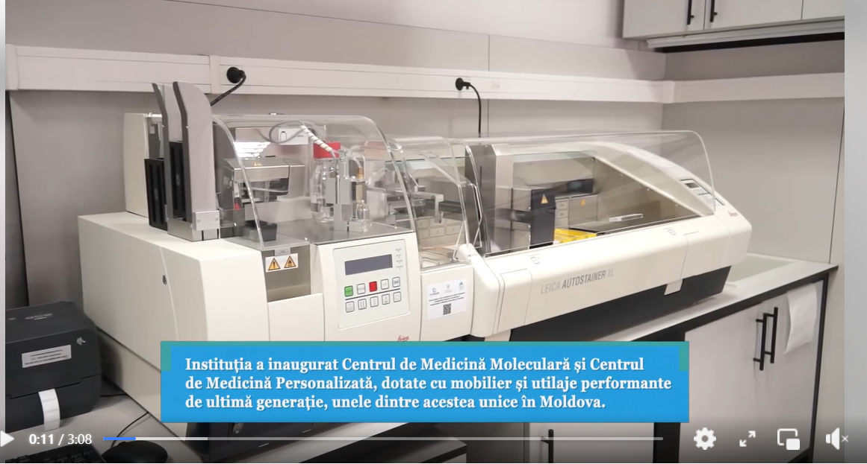
- A laboratory for the study of geographic information systems (GIS) equipped with state-of-the-art equipment and software was opened at the Academy of Economic Studies of Moldova.: https://www.facebook.com/100063747923578/videos/2366758940346171
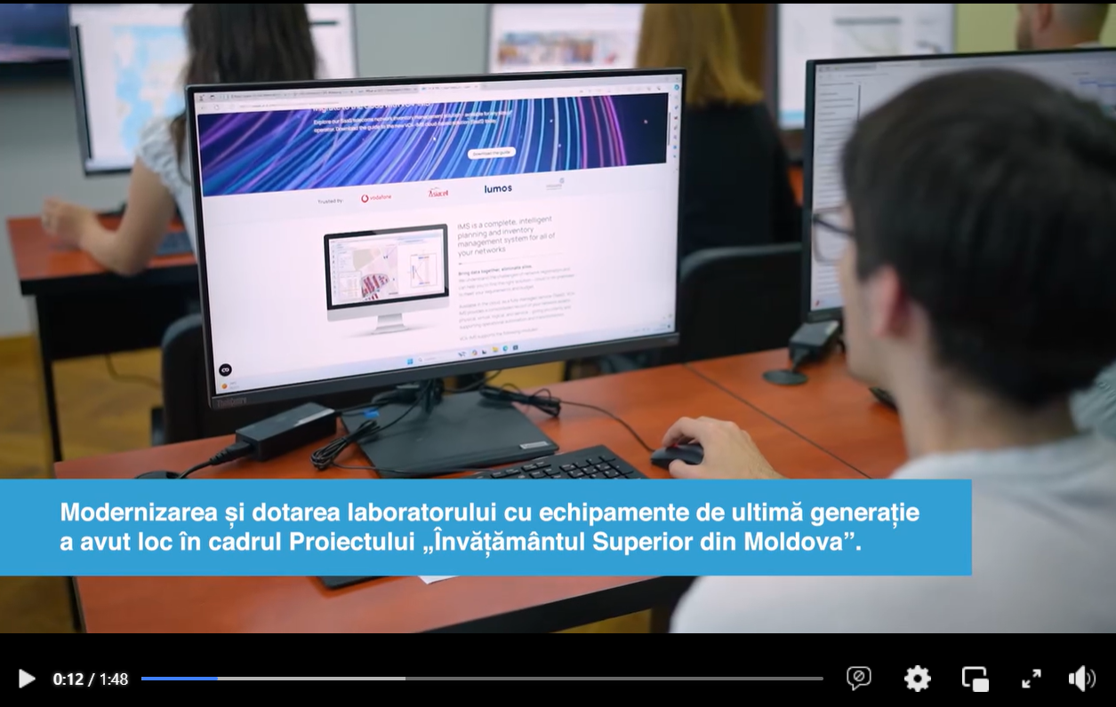
- Sports hall opened at "Ion Creangă" Pedagogical College in Balti: https://www.facebook.com/100063747923578/videos/1497646217794209
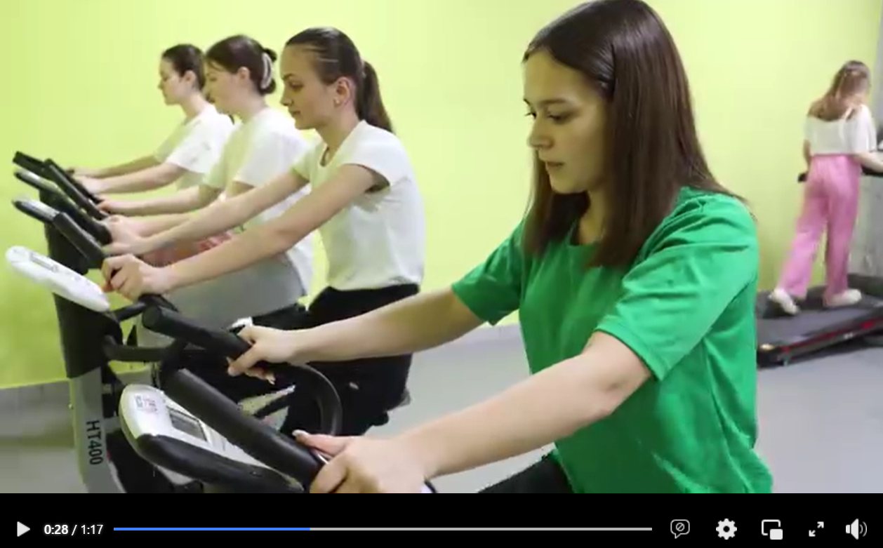
Also, 33 photo albums and 30 press releases were published online. The press releases were posted on the MoER web page: https://mec.gov.md/ro/advanced-page-type/comunicate-pism-0 and on the MoER social media accounts on Facebook, Telegram (https://t.me/+ObMWIlby9PlkN2Ji), Viber (https://bit.ly/3RCi2Z5), and on the MHEP Facebook account: https://www.facebook.com/profile.php?id=100063747923578. All these materials are published on MHEP subpage on MoER webpage: https://mec.gov.md/ro/content/proiectul-invatamantul-superior-din-moldova?fbclid=IwAR2iETAE-GYvd91z0SJzYeFSLaxAWMtEFWpsJUBX4p7Gixuc5V9G13QLo50%20.
Below some examples of published photo albums:
- Spaces for art and technology education at the State Pedagogical University "Ion Creanga" in Chisinau: https://www.facebook.com/media/set/?set=a.1118626973605556&type=3
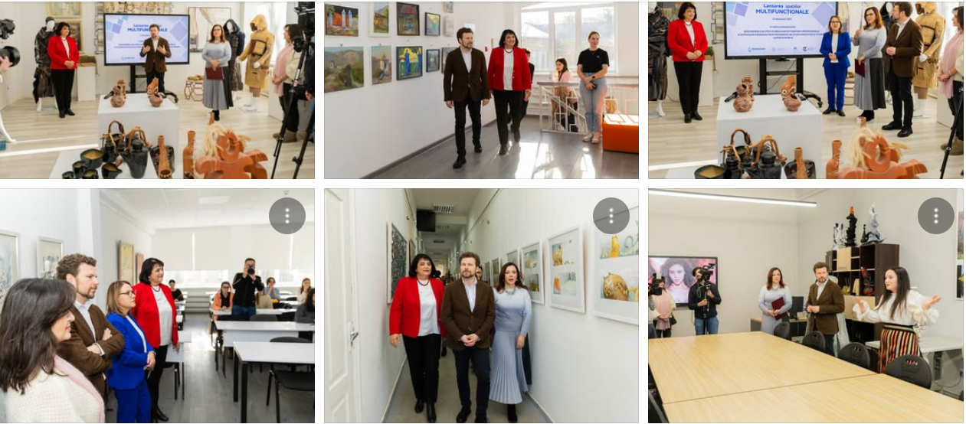
- Launching of educational spaces at M. Ciachir College in Comrat: https://www.facebook.com/media/set/?set=a.1117057453762508&type=3

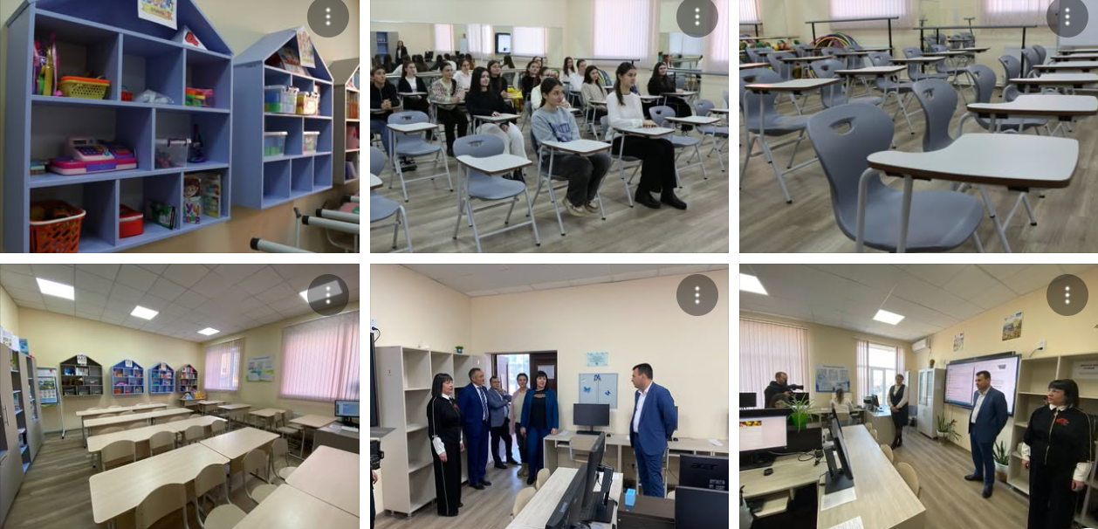

- Educational hub equipped with modern furniture and state-of-the-art equipment at "Iulia Hasdeu" College in Cahul: https://www.facebook.com/share/p/1BHDZAqQth/
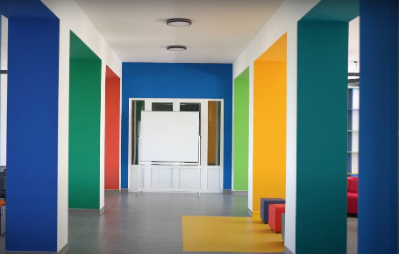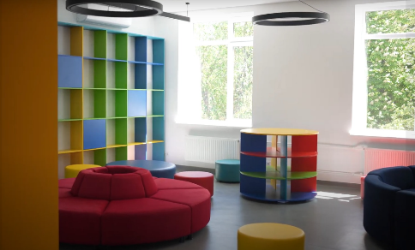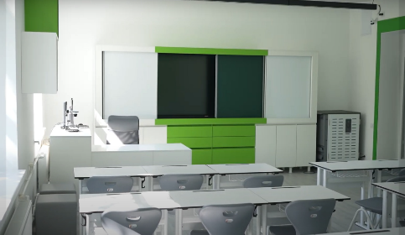

In total, more than 180 posts have been elaborated and published on the MHEP Facebook account and on the MoER social media account on Facebook with more than 68 thousand followers. The photo albums are also posted on the MoER web page https://mec.gov.md/ro/content/media , and on other platforms mentioned above.
At the same time, some of the final indicators of the first round of the project were disseminated through graphic cards. The cards were posted on the MoER web page https://mec.gov.md/ro/content/media , and on other platforms mentioned above.
Below some examples of cards:
- Overall indicator: Learning spaces equipped with equipment and furniture: https://www.facebook.com/share/p/1Eg2THp7RK/
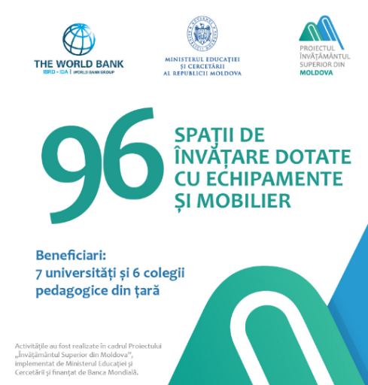

- Overall indicator: 14 new Bachelor's and Master's programs opened in Moldovan universities with the support of the World Bank: https://www.facebook.com/photo/?fbid=1092513972883523&set=a.483466387121621
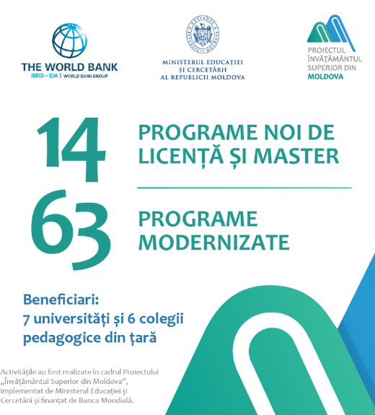
- Overall indicator: Study laboratories equipped with modern equipment and state-of-the-art information technologies: https://www.facebook.com/share/p/18aREBhSmY/
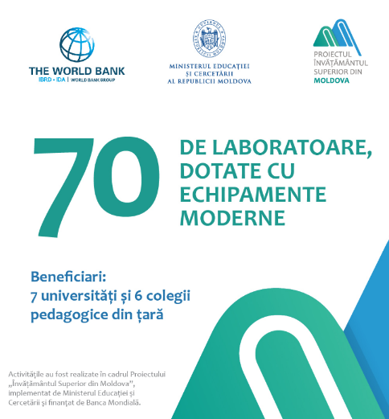
12 public events (https://mec.gov.md/ro/content/media ) have been organised regarding the second call conducted under the MHEP, and the inauguration of educational and learning spaces, laboratories and study centers, etc., renovated and equipped under the first round of funding. The teaching staff, students, leadership of the MoER, PMT and other stakeholders, mass media participated in these events. This information was posted on the MoER webpage, Facebook page of the MoER and MHEP. The media representatives were invited and were presented to all events, dozens of reports and articles were written in the Moldovan press.
Below some examples of launch of public events:
- Launch of multifunctional spaces at the State Pedagogical University "Ion Creanga": https://www.facebook.com/share/v/19ioEKWbqT/

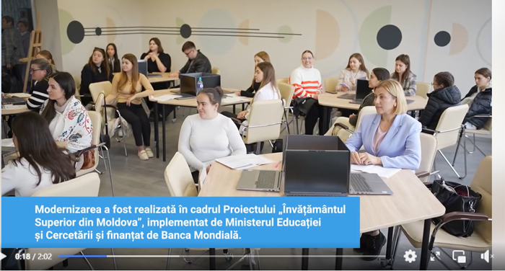
- Launch of 7 modern laboratories at the Technical University of Moldova: https://www.facebook.com/100063747923578/videos/1445578362919423
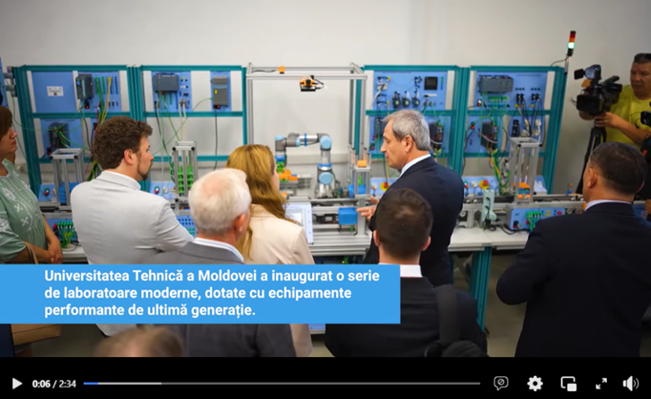
- Better study conditions for pupils at the Alexei Mateevici College in Chisinau: https://www.facebook.com/watch/?v=907559877960741

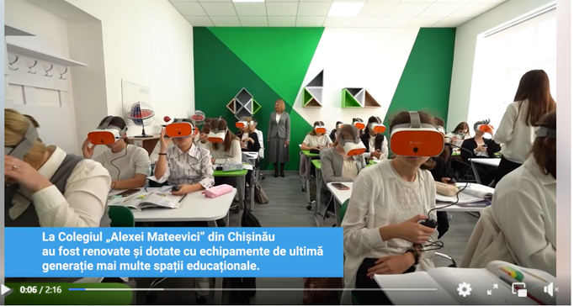
For wider media coverage of the launch events of the project results reels have been developed. Here some examples:
Innovation in education with access to augmented reality and virtual reality at the Technical University of Moldova: https://www.facebook.com/share/r/1FT94PoM8a/
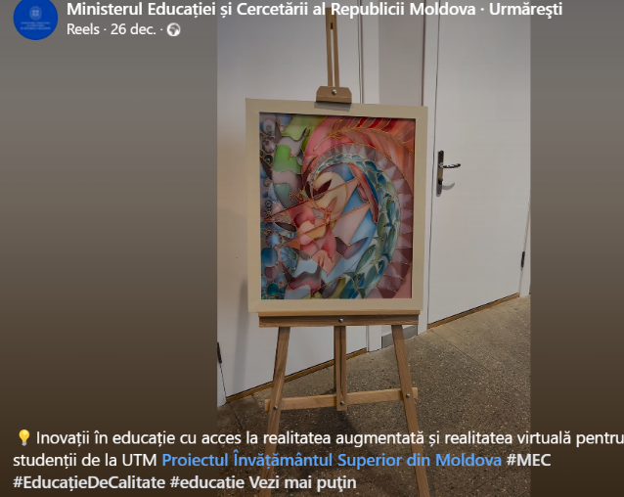
At the same time, the Communication Plan has been developed for the e-Admission Communication Campaign. In June 2024, preparations for the e-Admission communication campaign have started. The launch of the campaign can be seen here: https://mec.gov.md/ro/content/ministerul-educatiei-si-cercetarii-lansat-eadmiteregovmd-o-platforma-pentru-admiterea-online?fbclid=IwY2xjawIJuMBleHRuA2FlbQIxMAABHWc1PC3bxYLUmQZerjhS_r4Y0yvU3QhvTugZWh2DFMSJj9pHG5G3gfiOGA_aem_i0XS9dOoPA-HkU_t-rs8-A
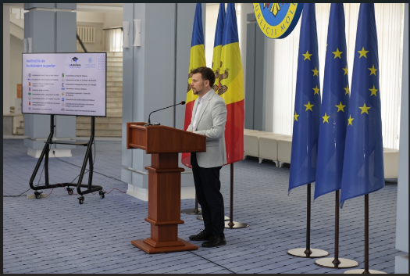
There were elaborated 3 explanatory videos, 6 videos with high school and college graduates who will submit their applications through the e-Admission platform, 10 infographics. All materials and products developed for this campaign are available in the newly created MoER sub-heading: https://mec.gov.md/ro/content/campanii
- Logo and slogan:


- Testimonial video: https://www.facebook.com/mec.gov.md/videos/1260139001617373
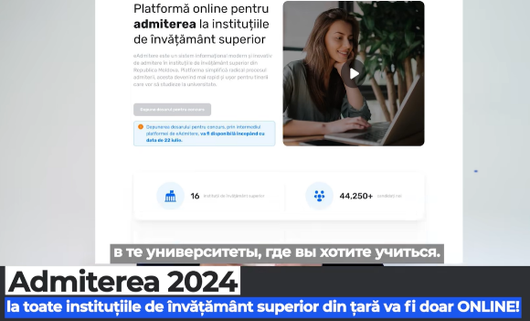
- Video grafic: https://www.facebook.com/mec.gov.md/videos/514592317898695/?rdid=MJjHm0CqdCRPLxtN#


- Tutorial video: https://www.facebook.com/mec.gov.md/videos/1144491533289685/?rdid=tOF8KxEu9Mo2C1P1#
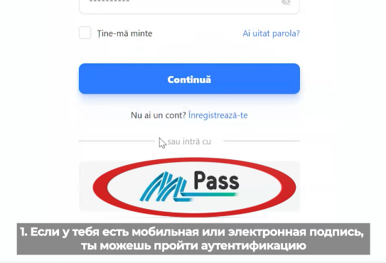
15 training sessions for high school graduates from 35 districts of the country are underway: https://www.facebook.com/share/p/1B1waxfk2e/
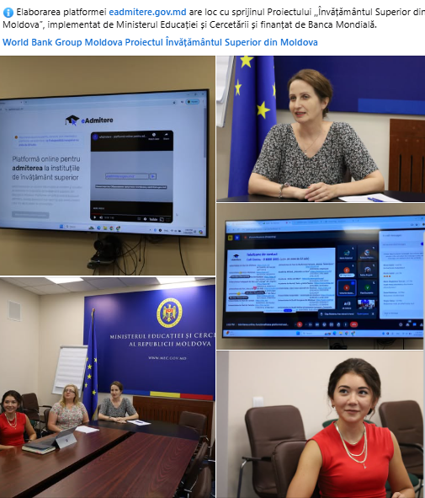
7% increase of the number of students enrolled in the 2024/2025 academic year in higher education institutions in Moldova is largely due to the public information about the modernizations in universities carried out under MHEP.

Component 3. Project Management
Project Management Team (PMT)
The Project Management Team (PMT) include: one Project Coordinator, one Financial Management Specialist, one Procurement Specialist, one Monitoring and Evaluation Specialist, one HEIP Officer and one Social and Environmental Specialist. Since launching the Project, the PMT continued to provide managerial, fiduciary, and technical support to the MoER in the Project implementation. The PMT is responsible for day-to-day project management activities including financial management, disbursement, procurement, and monitoring and evaluation. In addition to the specialists mentioned above, the MoER hired an IT specialist to assist the MoER with the development and implementation of all systems under MHEP.

The Project also finances specialized fiduciary assistance for the implementation of the HEIP under subcomponent 2.1, so that a Procurement Specialist and a Financial Management Specialist have been hired in 2021 to provide fiduciary support to HEIP beneficiaries.
The PMT has strengthened its procurement capacities and hired an additional procurement specialist to provide fiduciary assistance to HEIP beneficiaries for the implementation of sub-projects under the second call.

On September 25, 2023, two education consultants have been hired under MHEP to support HEIP beneficiaries with quality assurance that includes support/review of service consultancy ToRs, check of consultants’ deliverables, and assist the MoER and related agencies/units with the overall project implementation, as well as to maintain continuous and efficient communication between and within all the mentioned stakeholders.

In 2023, the contract was signed with the selected stakeholder engagement consultant to provide support to the MoER in engaging stakeholders under MHEP.

To promote the Project and carry out communication activities, a PR specialist was hired under MHEP, and the contract with the selected consultant has been signed on November 1, 2023.

To support the MoER, PMT and universities with new activities approved under the Project restructuring, two consultants have been hired as follows: i) one consultant to support with the implementation and monitoring of internationalization-related activities, and ii) one engineer/architect to provide assistance in the implementation and monitoring of renovation process of the selected dormitories of universities.
On November 11, 2024, an additional IT specialist has been hired to provide assistance in implementation of IT systems developed under MHEP.

Project restructuring
To ensure the quality and relevance of higher education in Moldova, the MoER proposed to restructure the Project to use the Project savings (about EUR 4.6 million) for renovation and refurbishment of two student dormitories of higher education institutions and for internationalization related-activities.
By letter no 11/2-7/152 dated Aprill 11, 2024, the Ministry of Finance requested to the Bank to restructure MHEP for meaningful use of identified savings. The first Project restructuring was approved by the Bank on July 07, 2024, and the Amendment to the Financing Agreement was signed on August 14, 2024. The Law for ratification of the Amendment no 2 to the Financing agreement was adopted by the Parliament of the Republic of Moldova on September 13, 2024. The proposed changes for the restructuring include: (i) cancellation of the Labor Market Information System (LMIS) development activities under Component 1, and (ii) introduction of Component 4 - Internationalization of higher education.
According to the approved Amendment 2, the POM was revised to incorporate new activities approved through restructuring. The revised POM was approved by the MoER’s Order no 1316 dated September 27, 2024.

Component 4 – Internationalization of higher education
This component supports internationalization of select higher education programs and improvement of on-campus living conditions of students by renovating and refurbishing select students, dormitories with modern amenities that would enhance student’s on-campus experience. These activities are implemented under two sub-components:
Sub-component 4.1 Internationalization of Higher Education programs, and
Sub-component 4.2 Enhancing Students’on-campus living experience.
Sub-component 4.1. Internationalization of Higher Education programs
The implementation of this sub-component is under the responsibility of the MoER. The MoER selected universities and Higher Education Programs - Bachelor’s and Master’s having high potential to attract international students, based on defined criteria. For internationalization of the select programs, the following activities have been conducted under this sub-component in the reporting period:
Activity no 1. Development of course materials in English for prospective Bachelor degrees
Implementation period  September 2024 – April 2025 | Implementation progress  During the implementation period, a call for proposals has been launched to select project proposals from universities with regards to internationalization activities and 4 universities have been selected for funding according to their submitted budgets: Moldova State University (MSU), Technical University of Moldova (TUM), State Pedagogical University „Ion Creangă” (UPSC), Academy of Economic Studies (ASEM).  One of the activities included in the project proposals refers to the development of one new course for each university and updating/translating several existing courses as per the list below:  1.Technical University of Moldova  Updating and translating Bachelor's programs:  1. Software engineering (4 years)  2. Business Administration (3 years)  3. Veterinary medicine (6 years)  Updating and translating Master's programs:  4. Software engineering  New Master's program:  5. Data Science  2. Academy of Economic Sciences  Existing programs:  6. Business and administration  7. Finances and banks  8. International economic relations  9. Hotel, tourism, and leisure services  New Master's program:  10. International Business and Law  3. State Pedagogical University “Ion Creanga”  Updated and translated Bachelor's programs:  11. Psychology  12. Animation  4. State University of Moldova  Updating and translating Bachelor' s programs:  13. Business management  14. Game design  15. Master's program International Law  16.Master's program Higher education pedagogy  The TORs have been developed for each university to identify eligible candidates to develop new programs and were submitted to the Bank for review and approval.
Activity no 2. Training of university teachers (English language learning)
Implementation period  September 2024 –December 2025 | Implementation progress  Upon the MoER request, each of the selected universities have provided a list of 70 teachers to attend English courses and improve by one qualification level their language skills. Thus, a total of 280 teachers will attend English courses. The ToR has been developed and the procurement has been conducted to select a company to provide English courses for the identified teachers from each university. The Contract was signed with the selected firm PI ACTR-ACCELS, American Councils for International Education on December 18, 2024, and term of the Contract is by December 2025.  Courses are expected to begin in January 2025. Before courses start, a placement test will be organized and teachers will be distributed in groups according to their English level. The duration of one qualification level is expected to last 150 hours. After the completion of the English courses, B2 candidates are expected to register for international English testing TOEFL/Cambridge.
Activity no 3. Purchase of didactic materials
December 2024 – May 2025 | Each of the 4 universities identified a list of didactic materials needed to support the new courses to be developed and the courses to be adjusted/translated.  Currently, the technical specifications are being developed and the procurement is expected to be launched in January 2025.
Activity no 4. Technical assistance for international accreditation of the study programmes in English
February – December 2025 | This activity will start upon completion of activity no. 1. The ToR will be developed to contract an international accreditation company to accredit 4 new programs and other adjusted/translated programs.
Activity no 5. Participation in World Education Fair for recruitment of foreign students

September 2024-  December 2025 | During November 23 – 28, 2024, the official delegation of the Republic of Moldova, led by the Minister of Education, Dan Perciun, conducted a study visit to the Republic of India to establish contacts with accreditation authorities, Minister of Education of India and other central authorities responsible for diploma recognition and program accreditations. The delegation composed of 16 members, out of which 11 from four universities (TUM, MSU, UPSC, ASEM) participated in meetings and the International Education Fair to showcase Moldova’s education offer. The visit was funded by Higher Education Project, WB and Ukraine -Moldova American Fund for Enterprise Development. As a result of the participation in the Education Fair, over 500 prospective Indian students became acquainted with the education system of the Republic of Moldova, English-taught study programs, and the study opportunities available. Additionally, the delegation met recruiting companies to promote the educational offer and discuss about potential enrollment of Indian students for the upcoming semester in February 2025.
Activity no 6. Study visits for the Foreign Departments staff of the selected higher education institutions for observing good practices of recruiting foreign students for Moldovan universities
September 2024-  December 2025 | During the visit to New Delhi, India, the delegation of the Republic of Moldova led by the Minister of Education, Dan Perciun, met the Honorable Minister of Education of the Government of India, Shri Dharmendra Pradhan. As a result of the visit, an interministerial agreement is expected to be developed and signed in the spring of 2025.  An official invitation by Moldovan authorities was launched to the Ministry of Education of India to visit the Republic of Moldova.  The official delegation also met the EduTotal Company to discuss the opening of a Study in Moldova desk in New Delhi, India.  The delegation had an official visit at the Department of Animal Husbandry and Dairying of India. Therefore, an agreement was reached for the Moldovan party to submit the dossier with the description of courses for evaluation and initiate the process for the recognition of diplomas from Moldova Technical University.  The delegation agenda included visiting the University of Delhi (one of the largest and most prestigious university of India) and Sharda University (largest private university in Delhi NCR). Hence, joined activities related to research and academic mobility are to be developed.  The visit had a big outreach in India and Moldova. Below are links to interviews and social media coverage.  - Moldova aims to attract more Indian students: Education minister Dan Perciun - India News News  - Sidhant Sibal on X: "Moldova aims to attract more Indian students: Education minister Dan Perciun Interview: https://t.co/6vrzH76oPI" / X  - Sidhant Sibal on X: "WION @WIONews Podcast: Moldova Aims to Attract More Indian Students says Education Minister Dan Perciun https://t.co/hwpltSEx7E" / X  - Moldova Aims to Attract More Indian Students: Education Minister Dan Perciun | WION Podcas  - WION on X: "Moldova's Minister of Education, Culture, and Research Dan Perciun speaks to WION's @Sidhant on the country's relationship with India. Watch this exclusive chat! #MoldovaIndia #WIONPodcast https://t.co/FXWlnFKQVj" / X  - https://www.facebook.com/share/p/1H8vMAf8Ez/  - https://mec.gov.md/ro/content/prima-intalnire-intre-ministrii-educatiei-din-republica-moldova-si-india-de-la-stabilirea  - https://www.instagram.com/mec.gov.md/p/DC4DkpGtJXx/?img_index=1  - https://moldova.europalibera.org/a/in-india-in-cautare-de-studenti-ministrul-dan-perciun-participa-la-un-forum-educational-din-new-delhi/33214862.html  - https://www.ziarulnational.md/dan-perciun-primul-ministru-al-educatiei-din-r-moldova-care-se-intalneste-cu-un-omolog-din-india-vom-consolida-colaborarea-bilaterala-pentru-a-deschide-noi-oportunitati-pentru-studenti-profesori-cercetatori-inovatori-si-forta-de-munca/  - Moldova eyes deeper education ties with India, explores joint research and student exchange  - ANI on X: "#WATCH | Minister of Education, Culture and Research of Moldova, Dan Perciun says, "This is my first visit to India as an Education Minister. It's a very important visit for us to kickstart the relationship. We are of course looking to see how we can fit into the Indian policy of https://t.co/VKznm0aMYX" / X  - https://x.com/ANI/status/1861366228759314740
Activity no 7. Develop the Study in Moldova website / Marketing and communication
Implementation period:  September 2024 – April 2025 | Implementation progress  During the implementation period, the TOR was developed and the procurement has been launched to hire an IT company to develop the Study in Moldova website. Currently, the process of evaluation of bids is in progress. The company is expected to be contracted in January 2025. For the implementation of the marketing and communication component, an additional agreement was signed with ProImagine company to develop the logo and branding manual for Study in Moldova brand. Final brand design is to be approved in January 2025.

Sub-component 4.2. Enhancing Students’on-campus living experience
The implementation of this sub-component is under responsibility of beneficiary universities. The MoER selected two students’ dormitories based on objective criteria from among the Universities and Colleges that are already implementing the project-financed sub-projects for improvement of quality and relevance of their programs for renovation and refurbishment of dormitories. The selected dormitories to be renovated under this component are: 1. Student Dormitory of the Moldova State University (MSU), and 2. Student Dormitory of the "Ion Creanga" State Pedagogical University in Chisinau.
1. Renovation of the student dormitory of the Moldova State University. The value of the Grant is EUR 1.8 million.
Following the public procurement procedure conducted by the beneficiary university, the Contract was signed with the selected firm (SC Gorgona SRL) to develop design documents. The design documents have been submitted to the MSU on June 08, 2024. Following the review of the designs by the WB engineer, the modifications have been operated in the designs according to the WB requirements and policies.
The procurement procedure for renovation works has been launched on November 11, 2024, and the deadline to submit bids was December 23, 2024. According to the design documents, the estimated period for execution of the renovation works is 6 months. Currently, the Evaluation Committee is reviewing the bids received.
2. Renovation of the student dormitory of Ion Creanga" State Pedagogical University in Chisinau. The value of the Grant is EUR 1.8 million.
Following the public procurement procedure conducted by the beneficiary university, the Contract was signed with the selected firm (Chisinau Proiect IMP) to develop design documents. Following the review of the designs by the PMT engineer, the modifications have been operated in the designs according to the WB requirements and policies.
The procurement procedure for renovation works has been launched on November 06, 2024, and the deadline to submit bids is January 13, 2025. According to the design documents, the estimated period for execution of the renovation works is 9 months.

Monitoring the environmental and social aspects of the Project
To properly avoid or mitigate some environmental and social impacts, the Project is implemented according to the Environment and Social Commitment Plan (ESCP), Environmental and Social Management Framework (ESMF), Labor Management Procedures (LMP) and Stakeholder Engagement Plan (SEP) prepared and approved until the start of the Project.
Under the first call of proposals, 20 subprojects of 13 institutions (7 higher education institutions and 6 pedagogical colleges) were approved. The rehabilitation works were financed from the MHEP for the pedagogical colleges only. The universities carried out some rehabilitation works financed from own resources in order to prepare the proper spaces for the equipment that will be procured under the MHEP. Under second call of proposals, 13 subprojects of 5 higher education institutions were selected. The selected subprojects do not include works financed from the project. The beneficiary institutions will finance the necessary renovation works from their own sources.
The institutions included the developed, disclosed and consulted ESMP Checklists or / and the site-specific ESMPs in the signed contracts for the rehabilitation works.
The rehabilitation works in 6 pedagogical colleges financed from the Project’s funds were completed. During the year 2024 the works held only at the pedagogical college „Alexei Mateevici” from Chisinau, where several on-site visits were carried out (on April 16, 2024, May 23, 2024, June 25, 2024, July 22, 2024, and September 05, 2024)
The additional site - visits were carried at the higher education institutions, in which the rehabilitation works are in progress. Even though these works are financed from the institutions’ sources, the ESHS requirements are monitored for all activities related to the implementation of the project. Thus, 25 site visits were conducted in all beneficiary institutions during the year 2024 (9 visits during the 1st semester of 2024 and 16 visits during the 2nd semester of 2024).
Labor Conditions and Occupational Health and Safety Performance
The Labor Conditions and Occupational Health and Safety (OHS) requirements during the rehabilitation works have been respected according to the provision of the Project’s LMP, specifically World Bank’s ESS 2 and national legislation.
The induction trainings on Environmental, Social, Health and Safety (ESHS) were provided to all workers. Also, the workers were informed that they can submit the grievances using the contact data placed on information boards at the site.
The all workers participating in the rehabilitation works were informed on the Project’s ESHS requirements. 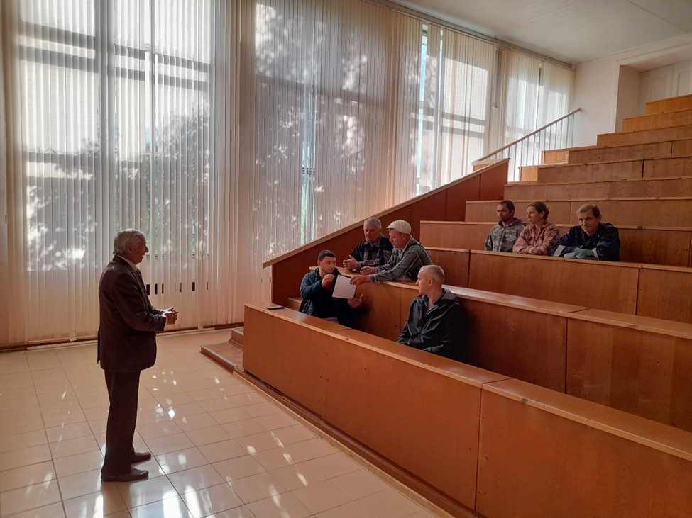
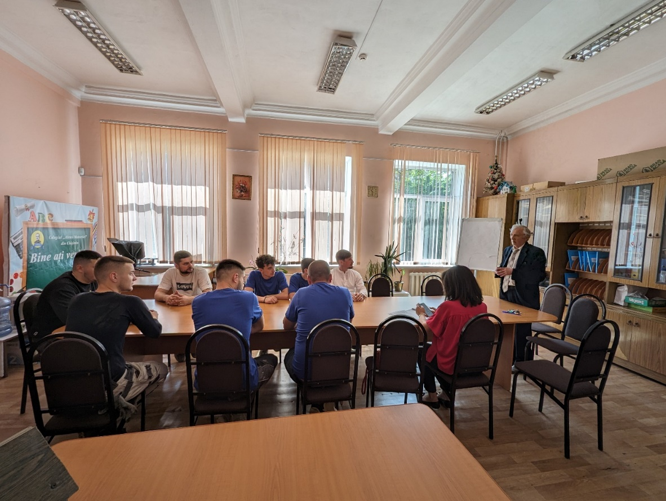
Figure 1: Information session of workers at Technical University of Moldova
A small number of contracted workers were involved in the planned works under the subprojects, considering that the small rehabilitation works were carried out and the duration of the works was from one month to three months.
Figure 2: Information session of workers at Pedagogical College "Alexei Mateevici"
In the table below are included the number of involved workers at every site.
Categories | Pedagogical College "Alexei Mateevici" in Chisinau | Pedagogical College "Mihail Chiachir" in Comrat | Pedagogical College "Vasile Lupu" in Orhei | Pedagogical College "Mihai Eminescu" in Soroca | Pedagogical College "Ion Creangă" in Balti |  | Pedagogical College "Ion Creangă" in Cahul
Male workers | 8 | 4 | 5 | 10 | 7 |  | 20
Women Workers | 0 | 0 | 2 | 2 | 0 |  | 8
Total number of workers involved in the rehabilitation works | 8 | 4 | 7 | 12 | 7 |  | 28
No. of trained workers on ESHS | 8 | 4 | 7 | 12 | 7 |  | 28
Total contracted workers, including women |  |  |  | 66 |  | 12

No safety related incident / accident has been observed during the carried-out rehabilitation works.
No grievances received from contracted workers during the rehabilitation works carried out during the year 2024.
Community Health and Safety
Access to the site
The workers used another access way /entrance inside the building than the one used by students, staff and visitors. This entrance was used also for the equipment and materials delivery and taking out the waste. Minimum interaction between workers and students was ensured. The work areas were marked and the necessary signals (no access, construction zone) were installed accordingly.
Waste management
The investments and works carried out within the Project did not generate asbestos-containing waste.
Cases of non-compliant waste management were not observed during the on-site visits, nor were they reported by subprojects management teams or community.
Noise and dust
The works that generated more dust and noise were carried out on weekends or in the evening hours when there are no or very few students and staff near the work area.
No grievances received from community member, including students, parents and staff of pedagogical colleges, related to the rehabilitation works carried out during the subprojects implementation.
Citizen and Stakeholder Engagement
During the year 2024 the Project’s and subprojects’ activities have mostly been completed and the stakeholders engagement activities were related to the achieved results and to improve the Project’s objectives using some engagement activities at Project and subprojects levels. MoER and universities engage the Project’s and subprojects’ beneficiaries in order to collect the feedback related to obtained results or to collect the suggestions on improvement of some results and achievement of the Project’s objectives, such us the online platform e-admission, National register of Qualification, improvement of the study programmes/curricula, fields of study etc.
The details on carried out engagement activities during the year 2024 are included in the Report on stakeholders engagement activities attached to this Report.
Operation of Grievance Redress Mechanism (GRM) within MHEP
The data and information on grievances resolution status during the Project implementation are included in the table below.
Complainant data | Submission level | Submission Date | Subject | Resolution status
FORS-COMPUTER SRL | Project level | May 06, 2022 | Technical specifications for procurement of equipment for the PMT. | The response no 01-02/22 dated May 12, 2022, was submitted to the complainant.  No further requests or actions from complainant side.
Head of the Rescue Committee of the Tiraspol State University | Project level | July 06, 2022 | The request of information on MHEP activity. | The response no. 02-02/22 dated July 8, 2022, was submitted to the applicant.  No other request or actions from applicant side.
NAQAER | Project level | March 02, 2021 | The activities of individual consultant to be hired under MHEP in the field of quality assurance in higher education. | By letter no. 04 / 1-09 /1792 dated April 16, 2021, the MoER submitted a response to NAQAER’s comments and provided detailed explanation of the issues raised in the letter and informed the complainant that would take into account the requests of the NAQAER.  No further requests or actions from complainant side.
FORS-COMPUTER SRL | Subproject (State Pedagogical University ION CREANGĂ) and Project level. | September 14, 2023 | The complainant requested the involvement of Project management in verification of the technical specifications and to expedite the provision of answers by subproject team. | The response was submitted via email on September 19, 2023. The Technical Specifications were revised and submitted to Governmental Electronical Agency (GEA) for coordination.  Another request submitted on October 05, 2023.
FORS-COMPUTER SRL | Project level | October 05, 2023 | The lack of response at the subproject level to the requests addressed in September 2023. | The answer was provided on October 06, 2023. The complainant was informed that the technical specifications was modified and repeatedly were sent to GEA (according to the procedures) for coordination.  No further requests or actions from complainant side.
FORS-COMPUTER SRL | Project level | October 06, 2023 | Request for clarification on technical specifications for equipment procurement at subproject level. | The answer was provided on October 09, 2023.  No further requests or actions from complainant side.
Total number of grievances received during the reporting period |  |  |  |  | 0
Total number of grievances received during the Project implementation |  |  |  |  | 6
Grievances resolved |  |  |  |  | 6
Grievances in the process of resolution |  |  |  |  | 0
Unresolved grievances |  |  |  |  | 0

The information on GRM operation under MHEP is placed on MoER’s and beneficiary institutions websites, including the option to submit verbally or anonymously the grievances, questions, suggestions, requests and other type of feedback related to Project and financed subprojects. The links with information on GRM operation and contact data of every beneficiary institutions are included below:

https://usmf.md/ro/relatii-externe/proiecte/fortificarea-educatiei-prin-cercetare-medicina-cadrul-usmf-nicolae
https://utm.md/subproiecte-banca-mondiala/
https://usm.md/?page_id=26463
https://upsc.md/proiect-invatamantul-superior-din-moldova/
https://usarb.md/petitii/; https://usarb.md/petitii-crema-it/;https://usarb.md/petitii-conproprecerc/
https://ase.md/subproiectul-ticpia/
https://proiecte.usch.md/proiectul-invatamantul-superior-din-moldova/.
https://cpam.md/?page_id=5463
https://cihcahul.md/implicari-proiecte/invatamantul-superior-din-moldova-7
https://colegiulmeminescusoroca.educ.md/2024/02/01/aviz-mecanismul-de-solutionare-a-reclamatiilor/
http://colegiu.md/achizitii-publice.html
https://cpcomrat.educ.md/%D0%BE%D0%B1%D1%8A%D1%8F%D0%B2%D0%BB%D0%B5%D0%BD%D0%B8%D1%8F/
https://cpic.usarb.md/eduspace
Project Restructuring and Additional Financing
In the context of the Project restructuring, including the renovation of 2 dormitories, the ESCP and SEP were updated, disseminated and consulted with the Project’s stakeholders. The final versions of the updated ESCP can be found on the MoER’s website https://mec.gov.md/sites/default/files/mhep_escp_revised_june_2024.pdf. According to the updated ESCP, the draft site-specific Environmental and Social Management Plans for two dormitories were prepared, which will be consulted and completed until the start of renovation works.
Also, the SEP was revised and updated considering the new activities to be included in the Project following additional financing approval. As well as the ESCP for the additional financing was developed and consulted. The final consulted versions of the updated SEP and ESCP for additional financing can be found on the following link https://mec.gov.md/ro/content/despre-proiect-0.

Financial management and disbursements within Moldova Higher Education Project
The overall Financial Management functions under the Project, including budgeting and planning, accounting, reporting, internal control procedures, flow of funds and external audit are handled by the Project Management Team working with the MoER and the Ministry of Finance.
The Project Financial Management (FM) Specialist hired under MHEP is responsible for the preparation of the annual project budget based on the Project Implementation Plan and Project Procurement Plan, and submit it to the Financial and Administrative Department of the MoER. The MoER includes it on the budget framework of the Ministry of Finance. The project budget is formed in according with the plan for allocating funds to project activities. The budget is prepared in enough detail, by activities and account codes.
As of December 31, 2024, the amount of EUR 20.01 million or 56.4% was disbursed out of the credit of EUR 35.7 million to support the Project implementation.

During the reporting period, all Interim Financial Reports of the Project were prepared in the established terms, according to the World Bank rules, as well as they were uploaded in the Client Connection system and were acceptable by the World Bank.
The ToRs for auditing the project for the year 2024 was submitted to the Bank and was approved on December 20, 2024. The procurement procedure is to be launched to contract the audit firm for project auditing.
Each HEIP beneficiary keeps detailed the project related records in an adequate accounting software according to the World Bank rules, and integrates with their basic accounting system.
According to HEIPOM, the HEIP beneficiaries under Component 2 submitted to the PMT the Interim Financial Reports for the sub-projects for the 3 quarters of 2024.
Procurements carried out under MHEP
Procurement under MHEP is caring out in accordance with the World Bank Procurement Regulations for Investment Project Financing Borrowers – Procurement in Investment Project Financing of Goods, Works, Non-Consulting and Consulting Services, issued on July 1, 2016, revised on November 1, 2016 and August 1, 2018 (hereinafter referred to as “Procurement Regulations”), as well as with the latest Guidelines on Preventing and Combating Fraud and Corruption in Projects Financed by IBRD Loans and IDA Credits.

The MoER developed a Procurement Plan (PP) for the entire scope of the proposed Project. The procurement plan is updated on regular basis arising from the needs of the Project. The Project uses the Systematic Tracking of Exchanges in Procurement (STEP) platforms. The Project's procurement plan is available in the World Bank's STEP.

Project Monitoring and Evaluation
The PDO-level and intermediate results indicators are monitored using the following sources and methodologies: (i) regular administrative data collection processes; (ii) National Bureau of Statistics data; (iii) surveys with beneficiaries; (iv) documents prepared by the MoER’s Departments involved in Project implementation; (v) results from the system – wide graduate tracer study funded by the Project; (v) data submitted by HEIP beneficiaries; and (vi) progress reports prepared by the PMT.
The Monitoring and Evaluation consultant hired under MHEP is responsible for gathering the relevant reports and information from MoER’s representatives, HEIP beneficiaries, NAQAER representatives, and other relevant parties involved in the project implementation to monitor the PDO and results, and for communicating with the World Bank.
The Project indicators are monitored according to the Monitoring and Evaluation Plan and Project Results Framework, which has been regularly updated and submitted to the Bank each semester. Annex 1 to this Report presents the updated MHEP Results Framework and monitoring indicators as of December 31, 2024.
At the same time, to monitor the activities carried out by HEIP beneficiaries and indicators to be achieved by them, a Monitoring & Evaluation Database was created under Component 2 of the Project. The information on the status of activities and procurements for each sub-project is updated monthly by the PMT and is shared with the leadership of the MoER for review and information.
During 2024, the PMT conducted visits to the institutions for field monitoring and provided support in implementation of subprojects under Component 2.
Surveys conducted under MHEP

1. Baseline survey on the perception of employers about the labor market orientation of selected higher education institutions’ programs in the Government's priority fields (engineering, information technologies, medicine, and pedagogy).
Contract signing: March 28, 2022
Consultant: Centre of Sociological, Politological and Psychological Analysis and Investigations (CIVIS)
Implementation period | Implementation progress
March 2022 – March 2023 | Following the procurement procedure conducted under MHEP, the Centre of Sociological, Politological and Psychological Analysis and Investigations CIVIS was hired under MHEP to conduct a nationwide survey with employers regarding their perception about the labor market orientation of selected higher education institutions’ programs in the last 3 years. The main aim of the study was to collect quantitative and representative data on the perceptions, attitudes, and behaviors of employers in four priority fields of study: pedagogy, health, engineering, and information technologies.  Findings of the baseline survey:  On average for the 4 priority fields of study, 44% of employers positively assess (to a large or very large extent) the compliance of the education system with the requirements of the labor market in relation to the studied professions:  ✓ pedagogy – 40%  ✓ medicine – 70%  ✓ engineering – 34%  ✓ information technologies – 33%  The progress survey on the perception of employers about the labor market orientation of selected higher education institutions’ programs in the Government's priority fields (engineering, information technologies, medicine, and pedagogy) will be conducted in 2025.
2. Baseline survey on the perception of employers about labor market orientation of selected higher education institutions’ programs of 7 additional areas of studies (agricultural science, veterinary science, mathematics and statistics, physical science, environmental science, biological science, and chemical science) in the last 3 years.
Implementation period | Implementation progress
November 2023- November 2024 | On November 28, 2023, an Amendment was signed with Centre CIVIS to conduct 2 surveys at the national level (baseline and progress) to measure the perception of employers about the labor market orientation of selected higher education institutions’ programs of 7 additional areas of studies (agricultural science, veterinary science, mathematics and statistics, physical science, environmental science, biological science, and chemical science) in the last 3 years due to implementation of the activities under MHEP.  Findings of the baseline survey:  On average for the 7 priority fields of study, 35% of employers positively assess (to a large or very large extent) the compliance of the educational system with the requirements of the labor market in relation to the studied professions:  ✓ Chemical sciences – 48%  ✓ Biological sciences – 47%  ✓ Environmental sciences – 30%  ✓ Physical sciences – 30%  ✓ Mathematics and statistics – 31%  ✓ Agricultural sciences – 31%  ✓ Veterinary medicine – 33%.  The progress survey will be conducted in 2025.
3. Survey (Baseline and Progress) with project beneficiaries to determine if effective engagement processes have been established through the Project.
Contract signing: September 28, 2022
Consultant: Axa Management Consulting LTD

Implementation period:  September 2022 – December 2024 | Implementation progress:  Contract completed  The objective of the study was to carry out two evaluations (baseline and progress) in order to determine if effective engagement processes have been established through the Project.  The samples for the Study were selected from the following target groups:  - Representatives of the Project implementation team;  - University students/pedagogical college students;  - Academic staff from institutions involved in the Project;  - Sub-project coordinators from educational institutions;  - Managers of educational institutions participating in the Project;  - Heads of quality assurance committees in educational institutions;  - Representatives of employers.  The baseline study was carried out from November 2022 to February 2023, and it established the baseline characteristics, identifying beneficiaries' needs and aspirations for engagement, thus providing a solid database for developing and implementing effective beneficiary engagement strategies throughout the Project's duration.  Findings of the baseline survey for the baseline of the Project indicator:  On average 56.54% of Project beneficiaries report effective engagement in the Project implementation activities.  In June 2024, Axa Management Consulting Company submitted the revised Methodology and questionnaire to the MoER for review and approval in order to conduct progress evaluation by the end of 2024 to determine to what extent the effective engagement of educational actors and partners in the processes of improving the labor market orientation of higher education institutions and quality assurance mechanisms has been increased. The progress survey has been conducted between August and December 2024.  In December 2024, the firm submitted the final report on the results of the progress survey, progress and comparisons with baseline results, conclusions, and recommendations.  Findings of the progress survey:  Data shows significant and increasing engagement of beneficiaries in the Project's activities, supporting the relevance and success of implemented mobilization strategies. With a 43.5% rise in participation between the 2023 baseline study and the 2024 progress study, the Project successfully fostered a robust collaborative platform, especially through infrastructure modernization and partnership strengthening activities.  High involvement from managers, sub-project coordinators, and teaching staff underscores consistent institutional and personal commitment. The general average of the effective engagement of the responding beneficiaries in the activities of the Project is 85.90%, increasing by 29.3% comparing with baseline results.  However, reduced participation in research and consultation activities, particularly among students and employers, suggests opportunities for optimization through targeted engagement strategies.

Annex 1. Moldova Higher Education Project Results Framework and Monitoring Indicators as of December 31, 2024
Project Development Objective(s)
The Project Development Objective is to improve the labor market orientation of selected higher education institutions and the quality assurance mechanisms
Project Development Objective Indicators
Indicator name | DLI | Baseline | Intermediate Targets |  |  |  |  | End target
Indicator name | DLI | Baseline | 1 | 2 | 3 | 4 | 5
To improve the labor market orientation of selected higher education institutions
Share of students of selected higher education institutions enrolled in Bachelor and Master's programs of government's priority areas (Percentage) |  | 0.00 | 0.00 | 0.00 | 5.00 | 10.00 | 15.00 | 15.00
 |  |  |  |  |  | Actual
 |  | 43.26% | 43.26% | 43.90% | 44.15% | 44.80%
 | Comments: The data include the number of students enrolled on budget and on contract in Bachelor and Master's programs of government's priority areas.
Perception of employers about the labor market orientation of selected higher education institutions' programs (Percentage) |  | 0.00 | 0.00 | 0.00 | 0.00 | 0.00 | 25.00 | 25.00
 |  |  |  |  | Actual
 |  | 44% |  |  | 44%
Comments: On March 28, 2022, the contract was signed with CIVIS sociological firm to conduct a survey to calculate the baseline for this indicator. Findings of the survey: on average for the 4 priority fields of study, 44% of employers positively assess (to a large or very large extent) the compliance of the education system with the requirements of the labor market in relation to the studied professions: pedagogy – 40%, medicine – 70%, engineering – 34%, information technologies – 33%.
On November 28, 2023, an Amendment was signed with Centre CIVIS to conduct 2 surveys at the national level (baseline and progress) to measure the perception of employers about the labor market orientation of selected higher education institutions’ programs of 7 additional areas of studies (agricultural science, veterinary science, mathematics and statistics, physical science, environmental science, biological science, and chemical science) in the last 3 years due to implementation of the activities under MHEP.
Findings of the baseline survey for the 7 additional areas of studies: on average for the 7 additional fields of study, 35% of employers positively assess (to a large or very large extent) the compliance of the educational system with the requirements of the labor market in relation to the studied professions: Chemical sciences – 48%, Biological sciences – 47%, Environmental sciences – 30%, Physical sciences – 30%, Mathematics and statistics – 31%, Agricultural sciences – 31%, Veterinary medicine – 33%.
 |  | To improve the quality assurance mechanisms
New Master's programs accredited based on the revised curriculum (Percentage) |  | 0.00 | 0.00 | 0.00 | 0.00 | 5.00 | 10.00 | 10.00
 |  | 0.00 | 0.00 | 0.00 | 0.00 | 18.8
 | Comments: The implementation of this activity started under MHEP with the development of the qualification standards, which are followed by the revision of the curriculum and then the accreditation of programs. As of December 31, 2024, a total of 308 qualification standards have been developed under MHEP. Based on the standards developed, 112 Bachelor and 143 Master programs have been updated. As of December 31, 2024, 27 new Master programs (18.8%) out of 143 updated Master programs have been accredited based on the revised curriculum.
Registration of NAQAER in EQAR (Text) |  | NAQAER is not registered in EQAR | NAQAER is not registered in EQAR | NAQAER is not registered in EQAR | NAQAER is registered in EQAR | NAQAER is registered in EQAR | NAQAER is registered in EQAR | NAQAER is registered in EQAR
 |  |  |  |  |  | Actual
 |  | NAQAER is not registered in EQAR | NAQAER is not registered in EQAR | NAQAER is not registered in EQAR | NAQAER is not registered in EQAR | NAQAER is not registered in EQAR
 | Comments: An international consultant was hired under MHEP who provided support to NAQAER (ANACEC Romanian abbreviation) in development of self-evaluation report and preparation of beneficiaries for interviews with EQAR. On May 23, 2022, NAQAER submitted a request to the ENQA Secretariat for an external evaluation to obtain membership status of the ENQA, with the registration of NAQAER in the EQAR. In January 2023, a contract was signed between NAQAER and ENQA for the provision of services for evaluation of NAQAER. During June 19-21, 2023, the documentation visit of the ENQA Review Panel was carried out at NAQAER for institutional evaluation of the Agency. The NAQAER evaluation report was validated during the ENQA Agency Review Committee meeting (06.11.2023). On November 8, 2023, NAQAER applied for registration in the EQAR Register. The external evaluation report and several other documents developed by NAQAER and ENQA were examined at the EQAR board meeting in December 2023. On January 15, 2024, ANACEC received a letter from the EQAR board informing that in accordance with EQAR’s Procedures for Applications, the Register Committee deferred the ANACEC’s application and asked to make additional representation on the recommendation provided. Currently, the MoER is implementing the recommendations of ENQA Committee and will resubmit the application in 2025.
Project Development Objective(s)
The Project Development Objective is to improve the labor market orientation of selected higher education institutions and the quality assurance mechanisms
Intermediate Results Indicators by Components
Indicator name | DLI | Baseline | Intermediate Targets |  |  |  |  | End target
Indicator name | DLI | Baseline | 1 | 2 | 3 | 4 | 5
 |  | 1 - Improving the Quality Assurance Mechanisms
Higher education Qualification standards developed and revised (Number) |  | 0.00 | 75.00 | 175.00 | 280.00 | 300.00 | 300.00 | 300.00
 |  |  |  |  |  | Actual
 |  | 0 | 29 | 84 | 305 | 308
 | Comments: As at December 31, 2024, a total 308 qualification standards have been developed as follows: In 2022, 55 qualification standards were developed under MHEP for 4 specific fields: Administrative Sciences, Economic Sciences, Manufacturing and Processing Technologies and Law; In 2023, 221 qualification standards have been developed under MHEP for 14 fields of study (arts, humanities, languages, social sciences, journalism, chemical sciences, environmental sciences, biological sciences, physical sciences, mathematics and statistics, engineering, architecture and construction, security services and transport services). In 2024, 32 qualification standards have been developed for 5 fields of study: public services, science of sports, veterinary, forestry and agriculture.
Bachelor's and Master's programs updated in accordance with the qualification standards developed and revised under the Project (Percentage) |  | 0.00 | 0.00 | 0.00 | 10.00 | 20.00 | 30.00 | 30.00
 |  |  |  |  |  | Actual
 |  | 0.00 | 0.00 | 0.00 | 16.6% | 33.1%
 | Comments: Currently, there are 370 Bachelor's programs and 400 Master's programs. As at December 31, 2024, a total of 255 Bachelor and Master programs (33.1%) have been updated based on the standards developed.
Students in higher education institutions benefiting from systemic interventions in quality, information systems and funding (number) |  | 0.00 | 44,000 | 56,000 | 69,000 | 80,000 | 91,000 | 91,000
 |  |  |  |  |  | Actual
 |  | 0.00 | 48,319 | 63,631 | 79,905 | 101,910
 | Comments: Data was collected from documents submitted by the Higher Education Department of the MoER. The Government Decision no 700 on amending the Government Decision no 343/2020 on approval of the Methodology for budgetary financing of public higher education institutions was approved on September 20, 2023. The proposed changes are the result of piloting the Methodology of budgetary financing of public higher education institutions, conducted under MHEP, and extensively discussed with the academic environment. The adjusted financing formula is being implemented in 11 higher education institutions started with the beginning of 2024. At the same time, all higher education institutions benefitted in 2024 from e-admission system developed under MHEP.
of which are female students (Number) |  | 0.00 | 25,000 | 33,000 | 40,000 | 47,000 | 53,000 | 53,000
 |  |  |  |  | Actual
 |  | 0.00 | 28,610 | 37,567 | 44,211 | 53,096
 | Comments: Data was collected from documents submitted by the Higher Education Department of the MoER.
The staff of MoER, NAQAER and higher education institutions trained in quality assurance in higher education through the Project (number) |  | 0.00 | 0.00 | 100.00 | 230.00 | 230.00 | 230.00 | 230.00
 |  |  |  |  |  | Actual
 |  | 0.00 | 0.00 | 200.00 | 350.00 | 350.00
 | Comments: an international consultant has been hired under MHEP who provided training to 200 specialists of higher education institutions in quality assurance from June 21 to June 25, 2022. During December 11-12, 2023, training has been delivered to 30 representatives of ANACEC and the MoER in quality assurance. During February 15-28, 2024, the online trainings have been delivered to 120 representatives of higher education institutions in quality assurance.
The new financial model (Text) |  | New financial model has been developed, but has not been piloted yet | New financial model is piloted in higher education institutions with financial autonomy | New financial model is piloted in higher education institutions with financial autonomy | New financial model is implemented system-wide | New financial model is implemented system-wide | New financial model is implemented system-wide | New financial model is implemented system-wide
The new financial model (Text) |  |  |  |  |  | Actual
The new financial model (Text) |  | New financial model has been developed, but has not been piloted yet | New financial model is piloted in higher education institutions with financial autonomy | New financial model is piloted in higher education institutions with financial autonomy | New financial model is implemented system-wide | New financial model is implemented system-wide
The new financial model (Text) | Comments: The developed financing formula is implemented in 11 higher education institutions. The Government Decision no 700 on amending the Government Decision no 343/2020 on approval of the Methodology for budgetary financing of public higher education institutions was approved on September 20, 2023. The proposed changes are the result of piloting the Methodology of budgetary financing of public higher education institutions, conducted under MHEP, and extensively discussed with the academic environment.
Higher Education Management Information System (HEMIS) (Text) |  | HEMIS does not exist | HEMIS does not exist | HEMIS does not exist | HEMIS is operational | HEMIS is operational and the data is used for planning or decision-making | HEMIS is operational and the data is used for planning or decision-making | HEMIS is operational and the data is used for planning or decision-making
 |  |  |  |  |  | Actual
 |  | HEMIS does not exist | HEMIS does not exist | HEMIS does not exist | HEMIS is under development | HEMIS is under development
 | Comments: The achievement of this indicator is in delay due to the fact that the Concept and ToR for development of HEMIS were revised following the discussions with main higher education institutions from Moldova. It was concluded that most universities have their own University management system, and the only issue is reporting to various institutions including the MoER. Therefore, the ToR was revised so that the HEMIS will be single window system for universities’ reporting and will allow integration with existing University Management Systems. The ToR was approved in August 2023. The procurement procedure has been conducted under MHEP to hire a firm to develop HEMIS. The contract was signed with the selected firm on March 7, 2024, and term of the contract is by December 31, 2025. Currently, the HEMIS is under development. It is expected that HEMIS will be operational in May 2025.
Unified electronic higher education admission system (e-Admission) (Text) |  | There is no unified electronic higher education admission information system | There is no unified electronic higher education admission information system | The e-admission system is being developed and tested | E-admission system is operational | E-admission system is operational | E-admission system is operational | E-admission system is operational
 |  |  |  |  |  | Actual
 |  | There is no unified electronic higher education admission information system | There is no unified electronic higher education admission information system | There is no unified electronic higher education admission information system | There is no unified electronic higher education admission information system | E-admission system is under development
 | Comments: The achievement of this indicator is in delay due to the fact that the concept and ToR on e-admission system have been changed. The revised e-admission concept has been publicly discussed with main universities from Moldova. In this context, the e-Admission centralized process was changed to semi-centralized process, which means that the e-Admission system will only ensure the submit applications, while the selection of candidates will be provided by each institution. The competition has been launched to select a firm to develop e-admission system, and the contract was signed with the selected firm on February 5, 2024. The e-admission system was developed and piloted in July 2024. During the piloting period, the system has served its purpose as being the unique access point to higher education, providing more than 16 thousand candidates with the opportunity to apply for higher education degree. Currently, the national e-admission system is in its redesign phase, piloting of the revised system is expected to start in March 2025, internally with higher education institutions, and in July 2025, externally with the national admission schedule.
Labor Market Information System (LMIS) (Text) |  | LMIS does not exist | LMIS does not exist | LMIS is being developed and tested | LMIS is operational and its data is used for planning and decision making | LMIS is operational and its data is used for planning and decision making | LMIS is operational and its data is used for planning and decision making | LMIS is operational and its data is used for planning and decision making
Labor Market Information System (LMIS) (Text) |  |  |  |  |  | Actual
Labor Market Information System (LMIS) (Text) |  | LMIS does not exist | LMIS does not exist | LMIS does not exist | LMIS does not exist | LMIS does not exist
Labor Market Information System (LMIS) (Text) | Comments: By letter no 08/2942 dated July 28, 2023, the Ministry of Labour and Social Protection requested the MoER to exclude the activities related to LMIS under MHEP. This indicator was cancelled.
 |  | 2 – Improving labor market orientation through targeted interventions
Laboratories of selected higher education institutions equipped (Number) |  | 0.00 | 0.00 | 0.00 | 3.00 | 6.00 | 9.00 | 9.00
 |  |  |  |  |  | Actual
 |  | 0.00 | 0.00 | 0.00 | 14.00 | 59.00
 | Comments: The sub-financing Agreements have been signed with the selected higher education institutions on October 24, 2022. As of December 31, 2024, a total of 59 laboratories have been equipped by higher education institutions:10 laboratories have been equipped by the State University of Medicine and Pharmacy, 10 laboratories have been equipped by the State University of Cahul, 15 laboratories by the State University of Moldova, 8 laboratories by the Balti Pedagogical University Alecu Russo, 13 laboratories by the Technical University of Moldova, and 3 laboratories by the Academy of Economic Studies of Moldova.
Higher Education Improvement Programs (HEIP) approved in accordance with the criteria established in the Project Operational Manual (Percentage) |  | 0.00 | 0.00 | 20.00 | 50.00 | 80.00 | 90.00 | 90.00
 |  |  |  | First call | Second call
 |  | 0.00 | 0.00 | 90.9% | 46.4%
 | Comments: The indicator was calculated based on the HEIP implementation documents mainly reports on the evaluation of proposals prepared by eligible applicants. In 2022, a total of 20 sub-project proposals (90.9%) out of 22 submitted have been approved for financing under the first call of subproject proposals - – 6 subprojects from 6 pedagogical colleges and 14 subprojects from 7 higher education institutions. In 2023, thirteen sub-project proposals (46.4%) from 5 higher education institutions have been approved out of 28 sub-project proposals submitted under the second call.
Students benefiting from direct interventions to improve learning (CRI, Number) |  | 0.00 | 0.00 | 28,000 | 35,000 | 42,000 | 49,000 | 49,000
 |  |  |  |  |  | Actual
 |  | 0.00 | 0.00 | 0.00 | 21,532 | 47,868
 | Comments: The data include the number of students of selected higher education institutions and pedagogical colleges benefitting from direct interventions under Component 2 to improve learning.
Female students benefiting from direct interventions to improve learning (CRI, Number) |  | 0.00 | 0.00 | 16,000 | 20,000 | 24,000 | 29,000 | 29,000
 |  |  |  |  |  | Actual
 |  | 0.00 | 0.00 | 0.00 | 11,261 | 29,029
 | Comments: The data include the number of female students of selected higher education institutions and pedagogical colleges benefitting from direct interventions under Component 2 to improve learning.
Partnerships between universities, pedagogical colleges and employers established through HEIP (Number) |  | 0.00 | 0.00 | 0.00 | 5.00 | 9.00 | 15.00 | 15.00
 |  |  |  |  |  | Actual
 |  | 0.00 | 0.00 | 0.00 | 26.00 | 74.00
Share of women enrolled in STEM programs developed or improved through HEIP (Percentage) |  | 0.00 | 0.00 | 0.00 | 0.00 | 10.00 | 20.00 | 20.00
 |  |  |  |  |  | Actual
 |  | 0.00 | 0.00 | 0.00 | 24.3% | 22.9%
 | Comments: In 2023, total number of students enrolled in Science (Chemistry, biology, physics), Technology, Engineering and Mathematics programs in the selected higher education institutions was 7759, of which the number of women enrolled in the mentioned programs is 1889, which constitutes 24.3% (baseline). In 2024, total number of students enrolled in Science (Chemistry, biology, physics), Technology, Engineering and Mathematics programs in the selected higher education institutions was 7903, of which the number of women enrolled in the mentioned programs is 1817, which constitutes 22.9%.
Research or academic programs contributing to adaptation or mitigation of climate change developed or improved through HEIP (number) |  | 0.00 | 0.00 | 0.00 | 1.00 | 3.00 | 4.00 | 4.00
 |  |  |  |  |  | Actual
 |  | 0.00 | 0.00 | 0.00 | 1.00 | 10.00
Comments: The State University of Medicine and Pharmacy developed through HEIP the Curriculum based on research at the discipline "Adaptation to climate change". The updated Curriculum was approved by the Commission for Quality Assurance and Curriculum Evaluation, Minutes no 1 dated August 28, 2023 and by the Council of the Faculty of Medicine, Minutes no 2 dated October 16, 2023.
The Technical University of Moldova developed through HEIP 9 programmes of which 2 new and 7 revised (8 Bachelor’s and 1 Master’s) contributing to adaptation or mitigation of climate change.
3 – Project management
Project beneficiaries reporting that effective engagement processes have been established (percentage) |  | 0.00 | 0.00 | 0.00 | 0.00 | 0.00 | 30.00 | 30.00
 |  |  |  |  | Baseline
 |  | 56.54% |  |  | 56.54% | 85.90%
Comments: On September 28, 2022 a contract was signed with the firm Axa Management Consulting to conduct a survey with project beneficiaries to determine if effective engagement processes have been established. On March 4, 2023, the firm submitted to the MoER for review and approval the final report on the survey conducted. Findings of the survey for the baseline of the Project indicator “Project beneficiaries reporting that effective engagement processes have been established”: on average 56.54% of Project beneficiaries report effective involvement in the Project implementation activities.
In June 2024, Axa Management Consulting Company submitted the revised Methodology and questionnaire to the MoER for review and approval in order to conduct progress evaluation by the end of 2024 to determine to what extent the effective engagement of educational actors and partners in the processes of improving the labor market orientation of higher education institutions and quality assurance mechanisms has been increased. The progress survey has been conducted between August and December 2024.
In December 2024, the firm submitted the final report on the results of the progress survey, progress and comparisons with baseline results, conclusions, and recommendations.
Findings of the progress survey:
Data shows significant and increasing engagement of beneficiaries in the Project's activities, supporting the relevance and success of implemented mobilization strategies. With a 43.5% rise in participation between the 2023 baseline study and the 2024 progress study, the Project successfully fostered a robust collaborative platform, especially through infrastructure modernization and partnership strengthening activities.
High involvement from managers, sub-project coordinators, and teaching staff underscores consistent institutional and personal commitment. The general average of the effective engagement of the responding beneficiaries in the activities of the Project is 85.90%, increasing by 29.3% comparing with baseline results.
However, reduced participation in research and consultation activities, particularly among students and employers, suggests opportunities for optimization through targeted engagement strategies.

4. Internationalization of higher education with enhanced students’ living condition
Number of teaching and non-teaching staff trained in English and other foreign languages (Number)
   |  | 0.00 | 0.00 | 0.00 | 0.00 | 150.00 | 150.00 | 30.00 | 30.00
   |  |  |  |  | 0.00
Number of foreign students enrolled (number
   |  | 0.00 | 0.00 | 0.00 | 0.00 | 300.00 | 300.00 | 150.00
   |  |  |  |  | 0.00
Number of students dormitories renovated (number)
   |  | 0.00 | 0.00 | 0.00 | 0.00 | 2.00 | 2.00 | 300.00
   |  |  |  |  | 0.00

Annex 2. Progress report on implementation of 20 sub-projects by HEIP beneficiaries under the first call within Component 2 of the Project as of December 31, 2024.

- Higher Education Institution: Technical University of Moldova
Sub-project name: Curricula upgrading for building professional skills in Information Security, Information Management, Data Science, for the purpose of increasing the competitiveness and data security of SMEs / (DATASEA - Abbreviation name)
Priority field: Information and Communication Technologies (061)
Sub-project duration: October 24, 2022 – October 23, 2024
Sub-project total budget: 298,200.00 EUR.
Sub-project completed
As of December 31, 2024, the amount disbursed to the subproject is EUR 268,380 (90%), and the amount pre-financed by the institution is 29,820 (10%), according to the point 107 of the HEIPOM (The Beneficiary shall pre-finance the 10 % balance of the total sub-project budget or will have to bear the costs for the advance which will be retained from the preceding request for payment, if that would be the case), and the amount spent is EUR 298,200.00 (100%).
Subproject development objective is to improve the quality of study programs in the field of Information and communication technologies by modifying and updating study programs in accordance with the development trends of the field and bringing the educational offer of the Technical University of Moldova closer to the requirements of the labor market, integrating the scientific results obtained within the Technical University of Moldova in order to implement a quality education based on research, as well as the application of green economy principles in the field of ICT (Green IT).
Specific objectives of the subproject: (i) updated curriculum for the training field of Information and communication technologies in two directions with a high degree of dynamism and innovation: data science and information security; (ii) strengthening the research capacity of the Technical University of Moldova in the areas of data analysis and information security by equipping the scientific laboratories with the necessary equipment and implementing the results obtained in the educational sector.

Sub-project implementation progress
According to the approved Procurement Plan, 13 procurement activities have been carried out, of which 2 for goods and 11 for consulting services. Following the procurement process, a total of 14 contracts have been signed and completed (5 for goods and 9 contracts for consulting services).
Achievement of indicators by sub-project
Indicators | Final target | Indicators achieved by December 31, 2024
Teaching and research laboratories (Data Analysis, Computer Networks, Information Security, Virtual Reality- 2 labs) equipped with modern equipment | 5 laboratories | 5 laboratories (Data Analysis, Computer Networks, Information Security, Virtual Reality- 2 labs) equipped
Physics laboratory for the development of fundamental skills of future ICT specialists equipped | 1 | 1 physics laboratory equipped
New programs developed, adjusted to labor market requirements, and authorized for provisional operation | 2 programs | 2 programs developed  (1 program for the first cycle of the Bachelor's degree in Information Security and 1 program for the second cycle of the Master's degree in Data Science)
Research or academic programs contributing to adaptation to climate change and mitigating its effects developed and improved by MHEP | 9 programs of which 2 new and 7 revised (8 Bachelor’s and 1 Master’s). | 9 programs of which 2 new programs (1 Bachelor's program for professional training, Bachelor program in Information Security and 1 Master's program and modular curriculum for professional training, Master's program in Data Science) and 7 revised.  7 Revised programs: Bachelor programs: 1) Data Science; 2) Computers and networks; 3) Applied informatics; 4) Information Management; 5) Information Technology;  Master programs: 1) Information Security; 2) Computers and information networks.
Updated Curriculum for Bachelor's Degree Programs in Information and Communication Technologies for Data Analysis. | 1 | Curriculum updated for Bachelor's Degree Programs in Information and Communication Technologies for Data Analysis
Developed modular curriculum and didactic support for professional training, Master's level in Data Science | 1 | Modular curriculum developed  and didactic support for professional training, Master's level in Data Science
Establishing new sustainable partnerships between Technical University of Moldova and ICT companies in the areas of data science and information security in compliance with Green IT principles. | 5 | 5 Partnership Agreements established
Training of didactic, scientific-didactic and auxiliary-didactic staff: i) in the use of the equipment for the laboratories in the study and research activity; ii) for the development of the GREEN IT concept, with the theme: "Improving ICT education in terms of minimizing the negative impact of IT operations on the environment through the design, manufacture, operation and decommissioning of computing technology and computer-related products in - an ecological way; iii) for the development of new study programs in the field of information and communication technologies. | 5 trainings | 3 trainings conducted (a total of 64 people trained):  a) for the development of the GREEN IT concept, with the theme: "Improving ICT education in terms of minimizing the negative impact of IT operations on the environment through the design, manufacture, operation and decommissioning of computing technology and computer-related products in - an ecological way; - the training was carried out and 19 people trained during 5 days of a total of 20 hours.  b) for the development of new study programs in the field of information and communication technologies – the training has been conducted and 46 people trained.  c) training for the use of the equipment in the Virtual Reality Laboratory.
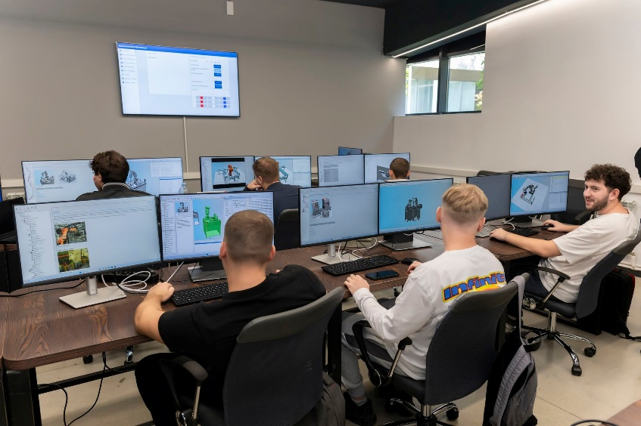
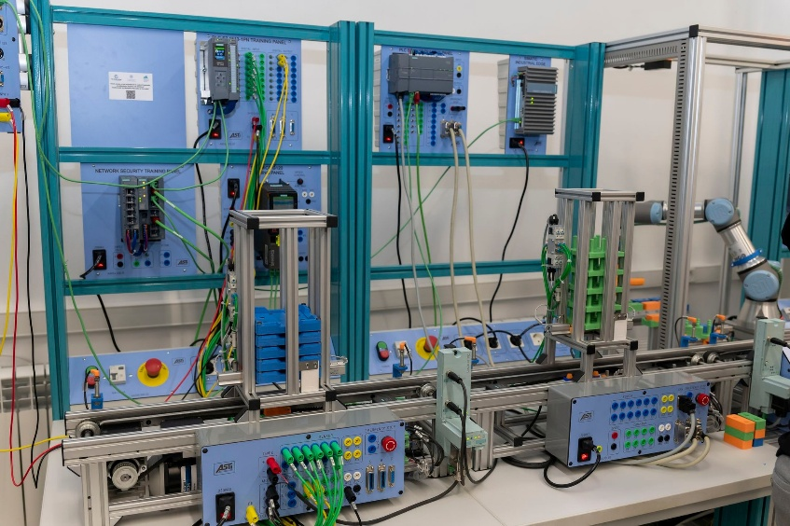
Figure 1: Equipped laboratories at the Technical University of Moldova

2. Higher Education Institution: Technical University of Moldova
Sub-project name: Curricula upgrading for building professional skills in Engineering, Electronics, Automation and Robotics, in response to the requirements of Industry 4.0/ (GEAR 4.0.- Abbreviation name)
Priority field: Engineering and engineering trades (071)
Sub-project duration: October 24, 2022 – October 23, 2024
Sub-project total budget: 1,849,550.00 EUR.
The Amendment to the Sub-Financing Agreement was signed and the implementation period has been extended by September 30, 2025.
As of December 31, 2024, the amount of EUR 1,136,936.52 was disbursed to the subproject. The real expenditures were EUR 1,202,154.82 (65%) out of the sub-project total budget. The difference of EUR 65,218.30 constitutes prefinancing resources of the institution.
Sub-project development objective is to increase the quality of the study programs in the General Field of Engineering and engineering activities by reducing the gap between the educational offer provided by the Technical University of Moldova and the demands of the labor market, dictated by the digitization of engineering activities and environmental challenges.
Specific objectives of the sub-project: i) redesign/revision of the Curriculum for the general field of study Engineering and engineering activities in line with the requirements of Industry 4.0; and ii) consolidation of teaching/training and research-development capacities of the Technical University of Moldova by equipping scientific, didactic, and technological transfer laboratories/centres with modern manufacturing equipment and automation of production processes.

Sub-project implementation progress

According to the approved Procurement Plan, 29 procurement activities have been carried out, of which 6 for goods and 23 for consulting services. 3 procurement activities are in progress, for which contracts have not yet been signed (2 for goods and 1 for consulting services). Following the procurement process, a total of 30 contracts have been signed (8 for goods and 22 contracts for consulting services).

Achievement of indicators by the sub-project
Indicators | Final target | Indicators achieved by December 31, 2024
Research and teaching laboratories within the Industry Innovative Cluster 4.0 equipped | 5 laboratories | 4 research and teaching laboratories within the Industry Innovative Cluster 4.0 equipped  The equipment for Advanced Manufacturing Technologies on CNC Machines (TAF-CNC) laboratory will be delivered in July 2025.
Chemistry laboratories equipped | 3 laboratories | 3 Chemistry laboratories equipped
Digitization of the classroom | 1 classroom | 1 Classroom digitized
Improving orientation towards the labor market through specific interventions. It will be measured with the tool that was developed within the study. | Increase by 25% | The tool was developed within the study and on July 1 started the piloting of the tool.
Development of Study programmes | 3 programs (Bachelor, Master, and continuous education) | 3 study programs developed:  1. Bachelor’s - Digital Technologies in Machine Construction / Digital Manufacturing Technology,  2. Master - "Integrated Product Development / Integrated Product Design)  3. Continuing education "Industry 4.0" professional training program, which include 5 thematic modules that will respond to the changes arising because of the 4th industrial revolution.
The modular curriculum, recommendations, and didactic materials for the "Integrated Product Development" Master's program developed | 1 curriculum | The modular curriculum, recommendations and didactic materials for the "Integrated Product Development" Master's program developed
The modular curriculum and didactic supports for the program in continuous professional training (LLL) industry 4.0 developed | 1 curriculum | The modular curriculum and didactic supports for the program in continuous professional training (LLL) industry 4.0 developed
Redesign curriculum and curricular content for 4 Bachelor programs and for 2 Master programs | 6 curricula | 6 Redesigned curricula for:  1. Curriculum and curriculum content for the Mechanical Engineering (ME) Bachelor’s degree program,  2. Curriculum content for the Machine Construction Technology (MCT) Bachelor’s degree program,  3. Curriculum content for the Machine and Production Systems Bachelor’s degree program,  4. Curriculum content for the Engineering and Construction Management Bachelor’s degree program,  5. Curriculum content for the Master's program Product and process engineering in machine construction, 6. Curricular content for the Master's program Engineering and management in production systems.
Training materials developed |  | Training materials developed
Conduct trainings | 4 trainings | 2 trainings completed  In progress – 1 training  1 training cancelled
Research or academic programs contributing to climate change adaptation or mitigation developed or improved through the HEIP (Number) | 9 programs of which 3 new and 6 revised (3 Bachelor and 3 Master). | Achieved  9 programmes developed of which 3 new and 6 revised (3 Bachelor’s and 3 Master’s).
Develop course units: i) Energy efficiency of industrial units; ii) | 2 course units | Course units developed:  1. Energy efficiency of industrial units; 2. Energy management in manufacturing.
Establishing new sustainable partnerships between UTM and companies in the engineering field to adjust the educational offer for the General Field of Engineering studies and engineering activities. | 1partnership | 1 Partnership Agreement established

3. Higher Education Institution: "Ion Creanga" State Pedagogical University of Chisinau
Sub-project name: Ensuring the quality and relevance of the professional training of future pedagogues through innovative study programs related to the labor market / (ACRVP – Abbreviation name)
Priority field: Education (Pedagogy) (011)
Sub-project duration: October 24, 2022 – October 23, 2024

The Amendment to the Sub-Financing Agreement was signed and the implementation period has been extended by February 28, 2025.
Sub-project total budget: 2,141,500.00 EUR
As of December 31, 2024, the amount of EUR 1,927,350.00 (90%) was disbursed to the subproject, of which the amount spent is EUR 1,924,975.76 (89.90%).
General objective: Reconceptualization of pedagogical studies programs from the perspective of integration, praxeological approach and digitization of the professional training process, in accordance with the requirements of the labor market.
Sub-project development objectives are to:
- improve the quality of pedagogical study programs in order to align them to the needs of the labor market;
- digitize the professional training process of student-pedagogues;
- facilitate the transition of graduate students from the university academic environment to the labor market;
- increase the degree of attractiveness of the teaching profession among potential students, general education graduates;
- strengthen the resources and institutional capacities of the State Pedagogical University in Chisinau.
Sub-project implementation progress
According to the approved Procurement Plan, 60 procurement activities have been carried out, of which 18 for goods, 4 for non-consulting services and 38 for consulting services. Following the procurement process, a total of 73 contracts have been signed (31 for goods, 5 for non-consulting services and 37 contracts for consulting services).
Achievement of indicators by the sub-project
Indicators | End target | Indicators achieved as of December 31, 2024
Spaces equipped with furniture, computer equipment, training materials and/or specialized equipment. | 10 multifunctional classrooms,  4 centers,  1 HUB | 0 multifunctional classrooms, 4 centers, and 1 HUB equipped with furniture, IT equipment, training materials and/or specialized equipment.
Bachelor and Master degree programs updated and modernized. | 45 study programs modernized | 1 study analysis elaborated.  23 Bachelor and 22 Master degree programs updated and modernized.
New Bachelor's and Master's degree programs created. | 8 new study programs elaborated | 8 new study programs developed (3 Bachelor and 5 Master programs).
Bachelor and Master study programs authorized and accredited. | 13 study programs authorized/accredited | 30 study programs accredited (27 Bachelor and 3 Master programs).
Thematic modules included in study programs, as well as those that contribute to the adaptation to climate change. | 10 thematic modules included in the study programs | 10 thematic modules developed and incorporated in education plans:  1) Educational leadership  2) Personal development  3) Education for participation and  democracy  4) Community education  5)Financial/entrepreneurial education  6) Health education  7) Ecological education  8) Climate change and measures of  adaptation  9) Media education  10) Education for communication
University courses in IT reviewed and improved (Bachelor, Master). | 2 courses, Bachelor's degree and 2 courses, Master in modernized IT | 4 IT courses updated (2 for Bachelor, and 2 for Master).
Master study programs organized in the form of distance education. | 10 distance Master programs designed | 10 Master programs for distance learning designed.
Partnerships between the university and other universities/pedagogical colleges, employers. | 10 partnership agreements | 17 partnership agreements signed.
Career guidance services. | 15 career guidance activities | 25 career guidance services carried out.
Training sessions for teaching, administrative and auxiliary staff. | 25 training sessions for teaching, administrative and auxiliary staff. | 25 training sessions carried out,  approx. 650 beneficiaries trained.  - 3 training sessions for pedagogical practice mentors;  - 2 training sessions for the analysis and updating of the tools and operating mechanisms of the institutional quality assurance system for monitoring the quality of study programs from the perspective of connecting to the needs of the labor market;  - 2 training sessions about the integration of the inter/transdisciplinary component;  - 2 training sessions on the application of interactive/innovative learning pedagogical strategies;  - 2 training sessions on the application of research in teaching activities;  - 2 training sessions on the integration of information technologies in teaching and research activities;  - 1 training session regarding distance learning;  - 4 training sessions in designing the didactic component in digital courses;  - 4 training sessions in the development of digital curriculum tools;  - 2 training sessions regarding the integration of information technologies in the didactic activity.  - 3 training sessions on personal development and educational leadership.
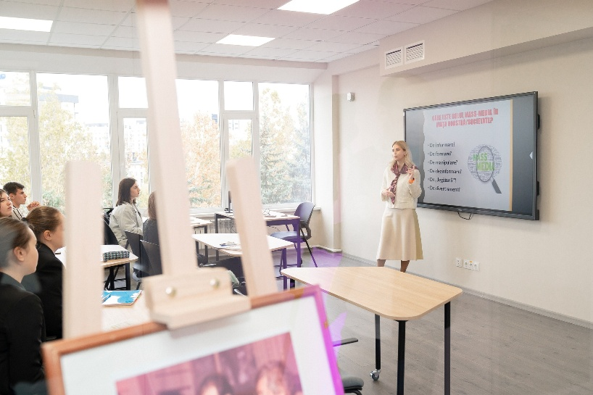
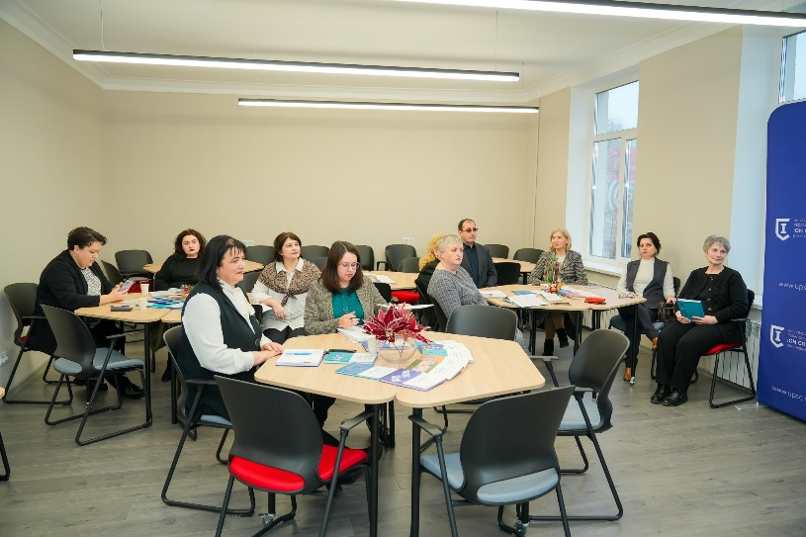
Figure 2. Training sessions for teaching staff at “Ion Creanga" State Pedagogical University of Chisinau

4. Higher Education Institution: Academy of Economic Studies of Moldova (ASEM)
Sub-project name: Information and Communications Technologies for Business Intelligence / (TICpIA – Abbreviation name)
Priority field: Information and Communication Technologies (061)
Sub-project duration: October 24, 2022 – October 23, 2024
Sub-project total budget: 629,292.00 EUR

The Amendment to the Sub-Financing Agreement was signed and the implementation period has been extended by March 31, 2025.
As of December 31, 2024, the amount of EUR 566,362.80 (90%) was disbursed to the subproject, of which was spent EUR 515,037.74 (81.8%).
Sub-project development objectives are to strengthen the capacity of the Academy of Economic Studies of Moldova in learning based on the needs that arise in the business environment and to strengthen academic excellence in Information and Communication Technologies (ICT).
Specific objectives of the sub-project: (i) modernization of the infrastructure with informational equipment; (ii) revising and updating the curriculum of the existing study programs within the accredited program "Information Technologies" and "Applied Informatics"; (iii) developing and updating the methodological-didactic support for the "Information Technologies" and "Applied Informatics" study programs; and (iv) creation of at least two new courses in the Information Technologies and Applied Informatics study programs.
Sub-project implementation progress
According to the approved Procurement Plan, 8 procurement activities have been carried out, of which 5 for goods and 3 for consulting services. 2 procurements are in progress (one for goods and one for consulting services), for which contracts have not yet been signed. Following the procurement process, a total of 9 contracts have been signed (7 for goods and 2 contracts for consulting services).
Achievement of indicators by the sub-project:
Indicators | Final target | Indicators achieved as of December 31, 2024
Learning premises equipped with ICT equipment | 8 | 15 learning premises equipped with ICT equipment
Learning premises equipped with furniture | 3 | 3 learning spaces equipped with furniture
Review and updating of Bachelor study programs: Information technologies and Applied informatics | 4 | In progress
Training for teaching staff on the topics: 1) Internet of Things: challenges and opportunities, 2) Web Design: development of the network environment, 3) Modernization of higher education in the field of ICT. | 3  (120 persons) | In Progress
New courses created to the existing study programs evaluated | 2 | In Progress  The contract signed on December 26, 2024 is being implemented

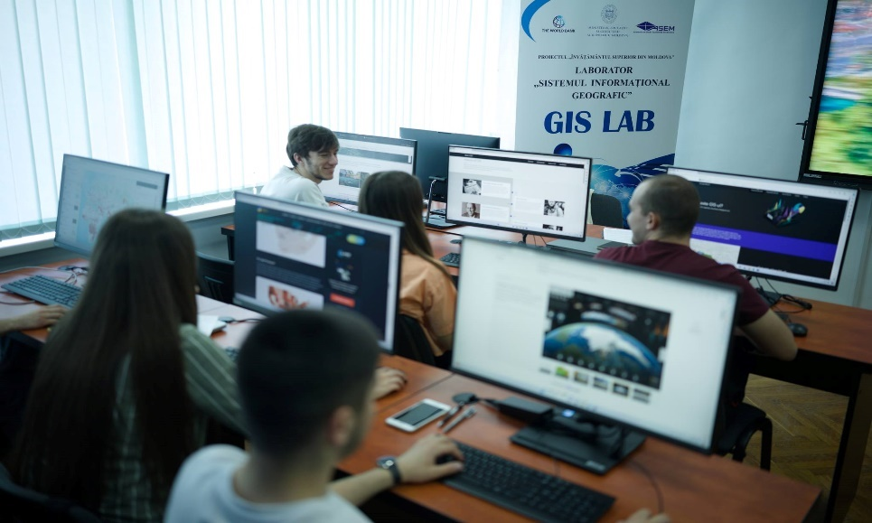
Figure 3. Equipped Laboratory of Geographic Information System at the Academy of Economic Studies

5. Higher Education Institution: "Alecu Russo" State University from Balti
Sub-project name: Educating Innovative Teachers for the Children of Moldova / (EPICoM – Abbreviation name)
Priority field: Education (Pedagogy) (011)
Sub-project duration: October 24, 2022 – October 23, 2024

The Amendment to the Sub-Financing Agreement was signed and the implementation period has been extended by March 31, 2025.
Sub-project total budget: 1,534,500.00 EUR
As of December 31, 2024, the amount of EUR 1,534,500.00 (90%) was disbursed to the subproject, of which was spent EUR 1,139,705.59 (74.3%).
Sub-project development objective is to modernize the educational infrastructure of the institution in order to stimulate the quality of the initial and continuous training of teaching staff.
Specific objectives of the sub-project: (i) Creating open, flexible, and inspirational learning environments with interdisciplinary and innovative approaches; (ii) Aligning the training of teaching staff to the requirements of the labor market; (iii) Creating ergonomic conditions for methodical consultations to specialists in the educational field; (iv) Expanding partnerships with educational agencies in the community and abroad; and (v) Promotion of the teaching profession to cover the supply of the labor market.

Sub-project implementation progress
According to the approved Procurement Plan, 86 procurement activities have been carried out, of which 15 for goods, 1 for non-consulting services and 70 for consulting services. 3 procurements are in progress, for which contracts have not yet been signed (2 for goods and one for consulting services). Following the procurement process, a total of 89 contracts have been signed (28 for goods, 1 for non-consulting services and 57 contracts for consulting services).
Achievement of indicators by the sub-project
Indicator | Final target | Indicators achieved as of December 31, 2024
School of the Future renovated and equipped (spaces equipped with furniture, ICT equipment and training materials) | 6 Didactic labs:  5 Educational centers:  1 Gym  1 Office of the school psychologist  1 Polyvalent/multifunctional Holl  1 University audio video recording studio. | Achieved  6 laboratories and 9 classrooms equipped as follows:  6 Didactic labs:  - Didactic laboratory for preschool education  - Didactic laboratory for primary education  - Mathematics instructional-simulative laboratory  - Instructive-simulative Informatics laboratory  - Geography didactic laboratory  - Biology Laboratory  5 Educational centers:  - Music Education Center  - Philological Education Center  - Teaching center of history and education for society  - Mathematics Resource and Consulting Center  - Career guidance center and relations with the labor market  1 Gym  1 Office of the school psychologist  1 Polyvalent/multifunctional Holl  1 University audio video recording studio.
Developed and edited curriculum materials | 19 course materials | Achieved  16 course materials developed
Methodological guidelines developed and published | 5 methodological guides | Achieved  6 Methodological guides developed and published
Training in the field of Education Sciences for teachers. | 36 trainings, 748 teachers | Achieved  29 trainings conducted;  680 persons trained
Education plans, specialty course books and curriculum upgraded in the general field of Education Sciences: Mother tongues, Foreign languages, Geography/biology, Mathematics/informatics, Pre-school education, Primary education, History and civic education. | 7 education plans and curriculum upgraded | Achieved  6 education plans and curriculum developed
Specialised software developed for: The virtual museum of the school and the locality, The School of the Future. | 2 | In progress – development of one software for The virtual museum of the school and the locality
Establish partnership agreements | 30 partnerships | 20 partnerships established

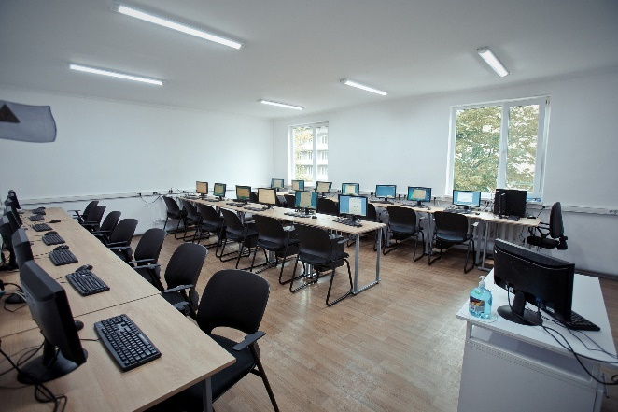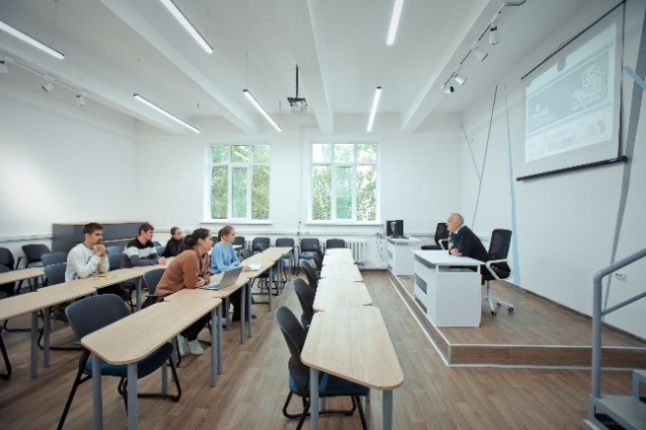
Figure 4. Equipped learning spaces at "Alecu Russo" State University from Balti

6. Higher Education Institution: "Alecu Russo" State University from Balti
Sub-project name: Creation of the Academic Environment oriented towards the training of competitive specialists on the IT labor market / (CreMA IT – Abbreviation name)
Priority field: Information and Communication Technologies (061)
Sub-project duration: October 24, 2022 – October 23, 2024

The Amendments to the Sub-Financing Agreement have been signed and the implementation period of sub-project has been extended by February 28, 2025.

Sub-project total budget: 255,000.00 EUR
As of December 31, 2024, the amount of EUR 229,500.00 (90%) was disbursed to the subproject, of which was spent EUR 229,500.00 (90%).
Sub-project development objective was to develop the academic environment oriented towards training of competitive specialists on the IT labor market and increase the employability of graduates.

Sub-project implementation progress
According to the approved Procurement Plan, 17 procurement activities have been carried out, of which 7 for goods, 1 for non-consulting services and 9 for consulting services. Following the procurement process, a total of 17 contracts have been signed (7 for goods, 1 for non-consulting services and 9 contracts for consulting services).
Achievement of indicators by the sub-project
Indicators | Final target | Indicators achieved as of December 31, 2024
Equipped classrooms and spaces | 3 classrooms and spaces | Achieved  Two spaces (Cybersecurity Software and Technical Apparatus Testing Room, USARB IT Graduate Employer Room) and coworking spaces equipped
Practicums developed for the field of study "Information and Communication Technologies". | 3 practicums | Achieved  3 practicums developed:  1. "Testing software applications"  2. "Intelligent systems"  3. "Technical means of cyber security"
Updated education plans and curricula | 1 education plan and curricula | 1 education plan and curricula at the field of study 061 "Information and communication technologies" updated
Guides developed and published: | 2 guides | 2 guides developed: 1. Internship in the field of study "Information and communication technologies", 2. Elaboration of proposals for educational/research projects and attracting funding grants.
Conduct trainings sessions on the topics: Testing of software applications, Intelligent systems, Technical means of cyber security, Entrepreneurship and the creation of innovative products, Offline and online communication with the private environment to establish collaboration in order to train competent specialists for the labor market, Organization of networking activities in offline format and online with the private environment for establishing collaborations, Identifying, negotiating and establishing partnerships in the field of ICT, Strengthening the university's capacity in developing educational/research projects and attracting grants. Updating the curricula and specialty textbooks in the ICT field of study. | 5 trainings | Achieved  5 trainings conducted as follows:  1. Training in the field of information and communication technologies "Testing of software applications"  2. Training in Information and Communication Technologies "Intelligent Systems"  3. Training in the field of information and communication technologies "Technical means of cyber security"  4. Training in the field of information and communication technologies, "Entrepreneurship and the creation of innovative products"  5. Training on "Identification, negotiation and establishment of partnerships in the ICT field"  Beneficiaries of the training sessions – 216 (76 teachers, 20 representatives of the local and regional private environment, 120 students)
Partnerships between universities/pedagogical colleges and employers established by EI (number) (newly created during the subproject implementation period) | 10 partnership agreements | 7 partnership agreements concluded
7. Higher Education Institution: "Alecu Russo" State University from Balti (USARB)
Sub-project name: Consolidation of the teaching, learning, research process in the field of engineering and engineering trades / (CONPROPRECERC – Abbreviation name)
Priority field: Engineering and engineering trades (071)
Sub-project duration: October 24, 2022 – October 23, 2024
Sub-project total budget: 189,000.00 EUR
Sub-project completed

As of December 31, 2024, the amount disbursed to the subproject is EUR 170,100.00 (90%), and the amount pre-financed by the institution is 18,882.53 (10%), according to the point 107 of the HEIPOM (The Beneficiary shall pre-finance the 10 % balance of the total sub-project budget or will have to bear the costs for the advance which will be retained from the preceding request for payment, if that would be the case), and the amount spent is EUR 188,982.53 (100%).
Sub-project development objectives was to: i) initiate and create a Master's program in the field of innovative engineering and technological transfer necessary for economic agents in the northern area of the Republic of Moldova; ii) continuous training of teaching staff and auxiliary staff involved in Bachelor and Master study programs in order to use the purchased equipment and engineering software; iii) promote teaching-learning, research-innovation activities aimed at training highly qualified specialists in the field of engineering, namely training of specialists for the first cycle of studies in the field of engineering and management, for the second cycle of studies in the field of innovative engineering and the transfer of technologists; iv) establish collaboration and partnership relations between the Physical and Engineering Sciences Department of USARB with companies with an engineering profile from the country and abroad for the practical implementation of the results obtained from the teaching-learning, research-innovation activities.

Sub-project implementation progress
According to the approved Procurement Plan, 12 procurement activities have been carried out, of which one for goods, one for non-consulting services and 10 for consulting services. Following the procurement process, a total of 11 contracts have been signed and completed (one for goods and 10 contracts for consulting services).
Achievement of indicators by the sub-project
Indicators | Final target | Indicators achieved as of December 31, 2024
Laboratories equipped with laboratory equipment | 2 laboratories | Two laboratories equipped: Materials Study and Materials Technology laboratories
Practicum developed Integrated computer-aided design systems for the Master's degree program "Innovative engineering and technological transfer in the automotive industry". | 1 practicum | Practicum developed Integrated computer-aided design systems for the Master's degree program "Innovative engineering and technological transfer in the automotive industry".
Course materials developed for and published for the Master's program "Innovative engineering and technology transfer in the automotive industry": Computer-aided manufacturing, Innovative non-conventional technologies. | 2 course materials | 2 Course materials developed for and published for the Master's program "Innovative engineering and technology transfer in the automotive industry": Computer-aided manufacturing, Innovative non-conventional technologies.
Trainings with the topics: Use of laboratory equipment in Materials Study and Materials Technology: CNC laser cutting and engraving machine, Study of SOLIDWORKS software, Use of laboratory equipment in Materials Technology: EDM drilling machine, Cutting machine with wire by electro erosion, Use of laboratory equipment in materials technology: CNC lathe, Additive technologies of forming parts from biodegradable plastics and composites in the automotive industry, Technologies of manufacturing parts and properties of materials used in the automotive industry. | 7 Training sessions for teachers, auxiliary staff, and students | Achieved  7 trainings conducted  95 persons trained  (30 students, 65 teachers, auxiliary staff trained);
Partnerships between universities/pedagogical colleges and employers established by EI (number) (newly created during the subproject implementation period | 5 partnership agreements concluded (2023 – 4 agreements, 2024 – 1 agreement) | 5 partnership agreements concluded

8. Higher Education Institution: Moldova State University
Sub-project name: Capitalising on the consolidated school-university partnership "Educational Cluster" in teacher training / (EduClass Abbreviation name)
Priority field: Education (Pedagogy) (011)
Sub-project duration: October 24, 2022 – October 23, 2024
The Amendment to the Sub-Financing Agreement has been signed and the implementation period of sub-project has been extended by March 31, 2025.

Sub-project total budget: 1,049,450.00 EUR
As of December 31, 2024, the amount of EUR 1,381,050.00 (90%) was disbursed to the subproject of which was spent EUR 1,139,705.59 (74.3%).
Sub-project development objectives are to: i) modernize the necessary resources to ensure attractive conditions for future teaching staff; ii) increase the number of students enrolled in Bachelor's and Master's programs and improving the process of aligning the higher education system with the requirements of the labor market; and iii) consolidate cooperation with representatives of the labor market in order to increase the absorption capacity of program graduates by the labor market.
Sub-project implementation progress
According to the approved Procurement Plan, 31 procurement activities have been carried out, of which 9 for goods, 1 for non-consulting services and 21 for consulting services. One procurement for consulting services is in progress, for which contracts have not yet been signed. Following the procurement process, a total of 36 contracts have been signed (14 for goods, 1 for non-consulting services and 21 contracts for consulting services).
Achievement of indicators by the sub-project
No | Indicators | Final target | Indicators achieved by December 31, 2024
1 | Laboratories equipped with furniture, multimedia systems, IT equipment | 5 laboratories | 6 laboratories equipped with furniture, multimedia systems, IT equipment
2 | Learning premises equipped with furniture, multimedia systems, IT equipment | 4 learning premises | 4 learning premises equipped with furniture, multimedia systems, IT equipment
3 | Training for students regarding: Strengthening motivation for employment in school and achieving a teaching career, building of motivation for professional training in the field of education and achieving a teaching career. | 40 Trainings | 40 trainings conducted  600 students trained
4 | Training for teaching staff on the: Implementation of the elaborated curricula; Implementation of the developed curricula; Application of the new course materials. | 22 Trainings | 13 trainings conducted  376 teachers trained
5 | Develop curriculum and course materials for: General Psychology, Applied Psychology, General Pedagogy, Applied Pedagogy, Didactics of history, Didactics of foreign languages, Didactics of chemistry, Advanced teaching technologies, Didactics of mathematics, Didactics of geography, Didactics of biology. | 11 Curricula and Course materials | 11 Curricula and Course materials developed
6 | The development of the Web Platform for results dissemination and use, for processing of multimedia materials / images / sound / video for Programs dissemination. | 1 Platform | Web platform developed
7 | Development of support materials for the internships. | 1 Support | 1 support materials for the internships developed
8 | Summer school with high school students to promote education professions | 1 Summer School | 1 summer school conducted  50 high school students attended
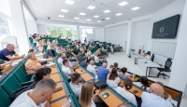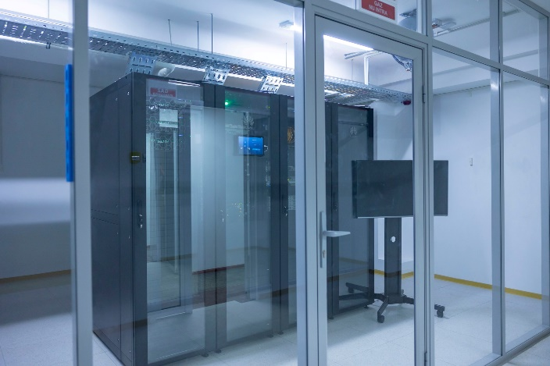
Figure 5. Launch of the Data Center at the State University of Moldova

9. Higher Education Institution: Moldova State University
Sub-project name: Center for Innovations in Information and Communication Technologies / (IT Hub MSU – Abbreviation name)
Priority field: Information and Communication Technologies (061)
Sub-project duration: October 24, 2022 – October 23, 2024
The Amendment to the Sub-Financing Agreement has been signed and the implementation period of sub-project has been extended by March 31, 2025.

Sub-project total budget: 793,045.00 EUR
As of December 31, 2024, the amount of EUR 713,740.50 (90%) was disbursed to the subproject, of which was spent EUR 613,869.21.86 (77.4%).
Sub-project development objectives are to: i) create the IT Hub Center of the State University of Moldova; ii) modernize courses and creation of a study program; iii) promote ICT programs; and iv) attract more students to study programs.

Sub-project implementation progress
According to the approved Procurement Plan, 18 procurement activities have been carried out, of which 10 for goods and 8 for consulting services. One procurement for consulting services is in progress, for which contracts have not yet been signed. Following the procurement process, a total of 25 contracts have been signed (17 for goods and 8 contracts for consulting services).
Achievement of indicators by the sub-project
No | Indicators | Final target | Indicators achieved by December 31, 2024
1 | Learning premises equipped with furniture, conditioning equipment digital, interactive IT equipment and software products | 8 Learning premises | 6 IT laboratories equipped  2 learning premises equipped
2 | Learning premises with digital, interactive IT equipment and software products | 1 Learning premise | One learning premise equipped with digital, interactive IT equipment and software products
3 | Teaching staff training for the Master's programs: Artificial Intelligence and Data Science (first year of studies – theoretical components), Artificial Intelligence and Data Science (first year of studies – practical components), Artificial Intelligence and Data Science (second year of studies – theoretical components), Artificial Intelligence and Data Science (second year of studies – practical components). | 6 Trainings | 3 trainings conducted  21 teachers trained
4 | Development of Master's programs: Artificial Intelligence and Data Science (first year of studies), Artificial Intelligence and Data Science (second year of studies). | 1 Program | Master's programs developed: Artificial Intelligence and Data Science
5 | Development of curricula, traditional course support, digital course support, automatic course evaluations for: Artificial Intelligence, Machine Learning, Cloud computing. | 3 Curricula | Achieved  3 curricula, traditional course support, digital course support, automatic course evaluations for courses: Artificial Intelligence, Machine Learning, Cloud computing developed
6 | Development for the Web platform and processing of multimedia materials for the dissemination of the "Artificial Intelligence and Data Science" Program. | 1 Platform | 1 web platform developed
10. Higher Education Institution: Moldova State University
Sub-project name: Modernized resources for study programs of chemical, pharmaceutical, and cosmetic technologies / (TehFarmCosm – Abbreviation name)
Priority field: Engineering and engineering trades (071)
Sub-project duration: October 24, 2022 – October 23, 2024
Sub-project total budget: 238,600.00 EUR)
Sub-project completed
As of December 31, 2024, the amount disbursed to the subproject is EUR 214,740 (90%), and the amount pre-financed by the institution is 21,811.23 (10%) according to the point 107 of the HEIPOM (The Beneficiary shall pre-finance the 10 % balance of the total sub-project budget or will have to bear the costs for the advance which will be retained from the preceding request for payment, if that would be the case), and the amount spent is EUR 236,551.23 (99.1%).

Sub-project development objective is to ensure sustainability of university studies in both cycles in the field of engineering and engineering activities offered by the State University of Moldova.
Specific objectives of the sub-project: (i) Increasing the quality of educational services by modernizing and developing the technical-material base of programs in the field of engineering and engineering activities; (ii) Improving the competitiveness of programs by developing the professional skills of teaching staff in international university centres that carry out a similar training process; (iii) Increasing the number of applicants for both study cycles in the field's programs; and (iv) Consolidation of cooperation with employers to increase the absorption capacity of program graduates by labor market.
Sub-project implementation progress
According to the approved Procurement Plan, 11 procurement activities have been carried out, of which 4 for goods and 7 for consulting services. Following the procurement process, a total of 11 contracts have been signed and completed (4 for goods and 7 contracts for consulting services).
Achievement of indicators by the sub-project
No | Indicators | Final target | Indicators achieved by December 31, 2024
1 | Laboratories equipped with laboratory equipment and IT equipment | 3 Laboratories | 3 laboratories equipped with laboratory equipment and IT equipment
2 | Review and update of curricula (2) and teaching plans (2) for the Bachelor’s programs: Technology of cosmetic and medicinal products, Industrial chemical technology | 2 curricula and 2 teaching plans revised | 2 curricula and 2 teaching plans revised for the Bachelor’s programs: Technology of cosmetic and medicinal products, Industrial chemical technology
3 | Review and update of curriculum and teaching plan for the Master’s program Modern technologies in cosmetics, pharmacy and environmental protection | 1 curriculum and 1 teaching plans | 1 curriculum and teaching plan revised and updated for the Master’s program Modern technologies in cosmetics, pharmacy and environmental protection
4 | Partnership agreements established | 8 Partnerships | 8 Partnership agreements established
5 | Training of teaching staff regarding the operation and maintenance of specific equipment. | 1 Training sessions | Training conducted  11 teachers trained
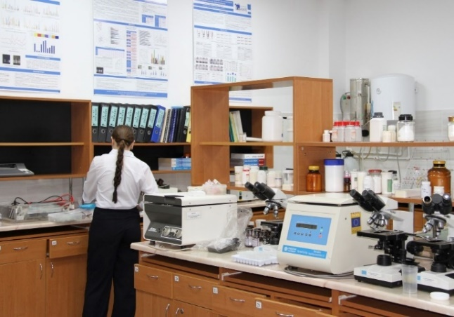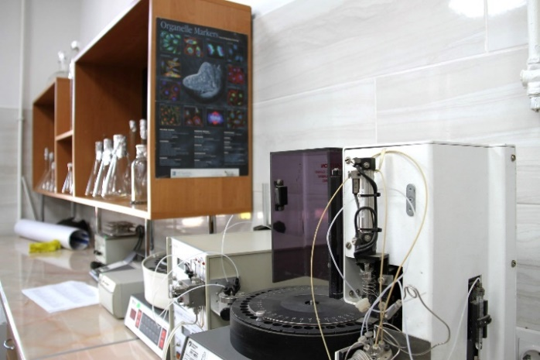
Figure 6. Equipped chemistry laboratories at the State University of Moldova

11. Higher Education Institution: State University of Medicine and Pharmacy "Nicolae Testemitanu" (USMF)

Sub-project name: Strengthening education through research in medicine at USMF "Nicolae Testemitanu"/ (FORCE_Med – Abbreviation name)
Priority field: Health (medicine) (091)
Sub-project duration: October 24, 2022 – October 23, 2024

The Amendment to the Sub-Financing Agreement has been signed and the implementation period of sub-project has been extended by February 28, 2025.

Sub-project total budget: 2,150,000.00 EUR
As of December 31, 2024, the amount of EUR 1,935,000.00 (90%) was disbursed to the subproject, the amount pre-financed by the institution is 77,439.43, and the amount spent is EUR 2,011,707.18 (93.57%).
Sub-project development objectives are to: i) increase the institutional capacity of the State University of Medicine and Pharmacy "Nicolae Testemitanu" to provide educational services and medical training through research in order to train competitive qualified specialists for the health field; ii) align the goals of the studies and the research skills of graduates in the field of health to the current requirements of the labour market.

Sub-project implementation progress
According to the approved Procurement Plan, 36 procurement activities have been carried out, of which 7 for goods and 29 for consulting services. One procurement for goods is in progress, for which contracts have not yet been signed. Following the procurement process, a total of 43 contracts have been signed (14 for goods and 29 contracts for consulting services).
Achievement of indicators by the sub-project
No | Indicators | Final target | Indicators achieved by December 31, 2024
1 | Platform for training through research (2 centres with 7 laboratories equipped with laboratory equipment and furniture: Morphology, Biochemistry, Cell cultures, Experiments on laboratory animals, Molecular biology, Biobank, Immunology. | 7 Laboratories | Achieved  7 laboratories equipped with laboratory equipment and furniture: Morphology, Biochemistry, Cell cultures, Experiments on laboratory animals, Molecular biology, Biobank, Immunology.
2 | Study rooms/laboratories equipped with Telemedicine type video transmission system | 3 Study rooms/laboratories | 3 Study rooms/laboratories equipped with Telemedicine type video transmission system
3 | Updated Curricula for study programs according to national and international standards: “Medicine Integrated studies program” and “Master's program Molecular Technologies in Health”. | 2 Curricula | 2 updated Curricula for study programs according to national and international standards: “Medicine Integrated studies program” and “Master's program Molecular Technologies in Health
4 | Licences for bioinformatic and biostatistical analyses: 2 Licences for bioinformatic analyses; 3 licences for biostatistical analyses. | 5 Licences | Completed – 5
5 | Updated / newly developed Curricula for the Molecular Technologies in Health Master's program for the disciplines: Medical biochemistry; Molecular biology; Pathophysiology; Medical genetics; Immunology; Pneumology; Bioinformatics; Pathology; Diseases sensitive to climate change (for Medicine integrated studies programs); Health and climate change (for 4 under-graduate programs) | 10 curricula | 10 updated / newly developed Curricula for the Molecular Technologies in Health Master's program for the disciplines: Medical biochemistry; Molecular biology; Pathophysiology; Medical genetics; Immunology; Pneumology; Bioinformatics; Pathology; Diseases sensitive to climate change (for Medicine integrated studies programs); Health and climate change (for 4 under-graduate programs
6 | Partnership to be developed with Czech Republic – Masaryk Memorial Cancer Institute | 1 Partnership | 1 Partnership Agreement concluded
7 | Training of local trainers:  Laboratory quality management system; Biosafety; Biosecurity; Biobanking and Data management. | 5 Training sessions | Completed – 5  20 teachers trained
8 | Training of students: Valorization of research results; Copyright; Funding opportunities in the fields of research and innovation at national and international level; Application methodology to national calls and Application methodology to international calls. | 5 Training sessions | Completed – 5  40 persons trained
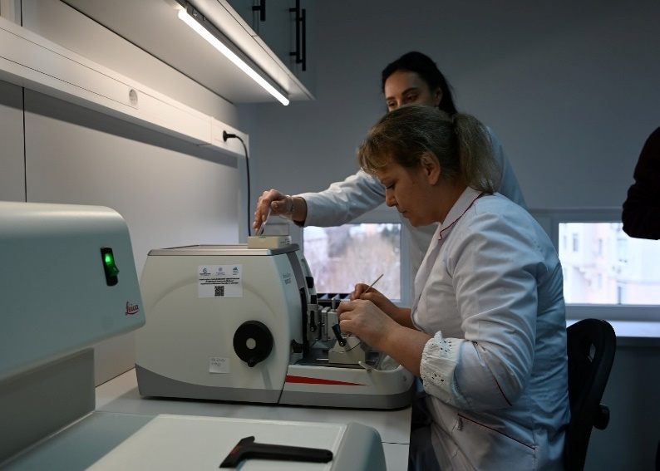
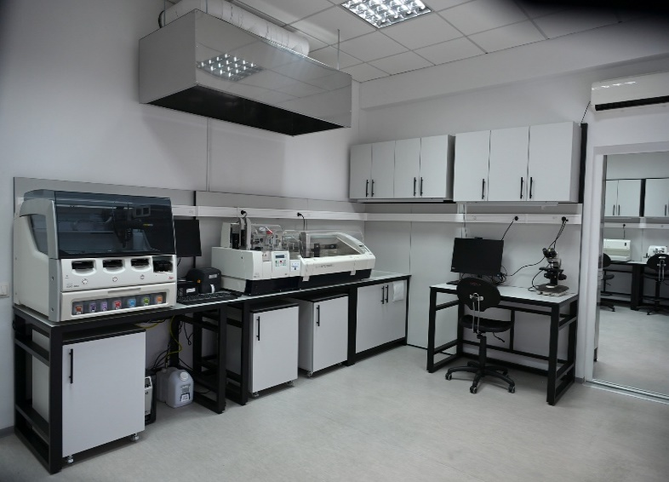
Figure 7. Equipped research laboratories at the State University of Medicine and Pharmacy "Nicolae Testemitanu"

12. Higher Education Institution: State University “B.P. Hasdeu” from Cahul
Sub-project name: Innovative Laboratory in IT / (InoLAB – Abbreviation name)
Priority field: Information and Communication Technologies (061)
Sub-project duration: October 24, 2022 – October 23, 2024
Sub-project total budget: 52,750.00 EUR.
Sub-project completed
As of December 31, 2024, the amount disbursed to the subproject is EUR 46,386.76 (84.9%), and the amount pre-financed by the institution is 4,399.03 (10%) according to the point 107 of the HEIPOM (The Beneficiary shall pre-finance the 10 % balance of the total sub-project budget or will have to bear the costs for the advance which will be retained from the preceding request for payment, if that would be the case), and the amount spent is EUR 50,785.79 (96.3%).

Sub-project development objective is to develop and modernize the general field of study: 061 Information and communication technologies, by improving the quality of educational services provided by the State University "B. P. Hasdeu" from Cahul.
Specific objectives of the sub-project: (i) Creation of an Innovative Laboratory in IT InoLAB, which aims to develop and apply information and communication technologies (ICT) in a collaborative and innovative format with certain benefits for students and teachers; (ii) Increasing the level of training of teaching staff who teach subjects related to the general field of studies: 061 Information and communication technologies; (iii) Revision of the study program 0613.4 Informatics, cycle I Bachelor; (iv) Elaboration of course materials for two specialized disciplines; (v) Development of the study plan and the curriculum by subjects for the new Master's program "Information and communication technologies for business"; (vi) Strengthening partnerships with the business environment in the region and with pre-university education institutions.
Sub-project implementation progress
According to the approved Procurement Plan, 10 procurement activities have been carried out, of which 3 for goods, 1 for non-consulting services and 6 for consulting services. Following the procurement process, a total of 11 contracts have been signed and completed (4 for goods, 1 for non-consulting services and 6 contracts for consulting services).
Achievement of indicators by the sub-project
No | Indicators | Final target | Indicators achieved by December 31, 2024
1 | Equip Innovative Laboratory in IT | 1 Laboratory | 1 Innovative Laboratory in IT equipped
2 | Teacher training mobilities | 2 Mobilities | Completed – 2
3 | Peer-reviewed Bachelor’s study programs | 1 Program | 1 Peer-reviewed Bachelor’s study programs
4 | Partnerships between universities/ with pedagogical colleges and employers established within HEIP (number) (newly created during the implementation of the sub-project) | 7 Partnership | Completed – 7 partnerships established
5 | Development and publication of course materials | 2 Course materials | 2 course materials developed for the Bachelor study program Informatics, cycle I: "Python programming language"; "The JavaScript Programming Language"
6 | Study programme & curricula for Masters study | 1 Study programme & curricula | 1 Study program and curricula developed for the Master's program: Information and communication technologies for business, General field of studies: 061 Information and communication technologies.
7 | Training sessions for teachers | 1 Training sessions | Completed - 1 training  30 teachers trained
8 | Training sessions for students & teachers | 1 Training sessions | Completed – 1 training  21 persons

13. Higher Education Institution: State University „B.P. Hasdeu” from Cahul
Sub-project name: Integrated engineering education through the "GreenINGLab" platform / GreenINGLab
Priority field: Engineering and engineering trades (071)
Sub-project duration: October 24, 2022 – October 23, 2024
Sub-project total budget: 44,770.00 EUR.
Sub-project completed
As of December 31, 2024, the amount disbursed to the subproject is EUR 40,293.00 (90%), and the amount pre-financed by the institution is 4,424.59 (10%) according to the point 107 of the HEIPOM (The Beneficiary shall pre-finance the 10 % balance of the total sub-project budget or will have to bear the costs for the advance which will be retained from the preceding request for payment, if that would be the case), and the amount spent is EUR 44,717.56 (99.9%).

Sub-project development objectives are to: i) increase the sustainability and relevance of study programs in the priority field 071 Engineering and engineering activities ii) increase the attractiveness of the study of exact sciences and the research skills of students; iii) correlate engineering studies with socio-economic and environmental issues; iv) consolidate individual and group methodical-didactic support, and increase the quality of skills acquisition and the accumulation of study program objectives in the priority field 071 Engineering and engineering activities, by implementing interactive study methods; v) increase career and employment opportunities and prospects for students and graduates in the priority field 071 Engineering and engineering activities; and vi) strengthen national and intersectoral academic networks.

Sub-project implementation progress
According to the approved Procurement Plan, 7 procurement activities have been carried out, of which 2 for goods and 5 for consulting services. Following the procurement process, a total of 7 contracts have been signed and completed (2 for goods and 5 contracts for consulting services).
Achievement of indicators by the sub-project
No | Indicators | Final target | Indicators achieved by December 31, 2024
1 | Equip engineering laboratory with specialised equipment | 2 Laboratory | 2 engineering laboratory equipped with specialised equipment
2 | Training for developing educational content in the engineering field with the application of STEM/STEAM elements; Training of Trainer on career guidance and counselling; Training on developing the curricula for the programs: 0710.1 Engineering and Management Food Industry and 0710.1 Engineering and Management in Machine Construction (Automotive) | 3 Trainings | Completed – 3 trainings  65 teachers trained
3 | Education plans developed for the Master's program "Management of Environmental Projects and Sustainable Development", and for graduates of the Bachelor's programs in the field 071 Engineering and engineering activities and for Curriculum development for the "Environmental and Sustainable Development Project Management" master's program | 2 Education Plans and curriculum for Bachelor and Master program | 2 Education plans developed for the Master's program "Management of Environmental Projects and Sustainable Development", and for graduates of the Bachelor's programs in the field of Engineering and engineering activities and for Curriculum development for the "Environmental and Sustainable Development Project Management" Master's program
4 | Academic mobilities | 2 Mobilities | Completed – 2 mobilities
5 | Establish partnership agreements | 5 Partnership | 5 Partnerships concluded
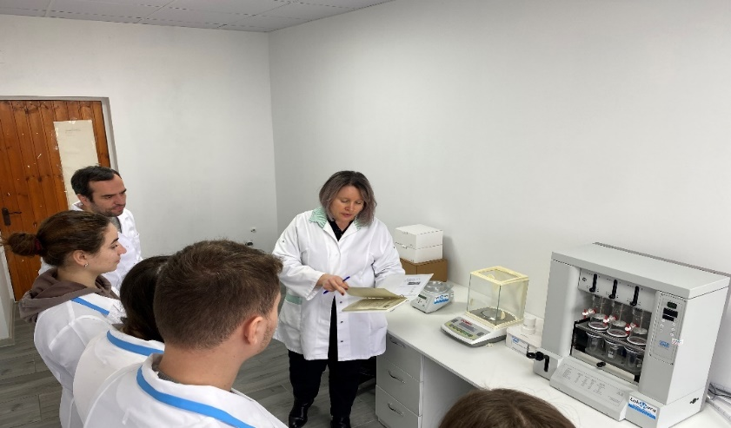

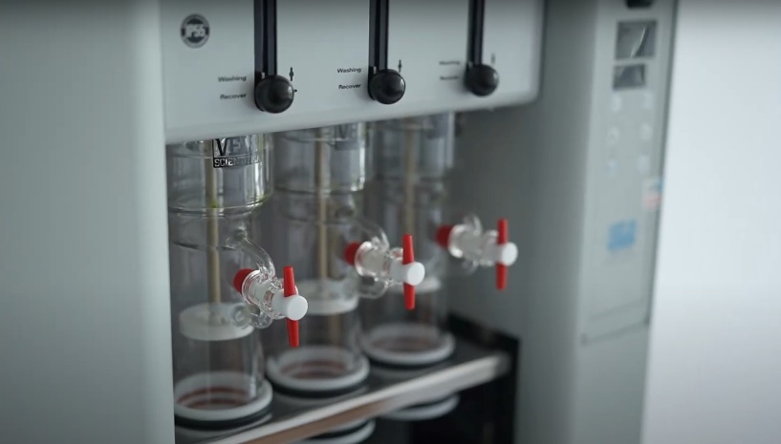
Figure 8. Equipped engineering laboratories at the State University „B.P. Hasdeu” from Cahul

14. Higher Education Institution: State University „B.P. Hasdeu” from Cahul
Sub-project name: Education for Competence Empowerment /(EDforCE – Abbreviation name)
Priority field: Education (Pedagogy) (011)
Sub-project duration: October 24, 2022 – October 23, 2024
Total budget of the subproject: EUR 355,600.00.

Sub-project completed
As of December 31, 2024, the amount disbursed to the subproject is EUR 320,040 (90%), and the amount pre-financed by the institution is 35,559.83 (10%) according to the point 107 of the HEIPOM (The Beneficiary shall pre-finance the 10 % balance of the total sub-project budget or will have to bear the costs for the advance which will be retained from the preceding request for payment, if that would be the case), and the amount spent is EUR 355,559.83 (100%).
Sub-project development objective is to improve the professional knowledge and skills of future teachers in order to promote specialties in the field of education.
Specific objectives of the sub-project: (i) Increasing the institutional capacity to train specialists in the field of education (pedagogy) with a continuation of the activities within the cluster laboratory after the end of the project; (ii) Increasing the attractiveness of study programs in the field of education (pedagogy); (ii) Aligning the educational offer to the requirements of the labor market; (iii) Improving and developing study programs, as well as developing course materials and different guides in accordance with the current needs of the labor market; (iv) Reducing the gender disparity in the training of specialists in the field of education; (v) Improvement and implementation of career guidance services; (vi) Increasing the number of inter-university partnerships; (vii) Orientation of cluster laboratory services for STEM academic programs; and (viii) Increasing ecological awareness by reducing electronic waste and using eco-friendly accessories.
Sub-project implementation progress
According to the approved Procurement Plan, 30 procurement activities have been carried out, of which 7 for goods, 2 for non-consulting services and 22 for consulting services. Following the procurement process, a total of 36 contracts have been signed and completed (12 for goods, 2 for non-consulting services and 22 contracts for consulting services).
Achievement of indicators by the sub-project
No | Indicators | Final target | Indicators achieved by December 31, 2024
1 | Equip Innovative Laboratory in IT with furniture, IT equipment, software and educational resources | 7 Laboratories | 7 laboratories equipped (Information Technologies Center, English Language Laboratory, Romanian Language Study Center, Preschool Pedagogy Center; Primary Education Pedagogy Center; Local History Laboratory; Career Guidance Center) equipped
2 | Teacher training mobilities | 2 Mobilities | Completed – 2 mobilities
3 | Curricula review for the Bachelor’s programs: English language, Romanian language and literature, Pedagogy in primary education and preschool pedagogy, History and civic education. | 4 Curricula | Achieved  4 education plans and curricula revised for the Bachelor’s programs: English language, Romanian language and literature, Pedagogy in primary education and preschool pedagogy, History and civic education.
4 | Curricula review for the Master's programs: Linguistic and Literary Education, Pedagogy and Interactive Educational Technologies, History of the Southeast European Space: Study, Methodology and Didactics, Teaching English Language and Culture. | 4 Curricula | 4 curricula revised for the Master's programs: Linguistic and Literary Education, Pedagogy and Interactive Educational Technologies, History of the Southeast European Space: Study, Methodology and Didactics, Teaching English Language and Culture.
5 | New guidelines developed for internships and Bachelor and Master theses writing and editing in the specialties: English language, Romanian language and literature, Linguistic and literary education, Pedagogy in primary education and preschool pedagogy, Pedagogy and interactive educational technologies, History and civic education, History of the Southeast European space: study, methodology and didactic. | Guidelines | 9 new guidelines developed for internships and Bachelor and Master theses writing and editing in the specialties: English language, Romanian language and literature, Linguistic and literary education, Pedagogy in primary education and preschool pedagogy, Pedagogy and interactive educational technologies, History and civic education, History of the Southeast European space: study, methodology and didactic.
6 | Review of the course materials | 7 course materials reviewed | 7 course materials revised for the subjects: History of American literature, Lexicology of the English language, Theory and practice of oral and written translation (in English), History Didactics and The Cultural-Scientific Integration of Bessarabia into the Romanian Unitary State (1918-1940), Didactics of Romanian language and literature, History of literary critics.
7 | Curriculum review for the program Romanian language for foreign citizens | 1 Curriculum | 1 Curriculum revised for the program Romanian language for foreign citizens
8 | Training for the teaching staff of the institution with the following topics: Continuous training of trainers, Documentation, research, teaching local history, Teaching the Romanian language as a foreign language, Diction and public discourse, Current trends in English language teaching; Diction and public discourse, Development of professional skills in the field of special education, Interactive methods in teaching history, Theoretical-practical connections between preschool and primary education. | 9 Training sessions | Completed – 9 trainings  248 teachers trained
9 | Trainings for the university students:  Integrating ICT tools into the educational process for first-cycle students and Career guidance and counselling | 2 Training sessions | 79 Students trained
10 | Partnerships between universities/pedagogical colleges and employers established through the HEIP | 13 Partnerships | Completed – 13 partnerships established

15. Institution: "Ion Creanga" Pedagogical College from Balti
Sub-project name: Education, Development, Humanization of Today's Pedagogical Specialists for the Eco Community / (EDUSPACE – Abbreviation name)
Priority field: Education (011)
Sub-project duration: October 24, 2022 – October 23, 2024
Sub-project completed
Sub-project total budget: 461,700.00 EUR
As of December 31, 2024, the amount of EUR 461,700 was disbursed to the subproject, with a real expenditure of EUR 461,700 (100%).

Sub-project development objective is to modernize the educational infrastructure of the institution in order to stimulate the quality of training specialists in the field of early and primary education.
Sub-project specific objectives: (i) training and developing the professional skills of future and current teachers, adaptable and responsive to the new requirements of the labour market, by implementing interdisciplinary, transdisciplinary and innovative strategies and activities; (ii) equipping and inaugurating simulation educational centers according to modern equipment standards for early childhood education and primary education institutions; (iii) ensuring ergonomic conditions for activity in simulation educational centers; (iv) promoting the image of the institution and pedagogical specialties and qualifications to meet the supply and demands of the labour market; and (v) identifying new partners and strengthening existing partnerships with educational agencies/educational institutions in the country and abroad.

Sub-project implementation progress
According to the approved Procurement Plan, 33 procurement activities have been carried out, of which 10 for goods, one for non-consulting services, 21 for consulting services and one for renovation works. Following the procurement process, a total of 39 contracts have been signed and completed (16 for goods, one for non-consulting services, 21 contracts for consulting services and one contract for works).
Achievement of indicators by the sub-project
Indicators | Final target | Indicators achieved as of December 31, 2024
Learning premises renovated and equipped with furniture, informational equipment, training materials and inventory | 3 simulation educational centres;  2 computer rooms;  5 classrooms;  1 gym | Achieved  3 simulation educational centres repaired and equipped;  2 computer rooms repaired and equipped;  5 classrooms repaired and equipped;  1 gym repaired and equipped
Chemistry, Biology and Physics laboratories equipped. | 3 laboratories | 3 laboratories equipped
Course materials developed and edited | 18 course materials | 18 curriculum supports have been developed
Teacher training sessions | 3 trainings | 2 training sessions conducted:  1. The methodology of monitoring and evaluating of child development based on child’s learning and development standards (early education)  2. The specifics of criterion evaluation through descriptors in specialized didactics (primary education)  39 teachers trained
Curricular support edited and published | 18 curriculum supports edited | 18 curriculum supports edited and published
Pedagogical and methodological activities in the field of educational sciences organised | 10 organized educational and methodological activities in the field of Educational Sciences.  180 students from secondary schools trained. | 10 organized educational and methodological activities in the field of Educational Sciences.  180 students from secondary schools trained.
Partnerships between universities/pedagogical colleges and employers established | 30 partnership agreements | 15 partnerships concluded
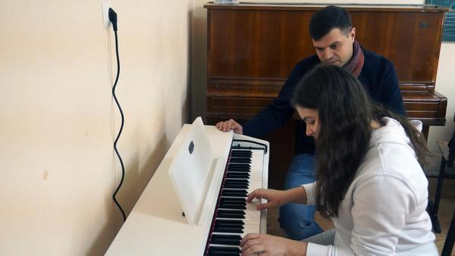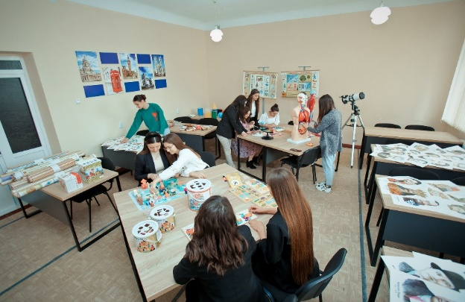

Figure 9. Better education conditions for the future teachers at the Pedagogical College in Balti

16. Institution: „Iulia Hașdeu” Pedagogical College from Cahul
Sub-project name: Creation of the Educational Hub (EduHub) within the College "Iulia Hasdeu" din Cahul / (EduHub – CIHCahul - Abbreviation name)
Priority field: Education (011)
Sub-project duration: October 24, 2022 – October 23, 2024
Sub-project total budget: 339,175.00 EUR
Sub-project completed

As of December 31, 2024, the amount of EUR 338,842.23 was disbursed to the subproject, with a real expenditure of EUR 338,842.23 (99.9%).
Sub-project development objective is to increase the employment rate of graduates in the field of education by implementing a quality professional training process correlated with the dynamic requirements of the labour market.
Sub-project specific objectives: (i) modernization of educational premises in order to improve study conditions, by endowing them with equipment and educational resources relevant to the initial professional training in the field of education; (ii) improving the initial training programs in the field of education to increase the quality of the professional training process, by revising the curriculum supports from the perspective of ICT implementation and development of critical thinking; and (iii) strengthening the professional skills of teaching and managerial staff in order to implement qualitative programs in the field of education, through involvement in professional development activities.
Sub-project implementation progress
According to the approved Procurement Plan, 28 procurement activities have been carried out, of which 9 for goods, 18 for consulting services and 1 for renovation works. Following the procurement process, a total of 34 contracts have been signed and completed (15 for goods, 18 contracts for consulting services and one contract for works).
Achievement of indicators by the sub-project
Indicators | End target | Indicators achieved as of December 31, 2024
Learning premises renovated and equipped with furniture, information equipment, air conditioners, training materials. | 2 laboratories, 2 classrooms and 1 multipurpose room | 2 laboratories, 2 classrooms and 1 multipurpose room equipped
Video educational content production studio equipped | 1 | Video educational content production studio equipped
Course materials developed | 6 course materials | 6 course materials developed:  2 for the Primary Education specialty and 4 for the Early Education specialty.
Guidelines developed | 2 guides | Two guides developed:  1. Guide for creating digital assessments,  2. Guide to creating interactive lessons developed
Teacher training sessions: The use of modern didactic strategies, The implementation of information and communication technology in the teaching-learning process, The evaluation of learning objectives in vocational technical education, The use of digital platforms Moodle, My Test in the evaluation of school results, The development of effective communication skills with parents and the community, The management of development personal and professional of teaching staff, Developing the skills to achieve the personal development plan.  Creation of educational content and other video materials  Training of management team members in strategic planning. | 9 trainings  34 teachers x 5 courses -2023  34 teachers x 2 courses - 2024  15 teachers - 1 course 2024  15 management team members -1 course 2024 | 9 trainings conducted as follows:  34 teachers x 4 courses in 2023 trained;  34 teachers x 3 courses in 2024 trained.  15 teachers x 1 course in 2024 trained.  15 management team members trained -1 course in 2024

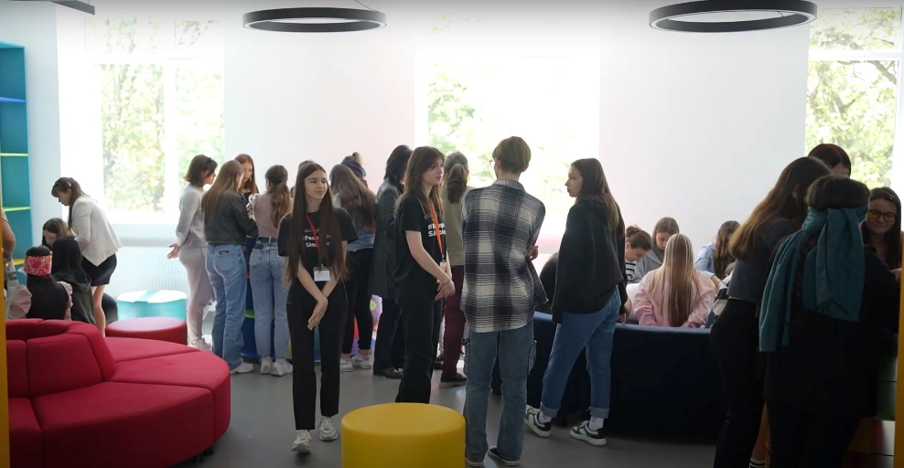
Figure 10. Renovated and equipped multifunctional hub at the Pedagogical College in Comrat

17. Institution: "Mihai Eminescu" College from Soroca
Sub-project name: Modern training – attribute of professional success / (IMASP – Abbreviation name)
Priority field: Education (011)
Sub-project duration: October 24, 2022 – October 23, 2024

Sub-project total budget: 542,500.00 EUR
Sub-project completed

As of December 31, 2024, the amount of EUR 540,238.88 was disbursed to the subproject, with a real expenditure of EUR 540,238.88 (99.6%).
Sub-project development objective is to implement modern training to ensure quality and create effective opportunities in professional training.

Sub-project implementation progress
According to the approved Procurement Plan, 48 procurement activities have been carried out, of which 13 for goods, one for non-consulting services, 33 for consulting services and one for renovation works. Following the procurement process, a total of 50 contracts have been signed and completed (16 for goods, 1 for non-consulting services, 32 contracts for consulting services and one contract for renovation works).
Achievement of indicators by the sub-project
Indicators | End target | Indicators achieved
Learning premises renovated and equipped with furniture, informational equipment, training materials and inventory. | 6 study rooms and 3 laboratories | 6 study rooms and 3 laboratories equipped with furniture, informational equipment, training materials and inventory.
Course materials developed for the Early Education specialty: Didactics of musical education I, Didactics of musical education II, Formation of elementary mathematical representations | 3 course materials | 3 course materials developed for the Early Education specialty: Didactics of musical education I, Didactics of musical education II, Formation of elementary mathematical representations
Course materials developed for the Primary Education specialty: Didactics of music education, Didactics of the Romanian language I, Didactics of the Romanian language II, Didactics of technological education | 4 course materials | 4 course materials developed for the Primary Education specialty: Didactics of music education, Didactics of the Romanian language I, Didactics of the Romanian language II, Didactics of technological education
Training conducted in the summer school regarding the initiation of future graduates in the fields of professional training with a pedagogical profile, qualifications: educator, music director, teacher – 2023 | 3 trainings  (30 graduates) | 3 trainings conducted  30 graduates trained
Teaching staff training | 13 trainings  30 persons | 17 trainings completed for teaching staff (30 teachers) on:  1. Using the tools and resources needed to carry out interactive activities and lessons.  2. Accumulation and implementation of good practices specific to the field of early childhood education (Educator qualification).  3. Accumulation and implementation of good practices specific to the field of early childhood education (musical conductor qualification).  4. Accumulation and implementation of good practices specific to the field of professional training Primary education (Teacher qualification).  5. Development of educational products in the teacher certification process.  6. Implementation of innovative methods and practices in the approach and integration of students with SEN in education.  7. Development and management of digital content in the teaching process -learning – assessment. "  8. Implementation of innovative methods and practices in the approach and integration of students with CES in education.  9. Motivation for the teaching career: priority of the reform policy.  10. Training on the New Educations. Education for tolerance.  11. Training on Financial Education with the aim of developing financial intelligence and consumer behaviour.  12. Training on the use of digital tools for the development of graphic design products.  13. Training on the use of the interactive whiteboard.  14. Training on the integrated approach to learning contents on the STE(A)M model.  15. Training on the use of the "Moodle" platform.  16. Training on Guidance and career orientation of fourth-year college students.  17. Training on the Integration of ICT tools in the educational process for first-year college students.
Training conducted in the summer school regarding the initiation of future graduates in the fields of professional training with a pedagogical profile, qualifications: educator, music director, teacher – 2024. | 1 training | 3 trainings conducted  30 graduates trained
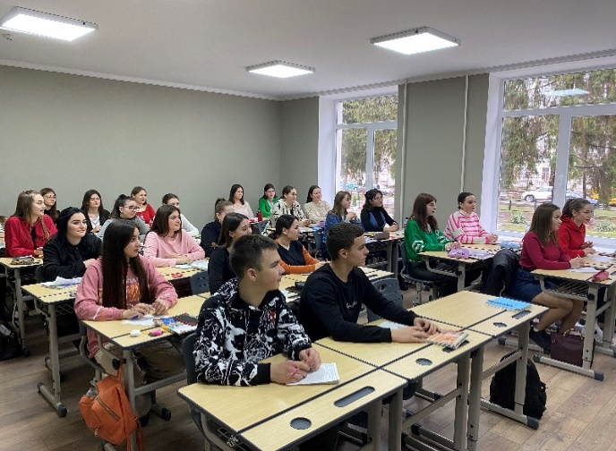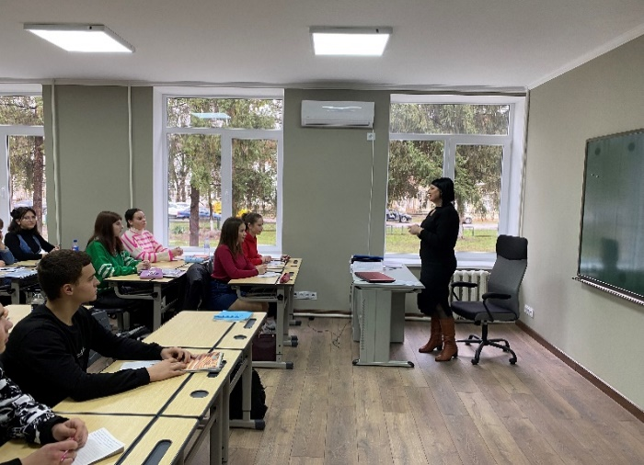
Figure 11. Renovated and equipped spaces at the Pedagogical College in Soroca

18. Institution: „Mihail Ciachir” College from Comrat
Sub-project name: Creating modern conditions for the formation of competitive human capital on the labor market at the "Mihail Ciachir" college in Comrat /(CUCoPiM – Abbreviation name)
Priority field: Education (011)
Sub-project duration: October 24, 2022 – October 23, 2024
Sub-project total budget: 386,830.00 EUR
Sub-project completed

As of December 31, 2024, the amount of EUR 369,421.10 was disbursed to the subproject, with a real expenditure of EUR 369,421.10 (95.5%).
Sub-project development objective is to create modern study conditions for development of students' personality as future specialists, focused on professional, intellectual, and social creativity through implementation of educational programs and formation of competitive human capital on the labor market.
Specific objectives of the sub-project: (i) increasing institutional capacities in order to train specialists in the field of education (pedagogy); and (ii) aligning the educational offer with the requirements of the labor market.
Sub-project implementation progress
According to the approved Procurement Plan, 28 procurement activities have been carried out, of which 8 for goods, 2 for non-consulting services, 17 for consulting services and one for renovation works. Following the procurement process, a total of 36 contracts have been signed and completed (16 for goods, 2 for non-consulting services, 17 contracts for consulting services and one contract for works).
Achievement of indicators
No | Indicators | Final target | Indicators achieved by December 31, 2024
1 | Equip 5 laboratories with IT equipment and furniture. | 5 Laboratories | 5 laboratories equipped with IT equipment and furniture.
2 | Equip 10 classrooms with IT equipment and furniture. | 10 Classrooms | 30 classrooms equipped with IT equipment and furniture.
3 | Develop five course materials: "Psychology of education" in the primary education specialty; „The musical alphabet" in the primary education specialty; „Didactics of the Russian language" in the primary education specialty; "Personal development in early education" in the Early Education specialty; "Educational partnership" in the Early Education specialty. | 5 Course materials | 5 course materials: developed "Psychology of education" in the primary education specialty; „The musical alphabet" in the primary education specialty; „Didactics of the Russian language" in the primary education specialty; "Personal development in early education" in the Early Education specialty; "Educational partnership" in the Early Education specialty.
4 | Develop Methodological guidelines for: i) the practical internship in the primary education specialty, ii) the practical internship "Early Education", the Educator qualification, iii) the practical internship "Early Education", the Musical Conductor qualification. | 3 Methodological guidelines | Completed – 3 Methodological guidelines developed
5 | Partnerships established | 5 Partnerships | 5 Partnerships established as follows:  1. Agreement on Cooperation with the Employment Service of the Gagauzia.  2. Bilateral study Agreement regarding the academic mobility of students with the "Ion Creangă" Pedagogical College in Balti City.  3. Bilateral study Agreement regarding the academic mobility of students with the "Iulia Hasdeu" College in Cahul City  4. Cooperation agreement with the Faculty of National Culture of Comrat State University of the municipality of Comrat. 5. Agreement on Cooperation with the Theoretical Lyceum named after G.A. Gaidarji, Comrat Municipality.
6 | Training of teaching staff in: Management of projects and priorities, Personal development and stress management, Management of the student class, Information technologies in the process of teaching-learning-evaluation and the creation of open digital educational resources, Evaluation of academic results and the elaboration of the portfolio, the project in modern didactic. | 7 Training sessions | 7 Training sessions conducted  52 teachers trained  66 students trained
7 | Summer School Camps for Students | 2 Summer Camps | 2 Summer Camps conducted  177 students trained
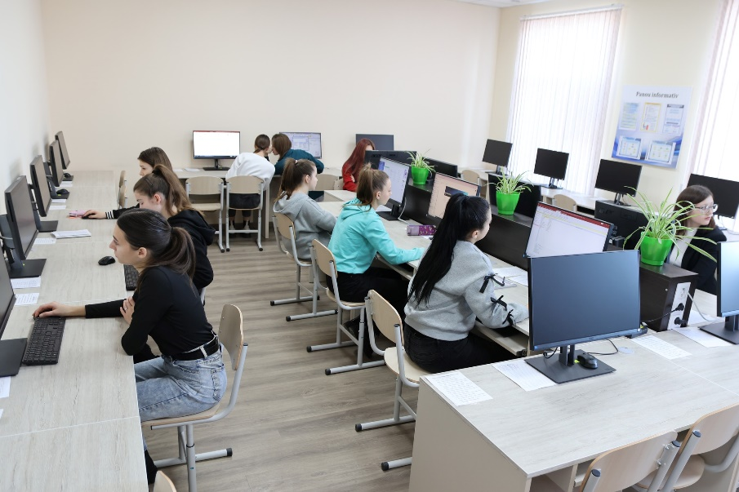
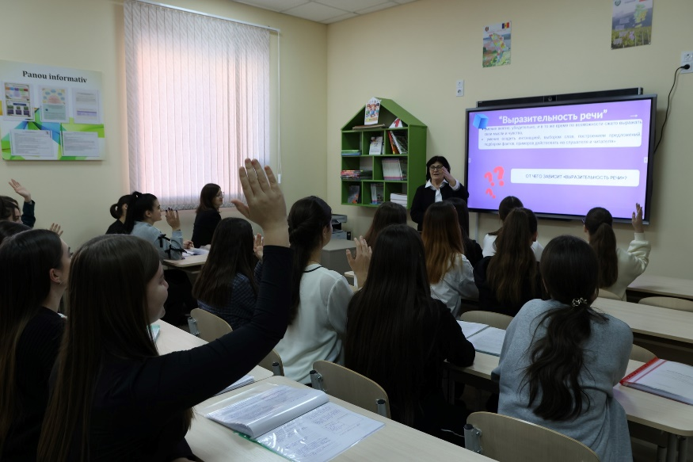
Figure 12. Renovated and equipped spaces at the Pedagogical College in Comrat
19. Institution: "Alexei Mateevici" Pedagogical College in Chisinau
Sub-project name: Quality assurance program in pedagogical education / (PACÎP – Abbreviation name)
Priority field: Education (011)
Sub-project duration: October 24, 2022 – October 23, 2024
Sub-project total budget: 808,500.00 EUR
Sub-project completed

As of December 31, 2024, the amount of EUR 790,500.00 was disbursed to the subproject, with a real expenditure of EUR 760,422.29 (94.1%).
Subproject development objective is transforming the "Alexei Mateevici" College in Chisinau into a modern, comprehensive educational institution, compatible with similar units and competitive in the professional training market for specialists at the national and European level, by modernising and implementing modern educational and informational technologies, and creating optimal conditions to ensure quality partnership with application institutions.
Specific objectives of the sub-project: (i) Creating an open educational space and 6 interactive educational hubs at the local level for the development of students' knowledge, skills, and competencies necessary to adapt more easily to the imperatives of the time, especially those related to sustainable development in the pedagogical field; (ii) Improving the professional skills of students aligned with the requirements of the labor market through interventions specific to the educational field; (iii) Increasing access to education by digitizing some curricular content in the pedagogical field; and (iv) Increasing the number of enrolled / selected candidates, including boys, to professional training programs in the field of pedagogy.

Sub-project implementation progress
According to the approved Procurement Plan, 35 procurement activities have been carried out, of which 7 for goods, 4 for non-consulting services, 23 for consulting services and one for renovation works. Following the procurement process, a total of 43 contracts have been signed and completed (15 for goods, 3 for non-consulting services, 23 contracts for consulting services and one contract for works).

Achievement of indicators
No | Indicators | Final target | Indicators achieved by December 31, 2024
1 | Learning premises renovated and equipped with specialized furniture, IT equipment, software resources and experimental teaching materials – 6 digital classrooms and 1 multifunctional room (Total area 590.6 square metres) | 6 digital classrooms  1 multifunctional room | 6 digital classrooms and  1 multifunctional room equipped
 | Summer/Winter School with the topic "Promoting pedagogical education among young people". | 1 Summer School | Summer school conducted  390 students trained
3 | Development and publishing of course materials | 22 course materials | 22 course materials developed and published: Evaluation in primary education, Professional ethics, Didactics of science, Didactics of physical education, Educational partnership, Didactics of history, Didactics of environmental education, National musical literature, Musical game technology, Practical mathematics course, Ecological culture, Studying of nature through applications and experiments, Interactive teaching strategies, Digital education, Fun mathematics, Educational software.
6 | Teacher training | 5 Training sessions | 5 training sessions conducted; 138 teachers trained in the field of: 1. Implementation of interactive information technologies in the teaching-learning process, 2. Robotics and digital graphics, Environmental education, Management of educational projects, 3. Development of digital lessons in the "Primary Education" specialty, 4. Development of digital lessons in the "Early Education" specialty; 5. Digitals lessons and use of interactive technology in educational process.
7 | Graduate students training | 3 Training sessions | 3 Training sessions conducted  45 graduates trained in the fields of: Implementation of interactive information technologies in the teaching-learning process, Robotics and digital graphics, Environmental education, Management of educational projects, Development of digital lessons in the "Primary Education" specialty, Development of digital lessons in the "Early Education" specialty.
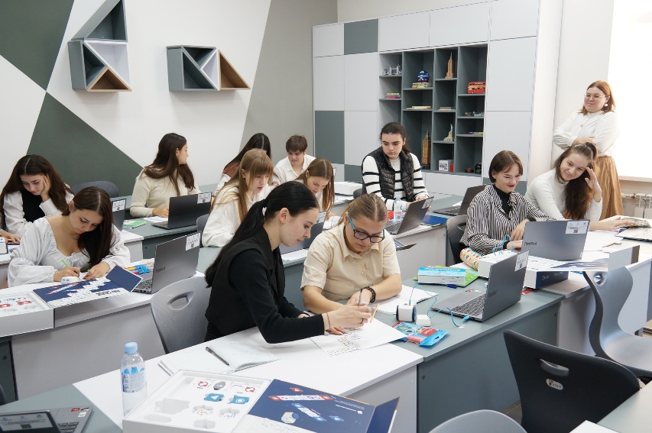
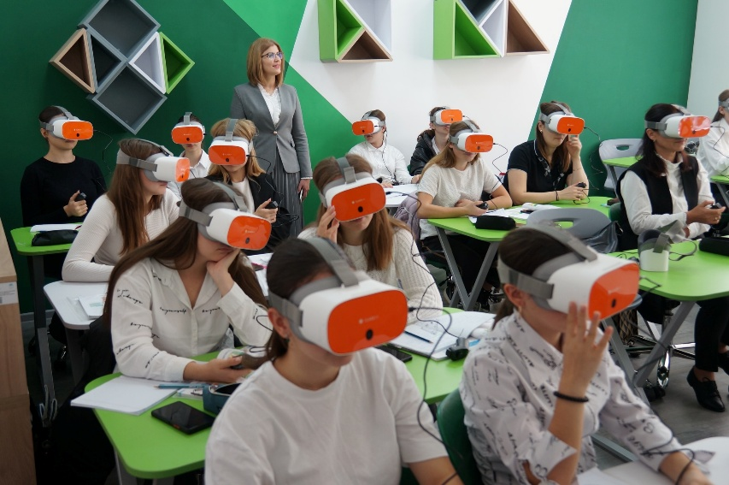
Figure 13. Renovated and equipped laboratories at the Pedagogical College in Chisinau

20. Institution: "Vasile Lupu" College from Orhei
Sub-project name: The Quality Education Project in the Orhei College / (PECCO – Abbreviation name)
Priority field: Education (011)
Sub-project duration: October 24, 2022 – October 23, 2024

The Amendment to the Sub-Financing Agreement was signed and the implementation period has been extended by February 28, 2025.

Sub-project total budget: 217,170.00 EUR
As of December 31, 2024, the amount of EUR 189,958.72 was disbursed to the subproject, with a real expenditure of EUR 189,171.00 (87.1%).
Sub-project development objective is to develop mechanisms to improve the quality of education, life skills and healthy behaviors among students in the field of education (pedagogy) to train competent and competitive specialists, increasing the chances of employment in the labor field.
Specific objectives of the sub-project: (i) creating new learning environments; (ii) developing professional skills of teaching staff; (iii) updating and using ICT in education; (iv) curriculum development; and (v) creating synergies and leveraging the capacities of all partner institutions regarding quality and relevance assurance in the professional training of competent and competitive specialists on the labor market.

Sub-project implementation progress
According to the approved Procurement Plan, 25 procurement activities have been carried out, of which 7 for goods, 2 for non-consulting services, 15 for consulting services and 1 for renovation works. Following the procurement process, a total of 29 contracts have been signed (11 for goods, 2 contracts for non-consulting services, 10 contracts for consulting services and 1 for renovation works).

Achievement of indicators
No | Indicators | Final target | Indicators achieved by December 31, 2024
1 | Laboratories repaired, equipped with school furniture and IT equipment | 2 Laboratories | 2 Laboratories repaired, equipped with school furniture and IT equipment
2 | Classrooms equipped with school furniture and IT equipment. | 7 Classrooms | 7 classrooms equipped with school furniture and IT equipment and 14 classes equipped with school blackboards.
3 | Development of four course materials | 4 Course materials | 4 Course materials developed: two in Primary Education and two in Early Childhood Education.
4 | Development of Curricula | 2 Curricula | 2 curricula developed in the optional component, Early Childhood Education and Primary Education.
5 | Providing the educational process with teaching aids (musical instruments, sports inventory and curricular aids) and teaching aids for private lessons in the specialties: Early Education and Primary Education. | Musical instruments - 5 items, inventory and sports equipment - 37 items, curricular aids for private teaching lessons - 65 titles of textbooks for primary classes | Educational process provided with teaching aids (musical instruments, sports inventory and curricular aids) and teaching aids for private lessons in the specialties: Early Education and Primary Education.
6 | Training of teaching staff | 6 Training sessions | 6 training sessions conducted on:  1. Training of teachers on the use of the Moodle platform in the creation of teaching materials and computer-assisted assessment; 2.Training of teachers - leaders of traineeships in the module Criterion-referenced assessment through descriptors in primary education; 3. Training of assessors for the unified system method of examinations; 4. Training of teachers - leaders of practical training periods in the programme "Management of well-being in the educational institution"; 5. Training of teachers of private methods and leaders of internships in the field of Digital Education, specialties Primary Education and Early Education; 6. Training of teachers in the use of information technologies in teaching  164 teachers trained
7 | Training of secondary school graduates in the promotion of the teaching profession, specialty Early Childhood Education within the Summer School Programme and specialty Primary Education within the Summer School Programme. | 2 Training sessions | 2 trainings of secondary school graduated conducted  60 graduates trained
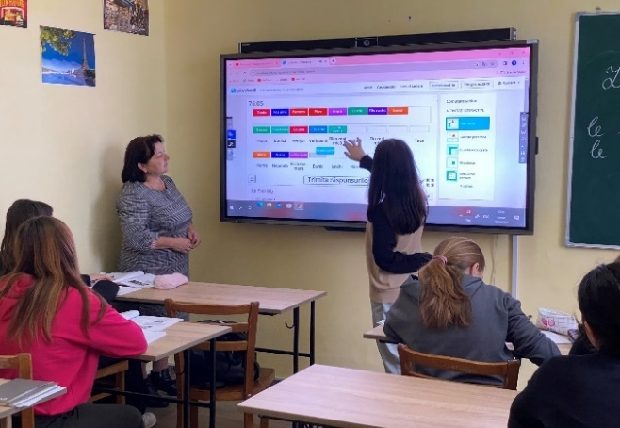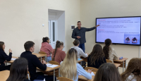
Figure 14. Renovated and equipped spaces at the Pedagogical College in Orhei

Annex 3. Progress report on implementation of 13 sub-projects by HEIP beneficiaries under the second call within Component 2 of the Project as of December 31, 2024

- Higher Education Institution: Nicolae Testemitanu State University of Medicine and Pharmacy of the Republic of Moldova
Sub-project name: Modernization and strengthening of education through research in pharmacy and medicine within Nicolae Testemitanu SUMPh FORCE FARM
Priority field: Health (09)
Sub-project duration: November 27, 2023 – September 15, 2025
Sub-project total budget: 2,000,000.00 euro
As of December 31, 2024, the amount of EUR 1,029,508.70 was disbursed to the subproject, of which was spent EUR 144,327.49 (7.2%).
Sub-project development objectives are to: i) Increasing the institutional capacities of "Nicolae Testemițanu„ SUMPh to provide educational services as pharmaceutical and medical training through research in order to train specialists with competitive qualifications for the field of Health (pharmacy and medicine) and ii) Adjust the study goals and research skills of graduates in the field of Pharmacy and Medicine to the current requirements of the labor market.
Sub-project implementation progress
According to the approved Procurement Plan, 23 procurement activities have been planned to be carried out. As of December 31, 2024, 1 procurement activity for goods has been carried out and 11 procurement activities for consultancy services. Following the procurement processes, a total of 13 contracts have been signed (2 for goods, 11 for consulting services).
Nr. | Activities | End target | Status of activity | Indicators achieved
1 | Equipping new created laboratories with teaching and research equipment:  - Plant and Pharmaceutical Biotechnology laboratory  - Pharmaceutical Nanotechnologies and Preformulation laboratory | 2 laboratories | In progress  The procedure for the purchase of equipment for the newly created laboratories and for the fortification of the laboratories was completed, with 2 contracts being signed. The equipment delivery is expected.
2 | Fortifying laboratories within the Scientific Center of Medicines:  - Laboratory development, analysis and standardtization of medicines  - Preclinical Medicine Research Laboratory | 2 laboratories
3 | Purchasing of educational software  and video equipment | 2 software  for 3 laboratories | In progress  Currently, the specification for the purchase of educational software and video equipment has been developed, prepared to be submitted for approval.
4 | Revision and updating of the Education Plan for the Pharmacy integrated studies program | 1 | Completed  The revised and updated study plan was approved by the Quality Assurance and Curricular Evaluation Commission (Minutes No. 1 of 26.09.2024) and the Council of the Faculty of Pharmacy (Minutes No. 1 of 27.09.2024). | Achieved  Education Plan for the Pharmacy integrated studies program  revised and updated
 | Revision and updating of the Curricula for the Pharmacy integrated studies program. | 11 Curricula | Completed  The revised and updated curricula:  - „Pharmaceutical Botany"  - "Pharmacognosy"  - "Pharmacology",  - "Pharmacotoxicology"  - "Clinical Pharmacy"  - "Physico-chemical methods of analysis"  - "Drug development and pharmaceutical research"  - "Biopharmacy and pharmaceutical nanotechnologies"  - "Plant and Pharmaceutical Biotechnologies"  - "Pharmacogenetics"  - "Ecology and Medicinal Plants"  were approved within the Quality Assurance and Curricular Evaluation Commission (Minutes No. 1 of 26.09.2024) and at the Council of the Faculty of Pharmacy (Minutes No. 1 of 27.09.2024). | Achieved  11 revised and updated curricula
5 | Training of teaching staff in the field of curricular improvement of research-based subjects | 25 teachers | Completed  Training has been conducted | Achieved  26 teachers trained
6 | Training of teaching staff in the field of career guidance | 40 teachers | Completed  Training has been conducted | Achieved  46 teachers trained
7 | Training students, masters, PhD students in the fields of biotechnologies and bioanalysis, pharmacogenetics and ecology | 50 students, masters, PhD students | In progress  The procurement process has been conducted, and currently the contract to be signed with the selected expert to conduct trainings.
8 | Training of specialists in the field of the acquisition and application of plant biotechnological methods, microscopic and phytochemical research, pharmaceutical biotechnologies (fermentation and cell cultivation, equivalence of biosimilars), obtaining liquid and solid nanoparticles, spectral, chromatographic, thermal and instrumental research methods in teaching and research activity | 50 specialists, 10 trainings | In progress  Currently, The TORs are being developed

- Higher Education Institution: Ion Creanga State Pedagogical University of Chisinau
Sub-project name: ENHANCE EDUCATION IN THE TEACHING CAREER FOR PROFESSIONAL PERFORMANCE (EduPerformance)
Priority field: 011 Education
Sub-project duration: November 27, 2023 – September 15, 2025
Sub-project total budget: 1,179, 868.00 EUR
As of December 31, 2024, the amount of EUR 637,234.81 was disbursed to the subproject, of which was spent EUR 311,973.30 (26.4%).
Sub-project development objectives: i) The sub-project looks to improve the study programs and training conditions of future teachers for professional performance and better insertion in the labour market, ii) We are aiming for these objectives in the sub-project development, iii) Increasing institutional capacities for education and research by developing an environment for innovation, creativity, and academic achievement, iiii) Continuous updating of study programs in accordance with the demands of the labour market and iiiii) Establishing the university's digital learning ecosystem.
Sub-project implementation progress
According to the approved Procurement Plan by the Sub-project closing date, 26 procurement activities have been planned to be carried out. As of December 31, 2024, 4 procurement activities for goods have been carried out and 17 procurement activities for consultancy services. Following the procurement processes, a total of 16 contracts have been signed (4 for goods, 12 for consulting services).
Nr. | Activities | End Target | Status of the activity | Indicators achieved
Objective 1: Increasing institutional capacities for education and research by developing an environment for innovation, creativity, and academic achievement
1 | Carrying out an exhaustive analysis of the institutional capacity regarding the insurance of the educational and research process in the field of Educational Sciences; | 1 study | Completed on June, 27th 2024  Published on the web site www.upsc.md | 1 study for the improvement of 10 study programs in the field of Educational Sciences developed and published
2 | Development of modern university infrastructure to provide a welcoming, appealing atmosphere for learning and researching for students; | 6 classrooms and multifunctional laboratories, 1 centre and 1 hub equipped | In progress  By the end of the subproject, 2025
3 | Supporting the professional development of the university's teaching, scientific, and supporting staff from the perspective of motivating young people to pursue a teaching career and improving services; | 4 continuous training programs | In progress  2 continuous training programs developed and finished (The Management of Educational Projects; Professional Identity and Career Management) during Jule-December 2024;  - 1 continuous training programs is in the process of being created (Artificial intelligence in education), period December-April 2025;  - 1 continuous training programs will be announced second time (Integration of Digital Technology in Early Childhood Education) | 2 continuous training programs developed and completed
- Objective 2: Continuous updating of study programs in accordance with the demands of the labour market
5 | Re-evaluating educational programs in means of adapting them to the needs of the labour market | 3 analysis studies | Completed in 2024 | 1 analytical study for the improvement of 10 study programs in the field of Educational Sciences conducted;  1 analytical study of teachers' opinions;  1 analytical study of students' opinions
6 | Updating study programs | 10 study programs | Completed in 2024 | 10 study programs (Bachelor's, master's) updated:  1. Geography and English,  2. Biology and Chemistry,  3.Chemistry and Biology,  4.Mathematics and Computer Science; Master's degree:  5. Modern Biology and Technologies in Education,  6. Contemporary Chemistry and Educational Technologies,  7. Geography and Educational Technologies,  8. Modern Physics and Educational Technologies,  9. Information Technologies in Education,  10. STEM Education and Innovative Teaching Approaches
7 | Development of university curricula and course materials; | 11 university curriculum and course materials | In progress  2 curricula and course (Didactic of Physics; Didactics of school physical experiments);  2 thematic modules: Outdoor Education and Non-Formal Education are in the process of being created (December-February, 2025) | 9 university curricula and course materials developed
Objective 3: Establishing the university's digital learning ecosystem
9 | Enhancing the learning and research process by integrating digital tools and internet resources into the digital educational ecosystem; | 10 digital educational products developed (e-courses, digital textbooks, digitized institutional platforms, etc.) | In progress
10 | Development of the Digitalization Strategy of Ion Creanga State Pedagogical University of Chisinau; | 1 university digitization strategy | In progress  The elaboration of the Digital Development Strategy of "Ion Creanga" State Pedagogical University of Chisinau will be implemented during February-April, 2025
11 | Modernization of the Information System of the University Scientific Library; Updating the informational infrastructure of the library, developing resources, and diversifying informational services and products, integrating the informational system of the scientific library into the informational system of the University, providing training and scientific research; developing platforms and services readily available to researchers, and developing open science tools | 1 research archiving database  1 annual activity program elaborated | In progress
Objective 4: Encouraging partnerships to increase the visibility and attractiveness of a teaching career
12 | Carrying out information activities to increase interest in the academic and pedagogical offers of the university, especially concerning the Physics, Informatics, Mathematics, Chemistry, Biology, and Geography majors. Developing better cooperation between the University - Alumni – Schools | 10 activities for the promotion of study programs in the field of educational sciences | In progress

- Higher Education Institution: Moldova State University
Sub-project name: Modernization of the professional training process in the Informatics and Applied Informatics specialties / MODERN-INFO
Priority field: Information and Communication Technologies (061)
Sub-project duration: November 27, 2023 – September 15, 2025
Sub-project total budget: 900,000.00 EUR
As of December 31, 2024, the amount of EUR 607,589.88 was disbursed to the subproject, of which was spent EUR 351,395.43 (39.0%).
Sub-project development objectives are to : i) Improve the quality and relevance of study programs in the field of ICT and prepare the students for the ever-changing demands of the labor market, ii) Modernize the educational process by updating the existing ICT study programs and creating new programs and courses, iii) Ensure adequate IT resources and infrastructure - purchase of equipment and software, necessary for the activities of the proposed specializations in the IT programs, iiii) Integrate entrepreneurial skills and research in ICT education and iiii) Promotion of ICT study programs to attract students from high schools and colleges.
Sub-project implementation progress
According to the approved Procurement Plan, 28 procurement activities have been planned to be carried out. As of December 31, 2024, three procurement activities for goods have been carried out and 12 procurement activities for consultancy services. Following the procurement processes, a total of 3 contracts have been signed (3 for goods, 0 for consulting services).
No. | Activities | End target | Status of activity | Indicators achieved
1 | Equipping specialized IT laboratories Networking and communications, Cyber Security, Web Development, Artificial Intelligence and Data Analysis, Immersive Technologies and Computer Graphics and Lesson video production studio. | 5 laboratories | In progress  2 contracts for ICT equipment completed.  1 contract for furniture completed.  Bidding Docs for Hardware, multimedia, network equipment and software products submitted to E-GOV Agency, comments received. Revised document to be re-submitted.
2 | Development of curricula and course materials for Bachelor”s degree: Web application development with Angular/Vue.js; Penetration testing and ethical hacking; Web and mobile application security; Containerization and virtualization; Automating the configuration of IT infrastructure and applications; Developing applications with the .NET Framework; Web application development with React; UI/UX design; Developing applications with the Spring Framework; Network security; Systems for monitoring and analyzing IT infrastructure and applications; Software design patterns; 3D graphics and animation; Web Content Management Systems; Virtual and augmented reality; Malware analysis; Video game development; Audio design and visual effects; Network Programming with Python; Spring Security and Spring Testing; Mobile app development with Android Studio/React Native; Developing server-side applications with Node.js. | 16 curricula and course materials | In progress  Selection process for 10 subjects underway. Selection process for 6 more subjects to be started in January 2025.
3 | Development of online resources and informative materials for the promotion of "Informatics" and "Applied Informatics" programs. | 1 | In progress  TOR developed. Selection process to be started in January 2025
4 | Organization of promotion activities for the "Informatics" and "Applied Informatics" study programs. | 3 | In progress
5 | Training of teaching staff for the "Informatics" and "Applied Informatics" programs. | 86 teaching staff | In progress

- Higher Education Institution: Moldova State University
Sub-project name: Modernization of the didactic process in the fields of Biological, Physical and Environmental sciences in the context of the requirements of the labor market / GEOBIOLAB
Priority field: Biological sciences (051), Environmental sciences (052), Physical sciences (053)
Sub-project duration: November 27, 2023 – September 15, 2025
Sub-project total budget: 514,600.00 EUR
As of December 31, 2024, the amount of EUR 92,300.00 was disbursed to the subproject, of which was spent EUR 92,297.84 (17.9%).
Sub-project development objectives: i) Strengthening the students training capacities in the fields of Biological, Physical and Environmental sciences in the context of adaptation to the needs and requirements of the labor market, ii) Modernization of training resources for students in the fields of Biological, Physical and Environmental sciences by adapting to the requirements of the modern society, iii) Adjustment of study plans and curricular training materials in the fields of Biological, Physical and Environmental sciences, in accordance with the current standards and requirements of the labor market and iiii) Improving the didactic-scientific process in the study fields of Biological, Physical and Environmental sciences through the training of teaching staff in renowned university centers and consolidation of cooperation with employer partners.
Sub-project implementation progress
According to the approved Procurement Plan, 8 procurement activities have been planned to be carried out. As of December 31, 2024, one procurement activity for goods has been carried out and 0 procurement activities for consultancy services. Following the procurement processes, one contract has been signed (1 for goods, 0 for consulting services).
No. | Activities | End target | Status of activity | Indicators achieved
1 | Provision of furniture, ICT, air conditioning and lab equipment for the laboratories Environmental quality monitoring and Agricultural products quality analysis. | 2 laboratories | In progress  Contract for the supply of lab equipment signed, equipment delivery underway.
2 | Updating the teaching plans in the fields Biological (051), Environmental (052) and Physical (053) sciences. | 5 education plans | In progress  TORs are being developed by the Departments of Biology and Ecology,  Geosciences and Forestry.
3 | Updating the curricula in fields of Biological (051), Environmental (052) and Physical (053) sciences. | 10 curricula | In progress  TORs are being developed by the Departments of Biology and Ecology,  Geosciences and Forestry.
4 | Updating the practical works in the fields Biological (051), Environmental (052) and Physical (053) sciences. | 3 practical works | In progress  TORs are being developed by the Departments of Biology and Ecology,  Geosciences and Forestry.
5 | Training of teaching staff in carrying out practical works using the equipment purchased under the subproject. | 15 teaching staff | In progress

- Higher Education Institution: Moldova State University
Sub-project name: Digitalization of education - the development of digital skills of teaching staff / DigiL
Priority field: Education sciences (011)
Sub-project duration: November 27, 2023 – September 15, 2025
Sub-project total budget: 857,270.00 EUR
As of December 31, 2024, the amount of EUR 18,300.00 was disbursed to the subproject, of which was spent EUR 11,587.50 (1.4%).
Sub-project development objectives: i) Improving the quality of the training of teaching staff from the perspective of professional activity in a digitalized professional environment, ii) The training of university teaching staff from the perspective of digitalization of the professional training of students - future teachers and in-service training of general education teaching staff, iii)Training of school managers to developing skills for effective management of digital technologies in school and iiii)The development of educational resources for building digital skills of future teachers, university professors, school managers and trainers.
Sub-project implementation progress
According to the approved Procurement Plan, 17 procurement activities have been planned to be carried out. As of December 31, 2024, three procurement activity for goods have been carried out and 4 procurement activities for consultancy services. Following the procurement processes, a total of 2 contracts have been signed (2 for goods, 0 for consulting services).
No. | Activities | End target | Status of activity | Indicators achieved
1 | The Digital Didactics Center and the Center for Digital Monitoring of the Educational Process created and equipped. | 2 digital centers | In progress  2 Contracts - for furniture and didactic equipment signed.  Bidding Docs for digital equipment developed and sybmitted to E-GOV agency, comments received. Revised document to be re-submitted.
2 | Development and installation of the information systems for digital monitoring of educational processes. | 1 IT system | In progress  Contract for the development of the information system concept signed.
3 | Development of the digital version of 6 courses of the Psycho-Pedagogical module. | 6 courses | In progress  TORs developed, selection of consultants process is underway.
4 | Development of the "Digital Education" university course/training for MSU teaching staff. | 1 training | In progress  TOR developed
5 | Development of the "Digital skills for education" module/training for MSU teaching staff. | 1 training | In progress  TOR developed
6 | Reconfiguration/modernization of the Learning Management System (LMS) platform. | 1 platform | In progress
7 | MSU teaching staff training for teaching the course "Digital management of the school institution". | 3 teachers | In progress

- Higher Education Institution: Moldova State University
Sub-project name: Strengthening the practical skills of students from the general fields of studies Chemical Sciences (050) and Education Sciences (011) / ChimBioFarmPro
Priority field: Chemical sciences (050) and Education sciences (011)
Sub-project duration: November 27, 2023 – September 15, 2025
Sub-project total budget: 319,130.00 EUR
As of December 31, 2024, the amount of EUR 254, 075.00 was disbursed to the subproject, of which was spent EUR 51,537.70 (16.1%).
Sub-project development objectives: i) Improving the practical skills of the students in the study programs offered by MSU in the general fields of studies Chemical sciences (050) and Education sciences (011), ii) Increasing the quality of educational services by modernizing the laboratories used in the study programs from the general fields Chemical sciences (050) and Education sciences (011), iii) Strengthening collaboration with employers to increase the quality of graduates training and employability, iiii) Strengthening international collaborations focused on both the study process and the research activity of students with existing partners and the establishment of new partnerships and iiiii) Increasing the competitiveness of study programs by developing the professional skills of teaching staff in international university centers.
Sub-project implementation progress
According to the approved Procurement Plan, 7 procurement activities have been planned to be carried out. As of December 31, 2024, two procurement activities for goods have been carried out and 0 procurement activities for consultancy services. Following the procurement processes, a total of 2 contracts have been signed (2 for goods, 0 for consulting services).
No. | Activities | End target | Status of activities | Indicators achieved
1 | Provision of furniture and lab equipment for 4 scientific and teaching laboratories | 4 laboratories | In progress  Furniture delivered.  Contract for lab equipment signed. Delivery of equipment underway.
2 | Updating the teaching plans and curricula for Bachelor’s degree programs Chemistry and Biopharmaceutical Chemistry | 2 teaching plan and curricula | In progress  TORs are being developed by the Department of Industrial and Ecological Chemistry.
3 | Updating the teaching plan and curricula for the Master’s degree program Advanced Materials in Chemistry and Biopharmaceutics | 2 teaching plan and curricula | In progress  TORs are being developed by the Department of Industrial and Ecological Chemistry.
4 | Training for teaching and non-teaching staff in conducting laboratory works with equipment supplied under the sub-project | 1 training | In progress
5 | Training for teaching and non-teaching staff in conducting laboratory works with specific equipment required by employers | 1 training | In progress

- Higher Education Institution: Moldova State University
Sub-project name: Creation of an educational-scientific cluster for the support of modern bio-technologies in the national economy / BIOTEHN
Priority field: Engineering and engineering trades (071)
Sub-project duration: November 27, 2023 – September 15, 2025
Sub-project total budget: 249,000.00 EUR
As of December 31, 2024, the amount of EUR 224,100.00 was disbursed to the subproject, of which was spent EUR 51,049.91 (20.5%).
Sub-project development objectives: i) Creating an educational-scientific cluster by strengthening the teaching, learning and research process, for the development of chemical bio-technologies, cosmetic and medicinal products in the national economy, ii) Professional training of scientific and didactic staff in the field of targeted bio-technologies, iii) Updating curricula and course materials for the disciplines: Biotechnology of medicinal and cosmetic products and Biochemical Engineering, iiii) Equipping two specialized laboratories within the Faculty of Chemistry and Chemical Technology (i) Biotechnology of medicinal and cosmetic products and (ii) Biochemical Engineering and one laboratory within the Institute of Chemistry for specialized internships and iiii) Strengthening connections between businesses, universities and research institutes, provision of career guidance services for students.
Sub-project implementation progress
According to the approved Procurement Plan, 7 procurement activities have been planned to be carried out. As of December 31, 2024, two procurement activities for goods have been carried out and 2 procurement activities for consultancy services. Following the procurement processes, a total of 2 contracts have been signed (2 for goods, 0 for consulting services).
No. | Activities | End target | Status of activities | Indicators achieved
1 | Supply of special furniture and lab equipment for the laboratories Biotechnology of medicinal and cosmetic products and Biochemical engineering. | 2 laboratories | In progress  Furniture supplied.  Contract for lab equipment signed. Delivery of equipment underway.
2 | Updating the curricula and course materials for the subjects Biotechnology of medicinal and cosmetic products and Biochemical Engineering. | 2 curricula and course materials | In progress  Consultants selected. Contracts to be signed.
3 | Teaching staff training in the fields of Modern Biotechnologies and Biochemical Engineering. | 2 trainings | In progress  TORs are being developed by the Department of Industrial and Ecological Chemistry.

- Higher Education Institution: Moldova State University
Sub-project name: Physics practicum: modern equipment and advanced technologies / ADVANCEDPHYS
Priority field: Physical sciences (053), Information and Communication Technologies (061), Engineering and engineering trades (071)
Sub-project duration: November 27, 2023 – September 15, 2025
Sub-project total budget: 660,000.00 EUR
As of December 31, 2024, the amount of EUR 114,500.00 was disbursed to the subproject, of which was spent EUR 21,104.55 (3.2%).
Sub-project development objectives: i) Modernization of the standard equipment, currently used in the laboratories of the Faculty of Physics and Engineering, equipping the teaching laboratories with advanced equipment in order to increase the quality of teaching activities of modern courses and the creation of new laboratories, ii) Update the laboratory equipment for practical work in the General Physics course for the general fields of study Physical Sciences (053), Information and Communication Technologies (061), Engineering and engineering trades (071), iii) The purchase of high-performance equipment for laboratory work for the Physics master's program, courses Physics of lasers and photonics and Methods of non-destructive optical characterization of materials and advanced structures (Picosecond laser system), iiii) Initiation and authorization of the master's program Engineering and management of environmental factors, the general field of study 071 Engineering and engineering trades, the field of professional training 0710 Engineering and management and iiii) The creation of the "Mechanical properties of materials" laboratory, the purchase of the respective equipment and the development of the course "Physics of plasticity and durability: methods of testing the mechanical properties of materials".
Sub-project implementation progress
According to the approved Procurement Plan, 10 procurement activities have been planned to be carried out. As of December 31, 2024, two procurement activities for goods have been carried out and 0 procurement for consultancy services. Following the procurement processes, one contract has been signed (1 for goods, 0 for consulting services).
No. | Activities | End target | Status of activities | Indicators achieved
1 | Procurement of equipment for laboratory work in General Physics (Bachelor’s degree). | 5 laboratories | In progress  Bid Evaluation Report approved. Standstill period.
2 | Procurement of equipment for 2 laboratories for Master’s degree courses: Physics of lasers and photonics; Methods of non-destructive optical characterization of materials and advanced structures; Physics of plasticity and durability: methods of testing the mechanical properties of materials. | 2 laboratories | In progress  Contract for 1 Lot (laboratory) signed.  Re-bidding shall be announced for 1 Lot.
3 | Development of the laboratory practicum in General Physics: Mechanics. Molecular physics, Electricity and Magnetism, Optics, Atomic and Nuclear Physics. | 5 laboratory practicums | In progress  TOR in process of development by the Department of Applied Physics and Informatics
4 | Development of the practicum for laboratory work for the course Deformation processes and methods for testing the mechanical properties of materials | 1 practicum | In progress  TOR in process of development by the Department of Applied Physics and Informatics
5 | Development of the practicum for laboratory work for the courses Lasers and Photonics and Characterization Methods of Advanced Materials and Structures | 1 practicum | In progress  TOR in process of development by the Department of Applied Physics and Informatics
6 | Training in the application of modern didactic methods in teaching General Physics course. | 1 training | In progress  TOR in process of development by the Department of Applied Physics and Informatics

- Higher Education Institution: Technical University of Moldova
Sub-project name: Improving the quality of training of ICT specialists by creating a hands-on learning platform with virtualization possibilities for future DevOps, SRE and platform engineers, as well as advanced computing possibilities for innovative fields, encouraging cooperation between the academic and working sectors and supporting adaptation higher education to the demands of a globalized digital environment– UNDERSEA
Priority field: Information Technology 061
Sub-project duration: November 27, 2023 – September 15, 2025
Sub-project total budget: EUR 807,300.00
As of December 31, 2024, the amount of EUR 233,100.00 was disbursed to the subproject, of which was spent EUR 42,358.67 (5.2%).
Sub-project development objectives: i) High performance computing platform for ICT and engineering training and AI/ML application development and ii) Updated curriculum for the field of training Information and communication technologies related to the field of Cloud Computing.
Sub-project implementation progress
According to the approved Procurement Plan, 6 procurement activities have been planned to be carried out. As of December 31, 2024, two procurement activities for goods have been carried out and 2 procurement activities for consultancy services. Following the procurement processes, a total of 3 contracts have been signed (2 for goods, 1 for consulting services).
No. | Activities | End target | Status of activities | Indicators achieved
1 | Curriculum update in related disciplines of the Cloud Computing field (computing in the clouds) 4 programs x 2 disciplines | 4 curricula | Completed | Updated curriculum in related disciplines of the Cloud Computing field (computing in the clouds) 4 programs x 2 disciplines
2 | Organizing the Cloud Computing Bootcomp | 1 event | In progress
3 | Development of the interactive training guide on Cloud Computing | 1 guide | In progress
4 | Laboratory Equipment for Applied Physics (2 sets for "Maxwellian Velocity Distribution" and 2 sets for "Heat Capacity of Gases") | 1 laboratory | Finalized  Contract concluded
5 | Endowment for developing a modern network infrastructure | 1 Laboratory | In progress  Contract concluded
6 | Study visits to Partner Universities for capacity building of the Project team |  | In progress

- Higher Education Institution: Technical University of Moldova
Sub-project name: Modernization of clinical education at the Faculty of Veterinary Medicine in accordance with the principles of One-World-One-Health– ONEHEALTH@Uni
Priority field: Veterinary Medicine - 084
Sub-project duration: November 27, 2023 – September 15, 2025
Sub-project total budget: 400,542.00 EURO
As of December 31, 2024, the amount of EUR 111,000.00 was disbursed to the subproject, of which was spent EUR 51,375.31 (12.8%).
Sub-project development objectives: i) Redesign/revision of the Curriculum for the General Field of Studies Veterinary Medicine in line with One-Health principles and ii) Strengthening UTM's teaching/training and research-development capacities by equipping scientific, didactic and technological transfer laboratories/centers with modern equipment for student training.
Sub-project implementation progress
According to the approved Procurement Plan by the Sub-project closing date, 4 procurement activities have been planned to be carried out. As of December 31, 2024, one procurement activity for goods has been carried out and 1 procurement activity for consultancy services. Following the procurement processes, a total of 3 contracts have been signed (3 for goods, 0 for consulting services).
No. | Activities | End Target | Status of activity | Indicators achieved
1 | Updating all study subjects of the Veterinary Medicine program, in line with the One Life-One Health principles | 1 curriculum for integrated studies | In progress  On September 13, 2024, the National Qualifications Council approved the Qualification Standard for the profession of veterinary doctor. In this context, changes to the integrated study program and curricular adjustments must be made in accordance with this Standard.
2 | Elaboration of the Guide for the circulation of food products intended for animals or those of animal origin intended for human consumption | 1 guide | In progress
3 | Elaboration of the Guide " Responsible and judicious use of veterinary medicines”. | 1 guide | In progress
4 | Endowment of teaching and research laboratories | 5 laboratories | In progress  Contract concluded. For the equipment that was not procured a new tender will be launched.
5 | Study visits to Partner Universities for capacity building of the Project team |  | In progress

- Higher Education Institution: Technical University of Moldova
Sub-project name: Modernization of education at the Faculty of Agricultural, Forestry and Environmental Sciences in line with GREEN and ECO principles-GreenBioHub@UNI
Priority field: Agriculture - 081
Sub-project duration: November 27, 2023 – September 15, 2025
Sub-project total budget: EUR 639, 090.00
As of December 31, 2024, the amount of EUR 279,811.54 was disbursed to the subproject, of which was spent EUR 127,745.54% (20%).
Sub-project development objectives: i) Creation and equipment of the GREEN BioHUB laboratory in the field of biotechnologies in plant engineering in order to prepare students from study programs in the field of 081-Agricultural Sciences to meet the demands of the labor market and ii) Harmonization of educational plans in order to capitalize on the laboratory in training and research activities for agricultural specialties in the field of biotechnologies in plant engineering.
Sub-project implementation progress
According to the approved Procurement Plan, 8 procurement activities have been planned to be carried out. As of December 31, 2024, two procurement activities for goods have been carried out and 0 procurement activities for consultancy services. Following the procurement processes, a total of 3 contracts have been signed (3 for goods, 0 for consulting services).
No. | Activities | End target | Status of activities | Indicators achieved
1 | Updating study programs | 3 study programs  (Agronomy, Horticulture and Viticulture, and Plant Protection) | In progress  On June 12, 2024, in accordance with Government Decision No. 412, the Nomenclature of Study Fields and Specializations in Higher Education was approved. According to point 3 of this decision, in the context of university autonomy, Master's and doctoral study programs in the fields of study listed in the approved Nomenclature will be developed by higher education institutions and will be accredited or provisionally authorized, in accordance with the law, starting with the 2024-2025 academic year.  Based on these provisions, and considering that the field of agricultural sciences now includes only three study programs (Agronomy, Horticulture and Viticulture, and Plant Protection), it has become necessary to reconceptualize the tasks described in the terms of reference for contracting experts, as per the approved Procurement Plan. Additionally, the MoER is working on approving the new Framework Plan for Bachelor's studies, and the consultant will need to adjust the drafted recommendations in line with the new provisions.  In this context, it was necessary to amend the Procurement Plan both to align the tasks with changes in the regulatory framework and to extend the implementation period.
2 | Elaboration of the "Plant propagation by in-vitro culture" Guide, which will contribute to strengthening the practical skills of teachers, scientific researchers, laboratory workers, graduate students, master's students, doctoral students and economic agents, in this cutting-edge field of science that will have a significant impact on the agricultural sector. | Plant propagation by in-vitro culture Guide | In progress
3 | Endowment of Green BioHub laboratory rooms | 2 laboratories:  1. Laboratory for Micro-propagation rooms and 1 Laboratory for Spectrophotometry | In progress  Contract concluded. For the equipment that was not procured a new tender will be launched.
4 | Study visits to Partner Universities for capacity building of the Project team |  | In progress

- Higher Education Institution: Technical University of Moldova
Sub-project name: Consolidation of fundamental training for the formation of professional skills in Engineering, Electronics, Automation and Robotics, in response to the requirements of Industry 4.0.
Priority field: Engineering and engineering activity 071
Sub-project duration: November 27, 2023 – September 15, 2025
Sub-project total budget: EUR 1,653, 068.00
As of December 31, 2024, the amount of EUR 453,300.00 was disbursed to the subproject, of which was spent EUR 161,939.65 (9.8%).
Sub-project development objectives: i) Redesign/revision of the Curriculum for all applied course units planned in the first 2 years of studies at the General Field of Studies Engineering and engineering activities in line with the requirements of Industry 4.0. and ii) Consolidation of UTM's teaching/training and research-development capacities by equipping scientific, didactic and technological transfer laboratories/centers with modern equipment for analysis, testing and manufacturing of materials.
Sub-project implementation progress
According to the approved Procurement Plan, 16 procurement activities have been planned to be carried out. As of December 31, 2024, 3 procurement activities for goods have been carried out and 7 procurement activities for consultancy services. Following the procurement processes, a total of 8 contracts have been signed (4 for goods, 4 for consulting services).
No. | Activities | End target | Status of activities | Indicators achieved
1 | Elaboration and development of the Integrated Curriculum for the block of applied course units from the first 2 years of studies, connected to the requirements established by Industry 4.0 for the training of engineers (course unit "Materials Study and Technology", course unit "Material resistance", course unit "Tolerances and Dimensional Control" and course unit "Technical drawing" | 4 Curricula for the block of applied course units from the first 2 years of studies | Completed | Developed Curriculum for the block of applied course units from the first 2 years of studies, connected to the requirements established by Industry 4.0 for the training of engineers
2 | Modernization of the curriculum for 3 study programs: Technologies and Systems in Telecommunications; Networks and Software in Telecommunications; Engineering and Management in Communications | 3 study programs and 3 curricula | In progress  The Procurement Plan will be modified (In accordance with Government Decision No. 412 dated June 12, 2024, the Nomenclature of Study Fields and Specialties in Higher Education was approved. According to point 3 of this decision, within the context of university autonomy, Master's and Doctoral study programs in the fields listed in the approved Nomenclature will be developed by higher education institutions and accredited or provisionally authorized, in accordance with the law, starting from the 2024-2025 academic year.  Based on these provisions, and considering that two of the study programs have been renamed to Technologies and Software in Communication Networks and Electronic Communication Security, it has become necessary to reconceptualize the tasks described in the terms of reference for contracting experts, as outlined in the approved Procurement Plan. Additionally, the Ministry of Education and Research is working on approving the new Framework Plan for Bachelor's studies, and the consultant will need to adjust the recommendations developed in line with the new provisions.  In this context, it is necessary to amend the Procurement Plan both to adjust the tasks in accordance with the changes in the regulatory framework and to extend the implementation.
3 | Modernization of the curriculum for the subject Mobility of the population, ecology, and safety | 1 curriculum | Finalized | Modernized curriculum for the subject Mobility of the population, ecology, and safety
4 | Staff training to strengthen the capacities to develop and develop the university curriculum in order to include disciplines related to the reliability of transport systems |  | In progress
5 | Staff training and certifications of the fundamental skills for using the Laboratory equipment in the teaching and learning process of specialists in the field of professional training Engineering and engineering activities, able to meet the demands of the labor market |  | In progress
6 | Endowment of 1 research, didactic and continuous training laboratories that will be used to strengthen the training of fundamental and relevant professional skills for future specialists in the field of Electronics and Telecommunications in the context of Industry 4.0 | 1 laboratory | In progress  Contract concluded
7 | Endowment of 4 scientific-didactic laboratories that will be used for the purpose of ensuring an educational path that would contribute to the formation of a solid foundation for the training of engineers able to meet the requirements of Industry 4.0 | 4 laboratories | In progress  Contract concluded and partially the equipment was delivered. For the equipment that was not procured a new tender will be launched. | .
8 | Endowment of a laboratory in automotive design and logistics in transport | 1 laboratory | In progress  Contract concluded. For the equipment that was not tendered a new tender will be launched.
9 | Elaboration of the Guide regarding the performance of laboratory work in the disciplines of Signals and Circuits, Operating Systems, Microprocessors. The guide will provide a clear structure and detailed instructions for each experiment, facilitating the understanding of theoretical concepts through practical application. | 1 guide | In progress
10 | Study visits to Partner Universities in Romania for capacity building of the Project team |  | In progress

- Higher Education Institution: Alecu Russo Balti State University
Sub-project name: DEZPROAUTO/Development of the scientific-didactic process in study programs from the automotive industry field
Priority field: Engineering and engineering activities - 071
Sub-project duration: November 27, 2023 – September 15, 2025
Sub-project total budget: EUR 189,000.00
As of December 31, 2024, the amount of EUR 50,200.00 was disbursed to the subproject, of which was spent EUR 11,822.95 (6.3%).
Sub-project development objectives: i) Development of the infrastructure of the laboratories of "Machine Organs" and "Modern Vehicles" of the Department of Physical and Engineering Sciences necessary for the training of highly qualified engineering specialists in the study programs of the first and second bachelor's cycles, as well as the development of the research process of students and teaching staff , by ensuring the credibility and veracity of the results obtained in the above-mentioned fields and ii) Modernization of study programs in the field of engineering and engineering activities necessary for economic agents in the northern part of the Republic of Moldova by modernizing curricula, course materials, introducing new course units in the education plan and iii) Accreditation of programs in the field of engineering and engineering activities, namely the program Engineering and management in car transport, first cycle license, and the master program Innovative engineering and technological transfer in the car industry.
Sub-project implementation progress
According to the approved Procurement Plan, 16 procurement activities have been planned to be carried out. As of December 31, 2024, 3 procurement activities for goods have been carried out and 7 procurement activities for consultancy services. Following the procurement processes, a total of 8 contracts have been signed (4 for goods, 4 for consulting services).
No | Activities | End target | Status of activities | Indicators achieved
1. | Study visits to universities/companies abroad regarding the training of teaching staff and visiting halls or laboratories in the field of "Modern vehicles" | 2 study visits | Negotiations are underway to conclude agreements with universities in Romania to establish and organize study visits | 4 people from USARB with study visits carried out for 5 days to universities/companies abroad regarding the training of teaching staff and visiting halls or laboratories in the field of "Modern vehicles" and "Unconventional Technologies"
2 | Accreditation of the Bachelor's program Engineering and Management in Road Transport and the Master's program Innovative Engineering and Technology Transfer | 2 study programs accredited | In progress  In 2024, 2 self-evaluation reports were developed for 2 study programs:  Bachelor's program "Engineering and Management in Road Transport" and Master's program "Innovative Engineering and Technology Transfer".  Both self-evaluation Reports were submitted to the National Agency for Quality Assurance in Education and Research (ANACEC), as follows:  - on May 15, 2024 Self-Evaluation for Bachelor's program "Engineering Management in Road Transport";  - on May 03, 2024 for Master's program "Innovative Engineering la Technology Transfer";
3 | Conclusion of collaboration agreements | Partnerships between universities and employers established during the implementation period of the sub-project - 6 (3 in 2024, 3 in 2025) | In 2024, 6 collaboration agreements were signed with employers:  - Constructorul S.A., signed on 25.03.2024:  - I&I Logistictrans, signed on 25.03.2024  - Î.M. ,,Direction of trolleybuses” from Bălți, signed on 29.03.2024  - SRL Arestocratus,  signed on 29.03.2024  - SRL Paronauto-Optim” from Bălți, signed on 02.04.2024  - SRL Slovegrena, signed on 24.04.2024 | 6 Partnerships between USARB and employers were signed
4 | Recruiting students for the first cycle - Bachelor's degree and the second cycle Master's degree in the Engineering and Management and Innovative Engineering and Technology Transfer study programs, and starting the training process in these two study programs. | 183 Students enrolled in Bachelor's and Master's programs in the Government's priority field 071 Engineering and engineering activities | In progress  In the academic year 2024-2025, 77 students were recruited, including 8 women, for the first cycle - Bachelor's degree and the second cycle Master's degree in the Engineering and Management and Innovative Engineering and Technology Transfer study programs | In the academic year 2024-2025, 77 students were recruited to studies, including 8 girls
5 | Continuous training of teaching staff "Tribological properties of machine parts". | 8 teachers and auxiliary staff | In progress  TOR elaborated, approved December 30, 2024, placed in STEP, approved, announcement placed on the website in January 2025.
6 | Continuous training of teaching staff in the "Electromobile" field. | 8 teachers and auxiliary staff | In progress  TOR elaborated, approved December 30, 2024, placed in STEP, approved, announcement placed on the website, January 2025.
7 | International summer school for students | 1 International summer school for students planned for 2025 | In progress  Negotiations are underway to conclude agreements with universities in Romania in order to establish and organize International summer school for students planned for 2025.
8 | Continuous training of teaching staff "Car testing" in car diagnostic centers. | 8 teachers and auxiliary staff, 10 days | In progress  TOR elaborated, approved December 30, 2024, placed in STEP, approved, announcement placed on the website, January 2025.
9 | Elaboration of the course support for the "Automotive Engineering" course unit | One course support for the "Automotive Engineering" course unit | TOR elaborated, approved, placed in STEP, approved, individual consultant selected, contract executed. | One course support developed for the "Automotive Engineering" course unit
10 | Elaboration of the course support for the "Electromobile" course unit | One course support developed for the "Electromobile " course unit | Completed  TOR elaborated, approved, placed in STEP, approved, individual consultant selected, contract executed. | One course support developed for the "Electromobile " course unit
2. | ENDOWMENT ACTIVITIES
2.1 | Consolidation of the infrastructure of the laboratories "Organs of machines" and "Modern vehicles" | 2 laboratories " | In progress  2 laboratories have been partially equipped: "Organs of machines" and "Modern vehicles". We are waiting for two more pieces/machines to complete the equipment. | 2 laboratories have been partially equipped: "Organs of machines" and "Modern vehicles"..

UNESCO Institute for Statistics. (2012). International standard classification of education: ISCED 2011. Montreal: UNESCO Institute for Statistics.
Procurements in progress, for which contracts have not yet been signed.
State Pedagogical University Ion Creanga
Academy of Economic Studies of Moldova.

